17. Embedding Video
Videos can be used to add additional information and interest to a page. You can simply link to a video that is already online, but often it is better to embed the video in your page. This means that the user can see the video and watch it without leaving your page.
There are 2 options for embedding video on Aberystywth University pages:
- Panopto – this is the internal storage system for lecture capture and videos. Videos are uploaded into Panopto and can then be embedded into a page.
- YouTube - It is also possible to embed a video from YouTube. We have a template to allow you to embed a responsive video (adjusts its size depending on the size of the user’s screen) which is set to not allow related videos to be shown at the end (to avoid inappropriate links).
(Note that YouTube videos can also be used in Page Intro content)

Panopto

Example
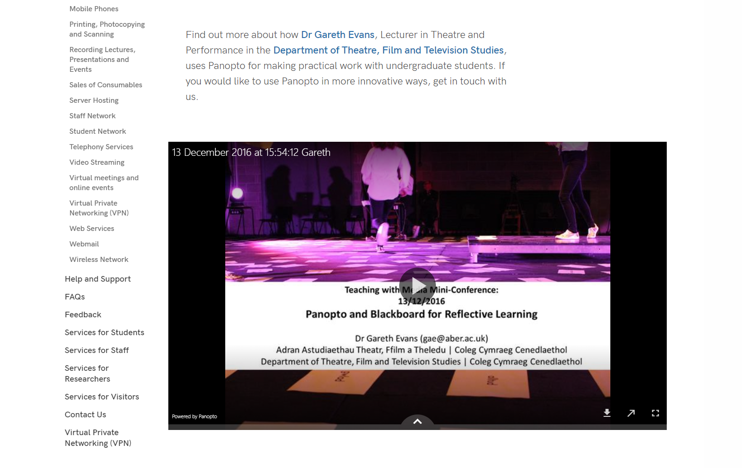

Preparation
- Go to the Panopto site – https://abercast.aber.ac.uk/.
- Choose to sign in using Blackboard.
- Log in with your usual username and password.
- Click Browse in the left menu.
- With the drop-down set to 'My folders', find the appropriate folder for the video to be uploaded to.
Note: if you don't have any folders, or don't have a suitable folder, you'll need to contact the Learning and Teaching Enhancement Unit (LTEU) to ask them to create one for you.
- Click on the Create button at the top of the screen next to the search box.
- Choose 'Upload media' from the menu that appears.
- Drag the video from your PC onto the area indicated on the screen. Alternatively click in the area and browse to find your video on your PC
- A progress bar will appear to show you the progress of the upload.
- When it says 'Upload complete. You can close this window now.' it's safe to click on the X in the top right corner to close the upload screen.
- You should now see your new video displayed in the list. Depending on the size of the video it may take a while to be processed. Until it has finished processing, you'll see a 'Processing' message.
- While you're waiting, you can edit the sharing permissions for the video if necessary. The default permissions match whatever your folder's permissions are. If you want the video to be embedded on the website and to be visible to all visitors, you need to make sure it's set to allow them to view it.
  - Put your mouse over the video and you'll see some icons appear - click on Share.
  - The current permissions will be displayed - click on the current permissions to show a drop-down menu of permission options
  - Choose 'Anyone with the link' to allow your video to be embedded and viewed by any website visitor.
  - Click the Save changes button at the bottom.
  - Click the X in the top right corner to close the window.
- When your video has finished processing, click on its title.
- Look at the web address in the address bar at the top of your web browser. Copy the end of the web address - the part after id=. For example for this web address: https://abercast.aber.ac.uk/Panopto/Pages/Viewer.aspx?id=488c4dd3-3728-47ca-9fdb-f32e8b2070bb you will need to copy the letters and numbers after id=, which are 488c4dd3-3728-47ca-9fdb-f32e8b2070bb.
Note: Panopto is controlled and supported by the Learning and Teaching Enhancement Unit – if you have any problems using Panopto, please contact the Learning and Teaching Enhancement Unit (LTEU).

Embedding your Video
- Open the section where you wish to place the video.
- Click on the Content tab.
- Click the 'Add content' button and choose the content template named “Panopto Video Embed”.
Note: If you don’t see this content template in the list, you’ll need to contact Information Services to ask them to enable the necessary template for Panopto videos.
- The Panopto Video Embed template will open:
- Insert a name for your new content in the Name box.
- Type or paste the ID of the Panopto video that you noted in preparation in the Panopto ID box – e.g. 488c4dd3-3728-47ca-9fdb-f32e8b2070bb.
- Click the 'Save changes' button to finish.
- You may need to reorder the content in your section if you want the video to display at the top of the page or between other content. By default, new content is added at the bottom so will be displayed after other content in the page. See Information Sheet 8 for more details on reordering content within your section.
- Remember to preview your page to be sure it looks as you’d expect, and then approve it.
- Repeat the process for the Welsh version of your page.

YouTube

Examples
Example of a YouTube video on a ‘normal’ page:
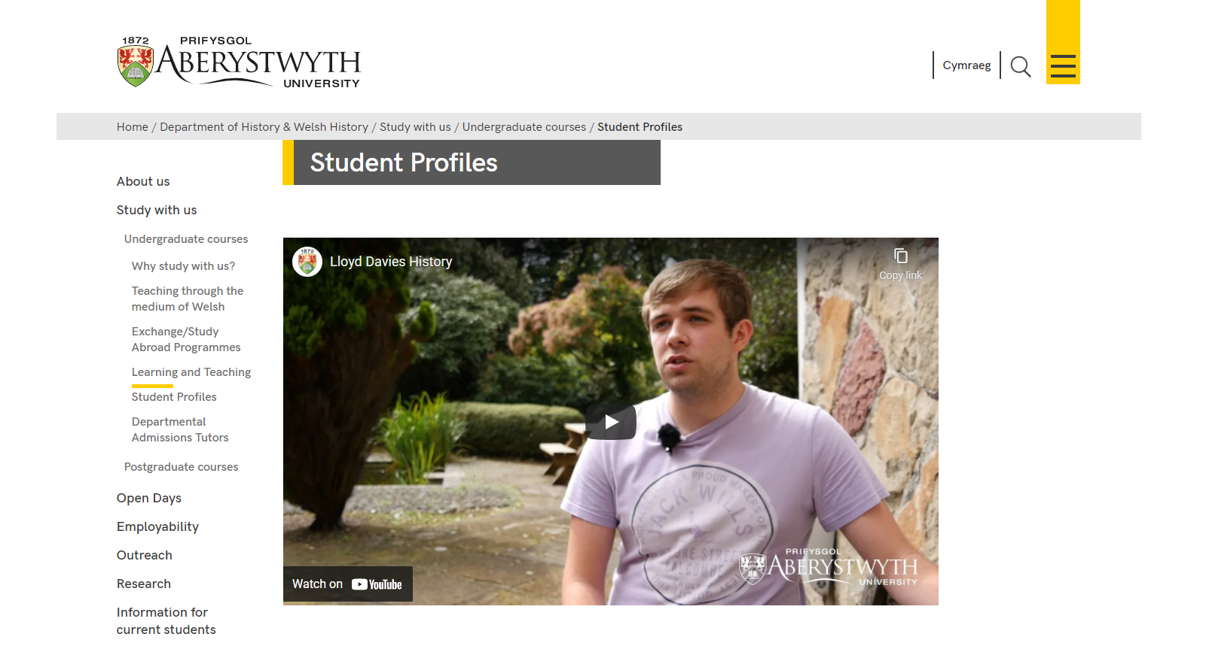

Preparation
- Upload your video onto YouTube
- When your video is ready, visit the YouTube page for your video. This link will be included in the email you receive when the video is ready.
- Note the YouTube code which is shown at the end of the web address of the page. The web address will look similar to this: https://www.youtube.com/watch?v=AR9vEg7IrEk – you just need the code at the end, after “?v=” – in this case it would be AR9vEg7IrEk.

Embedding your Video
- Open the section where you wish to place the video.
- Click on the Content tab.
- Click the Add Content button and choose the content template named “YouTube Video”.
Note: If you don’t see this content template in the list, you’ll need to contact Information Services to ask them to enable the necessary templates for YouTube videos.
- The YouTube Video template will open:

- Insert a name for your new content in the Name box.
- Type or paste the Code for the YouTube video that you noted in preparation in the ‘YouTube Code’ box – e.g. AR9vEg7IrEk.
- If you would like the video to begin playing when the user opens the web page, tick the Yes box in the Autoplay option.
- Click the Add button to finish.
- You may need to reorder the content in your section if you want the video to display at the top of the page or between other content. By default, new content is added at the bottom so will be displayed after other content in the page. See Information Sheet 8 for more details on reordering content within your section.
- Remember to preview your page to be sure it looks as you’d expect, and then approve it.
- Repeat the process for the Welsh version of your page.

