18. The Media Library & Bilingualism
Contents
18. The Media Library & Bilingualism 1
Introduction 2
Language Options for Media Library Files 3
Which Language Option Should I Choose? 4
Text version of flow chart 5
Fully Independent 6
Uploading the English and Welsh versions of the File 7
Inserting the Files into English and Welsh Pages 7
Independent Media File 9
Uploading the Bilingual File 9
Inserting the File into English and Welsh Pages 10
Fully Dependent 11
Uploading the English and Welsh versions of the File 11
Inserting the Files into English and Welsh Pages 12

Introduction
When using the CMS to create bilingual pages, you must provide an English and Welsh version of the text on the page. As well as the text on the page, you will also have to provide users with any necessary PDFs in the appropriate language.
When you switch language in the CMS, you can see the English and Welsh versions of the Site Structure and the content in the sections. The same is true for the Media Library. Categories of the Media Library can have different names in the English and Welsh versions of the Media Library, and files can have different names, descriptions and even the files themselves can differ.
When uploading files into the Media Library there are some language options that you can choose from which control how media files are displayed and used when switching language in the CMS.

Language Options for Media Library Files
The language options for media library files are found in the ‘Advanced options’ area of the file upload screen, after clicking on the Add Media button in the relevant area of the Media Library:
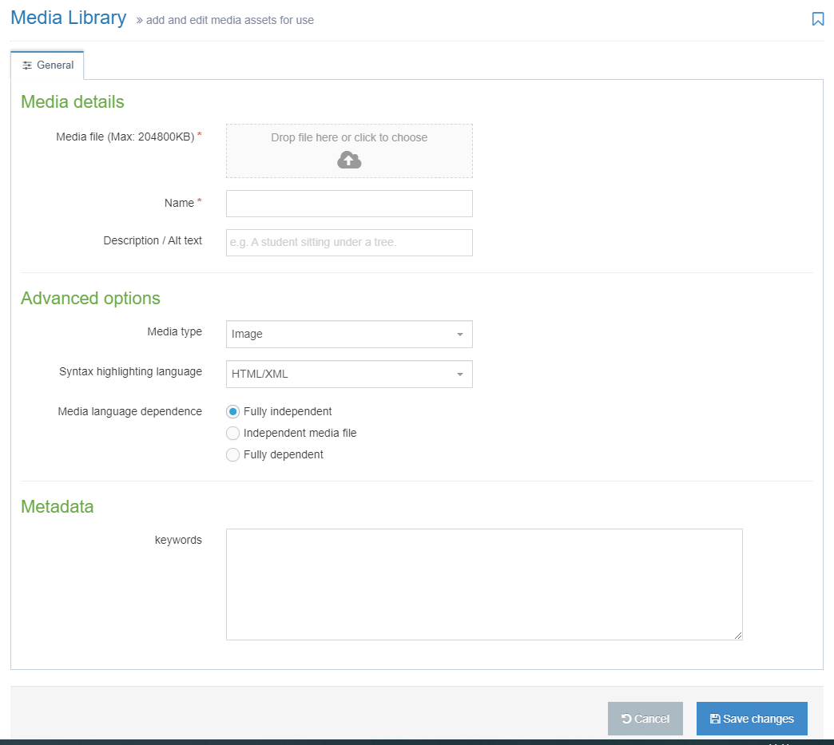
The options available are:
- Fully independent
- Independent media file
- Fully dependent
The default option is Fully independent.

Which Language Option Should I Choose?
The following flow chart should help you decide:

Text version of flow chart
- What type of file are you uploading?
  - Image
    - Does the image contain any text?
      - No: Fully Independent
      - Yes: Fully Dependent
  - PDF or other document
    - Is the document bilingual?
      - Yes: Independent Media File
      - No
        - Do you want the English and Welsh version stored together?
          - Yes: Fully Dependent
          - No: Fully Independent

Fully Independent
Fully Independent means that the file that you are uploading will be available to insert in pages on the English or Welsh side of the site, and the information about the file (e.g., description) will be the same regardless of where you are inserting the file.
This option is best for things like images which are intended to look the same on the English and Welsh side of the site. It can also be used when you have a separate PDF for each language.
This is not a suitable option for bilingual PDFs because the description that you enter in the Description box will be used as the link text in both the English and the Welsh side of the site.

Note: If you are using this option for bilingual PDFs, you will need to upload the file twice – once with an English description and once with a Welsh description. This is not recommended as one version of the document could be updated and the other forgotten, resulting in different information being available in English and Welsh. This would be confusing for users, would not meet our Welsh Language Standards and could also cause issues with consumer protection laws.

Uploading the English and Welsh versions of the File
Instructions assume that you are uploading a PDF file and working in English first.
- Browse to the area of the Media Library where you wish to store your files and click on the ‘Add Media’ button.
- Choose your English file, fill in the name and description (in English), and leave the ‘Media language dependence’ set to ‘Fully independent’.
- Click Save changes to upload the file.
- Click on the Add Media button again.
- Choose your Welsh file, fill in the name and description (in Welsh), and leave the ‘Media language dependence’ set to ‘Fully independent’.
- Click ‘Save changes’ to upload the file.

Inserting the Files into English and Welsh Pages
- Open the appropriate Section and modify the content where you wish the English PDF link to appear.
- Making sure your mouse is in the correct point in the content, click on the ‘Add an image or link to a file from the Media Library’ button.
- Find the first file you uploaded (the English version) in the Media Library and click on it to insert it.
- Click ‘Save changes’ to save
- Switch language in the CMS to Welsh, open the appropriate Section and modify the content where you wish the Welsh PDF link to appear.
- Making sure your mouse is in the correct point in the content, click on the ‘Add an image or link to a file from the Media Library’ button.
- Find the second file you uploaded (the Welsh version) in the Media Library and click on it to insert it.
- Click ‘Save changes’ to save
- Preview your pages to be sure that they look as expected and the links work correctly
- Approve the content in both languages to finish.

Independent Media File
Independent Media File means that the file that you are uploading will be available to insert in pages on the English or Welsh side of the site, but the information about it (e.g., description) will differ according to language. The file itself is independent of language, but the information about it is not. You will be able to add a description in each language for the one file.
This option is best for bilingual PDFs. Users on both the English and the Welsh side of the site will be able to view this one bilingual file, but when you insert it into a Welsh page, it will display Welsh link text, and when you insert it into an English page, it will display English link text.

Uploading the Bilingual File
Instructions assume that you are uploading a PDF file and working in English first.
- Browse to the area of the Media Library where you wish to store your file and click on the ‘Add Media’ button.
- Choose your bilingual file and fill in the name and description (in English).
- Change the ‘Media language dependence’ to ‘Independent media file’.
- Click Save changes to upload the file.
- Click on the Add Media button again.
- Now switch language in the CMS to Welsh – you should still be in the same area of the Media Library, but now you will be in the Welsh version – you may see categories marked as “Not translated” – this is because they haven’t been named in Welsh
- Click on the ‘Not translated’ file you just uploaded. You can tell which file is which by checking the filename in the 5th column.
- Fill in the name and Welsh description.
- Click ‘Save changes’ to save.
- Switch language in the CMS back to English.

Inserting the File into English and Welsh Pages
- Open the appropriate Section and modify the content where you wish the English PDF link to appear.
- Making sure your mouse is in the correct point in the content, click on the ‘Add an image or link to a file from the Media Library’ button.
- Find the file you uploaded in the Media Library and click on it to insert it. You will see that the English text is used as the link text for the file.
- Click ‘Save changes’ to save
- Switch language in the CMS to Welsh, open the appropriate Section and modify the content where you wish the PDF link to appear.
- Making sure your mouse is in the correct point in the content, click on the ’Add an image or link to a file from the Media Library’ button.
- Find the file you uploaded in the Media Library and click on it to insert it. You will see that the Welsh text is used as the link text for the file.
- Click ‘Save changes’ to save.
- Preview your pages to be sure that they look as expected and the links work correctly
- Approve the content in both languages to finish.

Note: If you need to re-upload a modified version of the file in future, you can modify it on either the English or Welsh side. As there is just one file this will update on both sides of the site. See Information Sheet 7 for more information on modifying files in the Media Library.

Fully Dependent
Fully Dependent means that the file that you are uploading will differ according to language. You will need to upload a different file on the English side and the Welsh side of the CMS. The information about the files (e.g., description) will also be different on each side. The English and Welsh files will be stored together in the Media Library in the same slot, just like English and Welsh versions of content.
This option is best when you have separate documents in English and Welsh and you wish to keep them stored together in the Media library.

Uploading the English and Welsh versions of the File
Instructions assume that you are uploading a PDF file and working in English first.
- Browse to the area of the Media Library where you wish to store your files and click on the ‘Add Media’ button.
- Choose your English file, fill in the name and description (in English).
- Change the ‘Media language dependence’ to ‘Fully dependent’.
- Click Save changes to upload the file.
- Now switch language in the CMS to Welsh – you should still be in the same area of the Media Library, but now you will be in the Welsh version – you may see categories marked as “Not translated” – this is because they haven’t been named in Welsh
- Click on the ‘Not translated’ file you just uploaded. You can tell which file is which by checking the filename in the 5th column, and there is an orange triangle alert icon in column 1.
- Choose your Welsh file, fill in the name and description (in Welsh).
- Click Save changes to upload the file.
- Switch language in the CMS back to English.

Inserting the Files into English and Welsh Pages
- Open the appropriate Section and modify the content where you wish the English PDF link to appear.
- Making sure your mouse is in the correct point in the content, click on the ‘Add an image or link to a file from the Media Library’ button.
- Find the file you uploaded in the Media Library and click on it to insert it.
- Click ‘Save changes’ to save
- Switch language in the CMS to Welsh, open the appropriate Section and modify the content where you wish the Welsh PDF link to appear.
- Making sure your mouse is in the correct point in the content, click on the ’Add an image or link to a file from the Media Library’ button.
- Find the file you uploaded in the Welsh version of the Media Library and click on it to insert it.
- Click ‘Save changes’ to save.
- Preview your pages to be sure that they look as expected and the links work correctly
- Approve the content in both languages to finish.

Note: If you need to re-upload a modified version of the files in future, you will need to modify the English and Welsh versions of the file separately. See Information Sheet 7 for more information on modifying files in the Media Library.

