21. Editing an Image-based Department Homepage
Note: Please refer to Information Sheet 9 to familiarise yourself with the basic layout of Department Homepages before attempting to edit an image-based homepage.
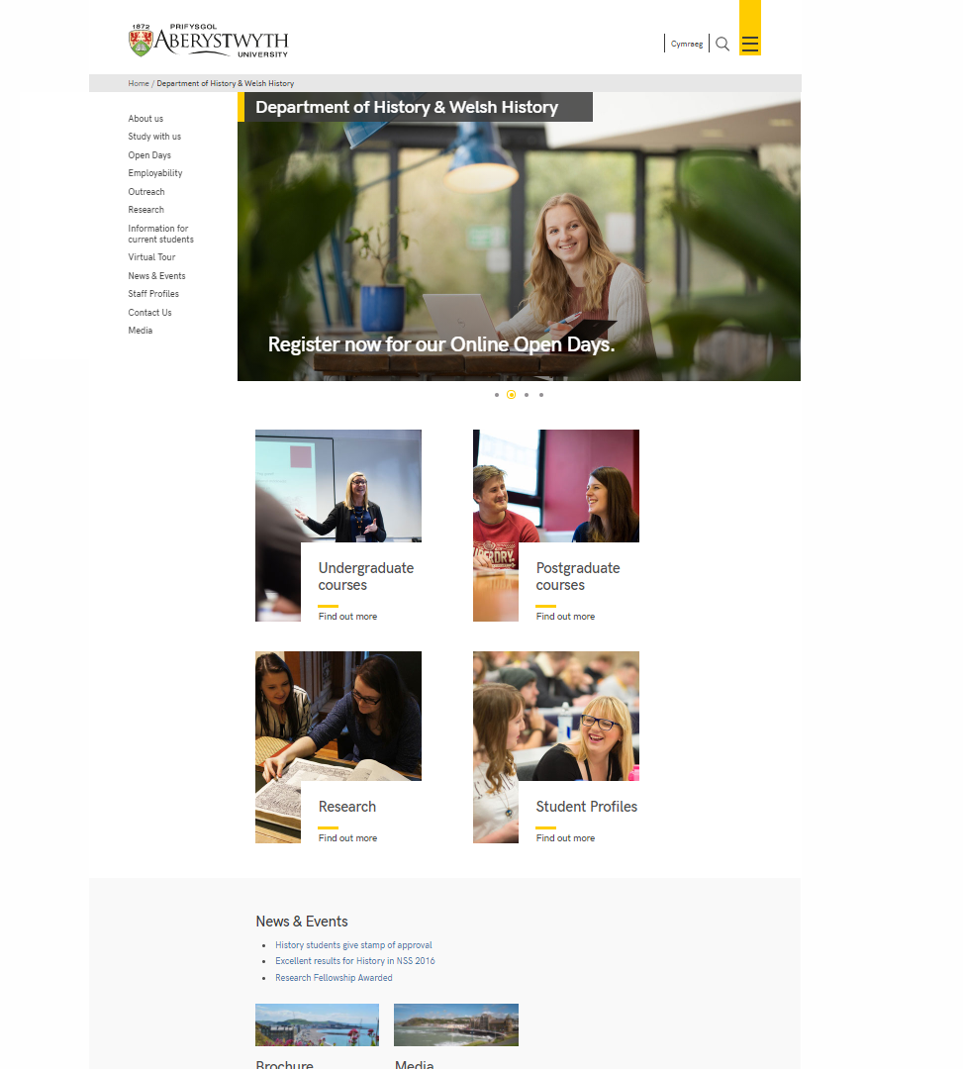

Top Story (double-width block)
Note: If your department homepage has an 'image slider' instead of a double-width image block, you will not be able to edit it yourself. Please contact Information Services if you need to make changes to an image slider.
- In the CMS Site Structure, click on the "top story" section to open it
- Click on the Content tab.
- Find the content using the "Background image block (no text) (top story)" content template - the template used is shown beneath the name of the content:

- Click on the name of the content to open it for editing:
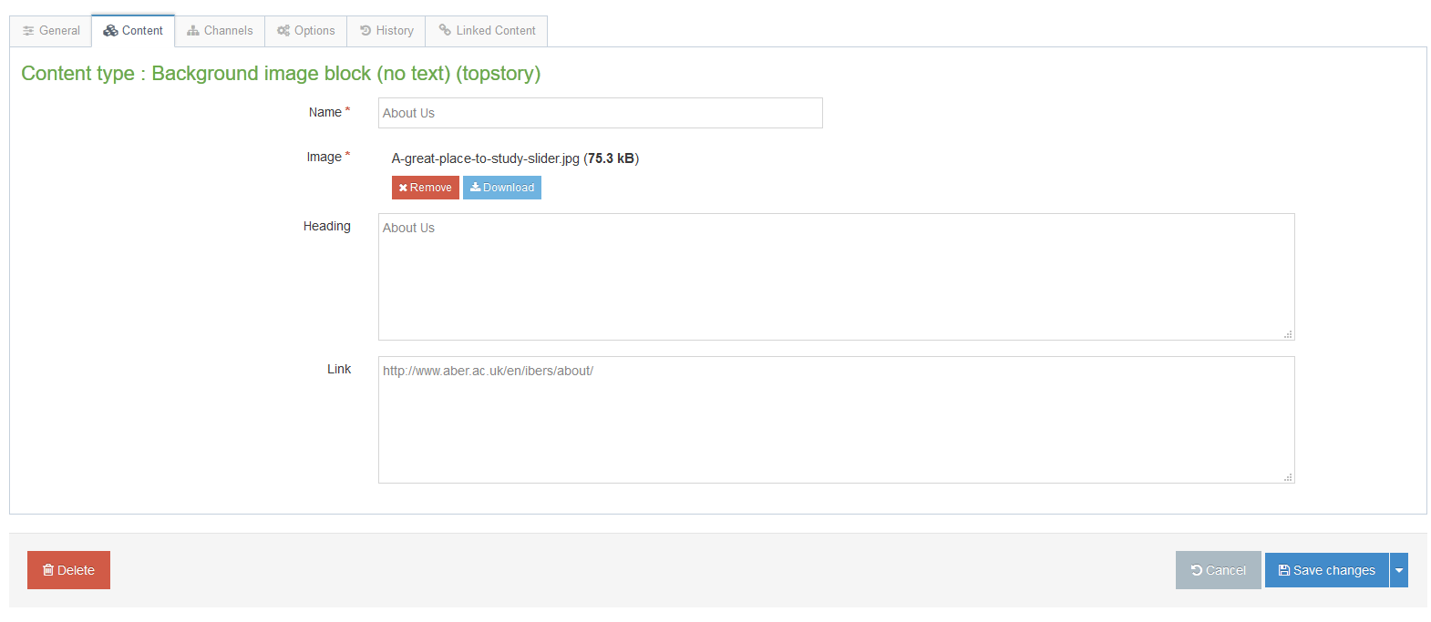
- Make your required changes:
  - To change the image, click on the "Remove" button to remove the existing image, then click in the empty box to select your new image.
  - To change the heading text, replace the existing text with your new text.
  - To change the link, replace the existing link with your new link.
- Click on Save changes to finish.

Column 1
- In the CMS Site Structure, click on the "column 1" section to open it
- Click on the Content tab.
- Find the appropriate image block content using the "Background image block (no text)" content template - the template used is shown beneath the name of the content:
- Click on the name of the content to open it for editing:
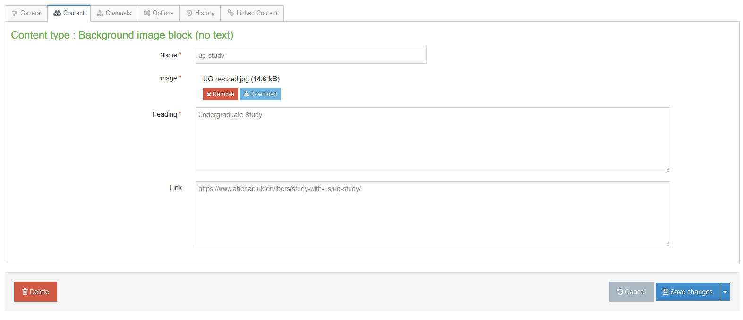

- Make your required changes:
  - To change the image, click on the "Remove" button to remove the existing image, then click in the empty box to select your new image.
  - To change the heading text, replace the existing text with your new text.
  - To change the link, replace the existing link with your new link.
- Click on Save changes to finish.

Column 2
- In the CMS Site Structure, click on the "column 2" section to open it
- Click on the Content tab.
- Find the appropriate image block content using the "Background image block (no text)" content template - the template used is shown beneath the name of the content:
- Click on the name of the content to open it for editing:

- Make your required changes:
  - To change the image, click on the "Remove" button to remove the existing image, then click in the empty box to select your new image.
  - To change the heading text, replace the existing text with your new text.
  - To change the link, replace the existing link with your new link.
- Click on Save changes to finish.

Column 3
- In the CMS Site Structure, click on the "column 3" section to open it
- Click on the Content tab.
- Find the appropriate image block content using the "Background image block (no text)" content template - the template used is shown beneath the name of the content. Note that in column 3 you are likely to see several different types of content such as Chat Links and Social Media Links as well as Background image block (no text), so be sure to click on the right one.
- Click on the name of the content to open it for editing:
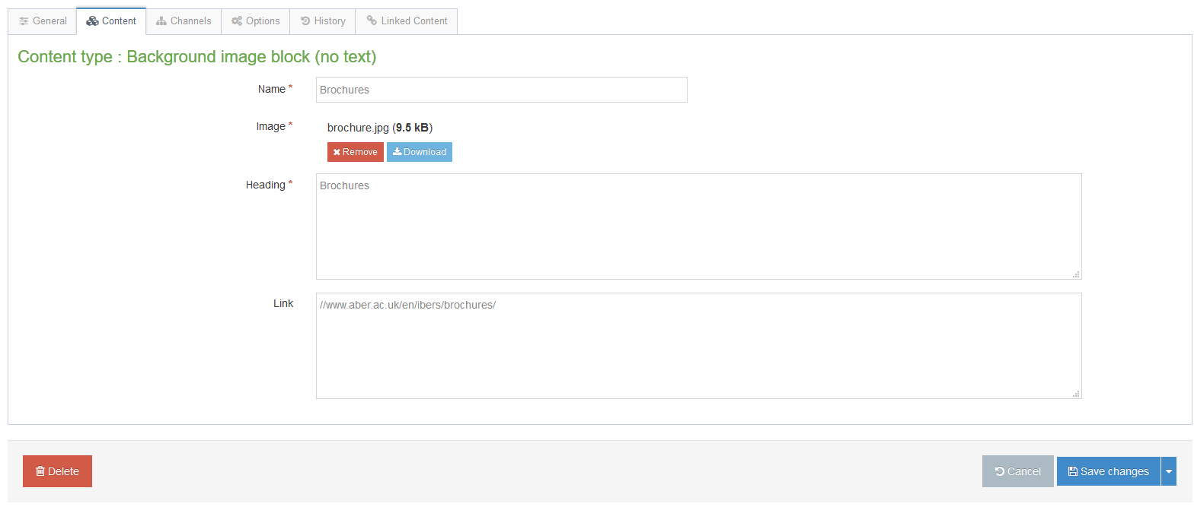

- Make your required changes:
  - To change the image, click on the "Remove" button to remove the existing image, then click in the empty box to select your new image.
  - To change the heading text, replace the existing text with your new text.
  - To change the link, replace the existing link with your new link.
- Click on Save changes to finish.

Checking your Work
Before proceeding, preview your department homepage, by using the 'preview section' option on your department's main section.
Make sure that the edits to the image blocks look as expected, and that they link to the correct locations.

Finishing Off
When you are happy that your image blocks look and behave correctly, you will need to approve them. See Information Sheet 6 for more information on approving content.
Your changes will be automatically published to the staging server at the next scheduled publish (10 past the hour). They will then be transferred to the live site at the next scheduled transfer (these take place through the day at approximately 9:30, 11:30, 14:30 and 16:30).

