24. Getting Started as a Department Web Editor
Note: You should have attended a CMS Training Session before proceeding. If you have attending training but do not yet have permission to access your department’s section in the CMS, please contact Information Services. If you haven’t been trained yet, please contact Information Services.
Now that you have had CMS training, you will be starting out on editing and creating new pages in your department’s website. Sometimes the step between the CMS training to maintaining a real site can seem daunting, so this information sheet is designed to help you over that hurdle.

Contents
24. Getting Started as a Department Web Editor 1
Contents 1
1. Getting Help 3
2. Changes to your CMS Site Structure 4
3. Understanding the Site Structure 6
4. Your Department Homepage 8
5. Changing an Existing Page on your Department Site 9
A. Finding the Right Section 9
B. Making the Change 11
6. Creating a New Page on your Department Site 13
7. Changing the Left Menu for your Department (Moderators only) 16
A. Adding a New Item in the Department’s Left Menu 16
B. Changing the Order of the Left Menu 16
C. Adding a link in the Left Menu which goes to a page outside of your Department 16
8. Using the Media Library 17
9. Ensuring Bilingualism 19
A. Ensuring compliance with the Welsh Language Standards. 19
B. Welsh Language Standards Requirements - Websites 19
C. New Pages 20
D. Modifying Existing Pages 22
10. Approval 23
11. Understanding When your Changes will be Live 24
How this affects you 25
12. Making Big Changes 26

1. Getting Help
If you need some help using the CMS please check our website: https://www.aber.ac.uk/en/is/it-services/web/
We provide training materials and information sheets, as well as a number of FAQs regarding CMS use.
Training materials: https://www.aber.ac.uk/en/is/it-services/web/cms/training/
Information Sheets: https://www.aber.ac.uk/en/is/it-services/web/cms/info-sheets/
FAQs: https://faqs.aber.ac.uk/
If you can’t find the answer you need, please contact us:
IT Service Desk
Phone: 2400
Email: is@aber.ac.uk

2. Changes to your CMS Site Structure
Once your new permissions have been set, your Site Structure will look quite different to the way it looked in your training session. There will be additional sections displayed.
During training your site structure looks something like this:
Once you have additional permissions, this will change to something like this:
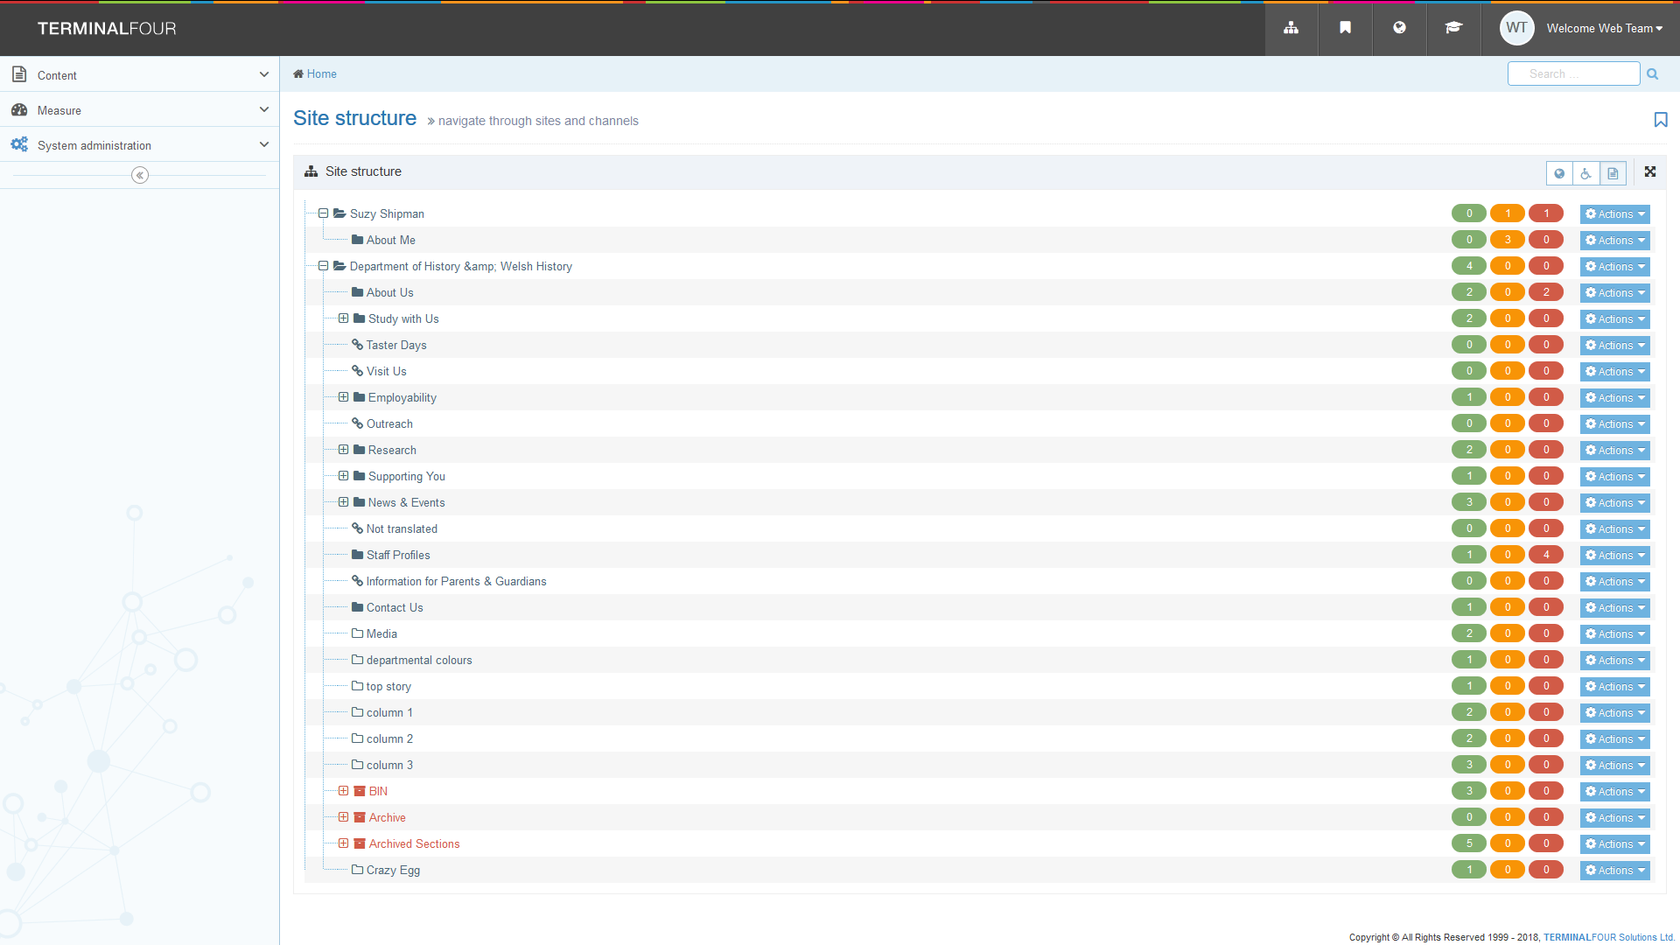
You will keep your training section in case you want to run through the training exercises again or try new techniques, so feel free to make additional sections within that area as required (only possible if you are a moderator).
You will see that each main area of the site has text that is next to a + sign that is not indented. Sub-sections within this are indented so you can see that they belong inside the main area.
In the example above, the CMS user had been given access to the Department of History & Welsh History section, so they could now see that area of the university website in their site structure.

3. Understanding the Site Structure
When you look at the sections within your department area, you may recognize some of them from the left menu on your department website. All sections with blue folder icons have had the ‘show in navigation’ tick-box ticked, so they will be showing up in your department’s left menu. For example, the Department of History & Welsh History left menu contains the sections with blue folder icons that you could see on the previous page.
Other sections with clear folder icons won’t be in the menu, but they may still be used in some way. Some of them are used to build up your department homepage (more about that in the next topic), and others may be used for pages that are linked to elsewhere, but aren’t wanted in the left menu.
Many sections will have a plus sign to the left of them, indicating that they contain sub-sections. You can click on the plus sign to see the sub-sections:
In the example above, there are 3 sub-sections inside the Study with Us section. Two of these sub-sections are displayed in the left menu when a user visits the Study with Us page, because they are marked with blue folder icons in the site structure. One sub-section (image-menu) is not displayed because it has has had the 'show in navigation' tick box unticked, and has a clear folder icon. This section is a hidden section that is used to insert an image-menu in the parent section.

4. Your Department Homepage
Your department homepage is a special kind of page. It is made up of content from several different sections in the CMS. Some content is within the main top level section (eg the section called ‘Department of History & Welsh History’ in the example we are using). Other content is in some of the sections with clear folder icons that you can see in the site structure, such as ‘column 1’, ‘column 2’, ‘column 3’, ‘top story’, and ‘departmental colours’.
If you want to make changes to your department homepage you will need to be careful and make sure that you understand which content you need to edit to make the changes you need. Please read InfoSheet9.0 - Editing Departmental Homepages before attempting to edit your homepage.
Your department may be using the News System. If it is you may have a special area at the bottom of your homepage which is automatically filled with the latest news items. Please read InfoSheet10.0 - Working with Departmental News for more information on how the news system works and how to add a news article.

5. Changing an Existing Page on your Department Site

A. Finding the Right Section
If you need to make a change to an existing web page, the first thing you will need to do is find it in the CMS site structure. If you are not sure where to look, browse to the web page in your web browser and take a look at the breadcrumb trail at the top of the page. It will look something like this:
The breadcrumb trail goes across the top of the page above the main heading and tells users where they are within the site. It is useful for you when looking for your page in the CMS site structure because the breadcrumb trail is made up of section names.
In the example above you can see that this section is called ‘Teaching through the medium of Welsh', and working towards the left you can then see that it is inside the section called ‘Undergraduate Study', which is in the section called ‘Study with Us’, which is in the section called ‘Department of History & Welsh History’.
In the CMS site structure you can already see the main department section (‘Department of History & Welsh History’), so now you would need to expand ‘Study with Us’, and within that expand ‘Undergraduate Study’ and in there you would see a sub-section called ‘Teaching through the Medium of Welsh'. This is the section representing the page you want to edit.

B. Making the Change
Now that you have found the correct section, you will need to open it to find the content inside. Remember that you will need to click on the section and then click on the Content tab to find the content. In the Content tab you will find a list of any content that is within this section. For example, in the Teaching through the Medium of Welsh section mentioned above:
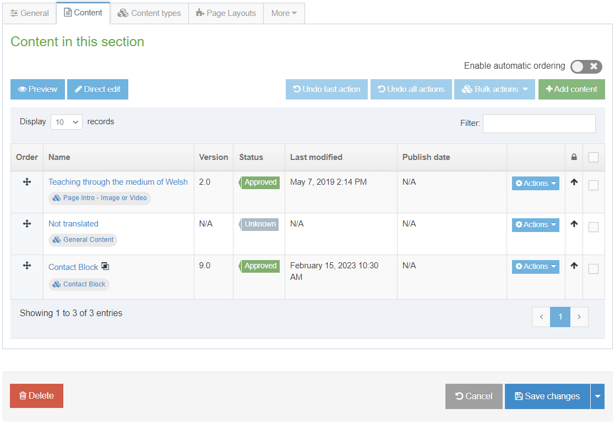
Now you will need to decide which piece of content you are going to edit. Look at the names of the pieces of content to see if you can see which is the main text on the page. In this example we can see 2 pieces of content called ‘General Content’, and ‘Contact Block’. The content that is the main text of the page will be the one called ‘General Content’ in this example. If you are not sure which one is the one you need, you can click on each of them in turn and if it’s not the right content, just click Cancel and look at another.
Once you know which content is the one you need to edit, click on its name, and the editor will open up.
Make the changes as necessary and click 'Save changes' to save. If you can, make the same changes on the Welsh version of this piece of content too. See the section on Ensuring Bilingualism for further information. Once you are finished, don’t forget to approve the content (Moderators only), or ask a Moderator to approve it for you, so that it will go live.
For more information on editing content please see the following information sheets:
- InfoSheet4.0 - Editing Content
- InfoSheet4.1 - Editing Content - Formatting Text
- InfoSheet4.2 - Editing Content - Inserting Links
- InfoSheet4.3 - Editing Content - Inserting Images
- InfoSheet4.4 - Editing Content - Inserting Tables
- InfoSheet4.5 - Editing Content - Inserting Links to Documents

6. Creating a New Page on your Department Site
Note: Only Moderators can create a brand new page. If you are a Contributor, please ask a Moderator in your department to create the page for you. Both Moderators and Contributors can add content to a page.
When creating a new page on your department site, the first thing to think about is where do you want this page to appear. Look at your website in a web browser and find the best place for the page you want to add. For example, I might want to add a new page for a new research project. So, I would need to look for a section about research, and perhaps find a sub-section inside it that is about research projects. My new section could go inside that. This would mean that the research projects page would be the ‘parent page’ for my new page.
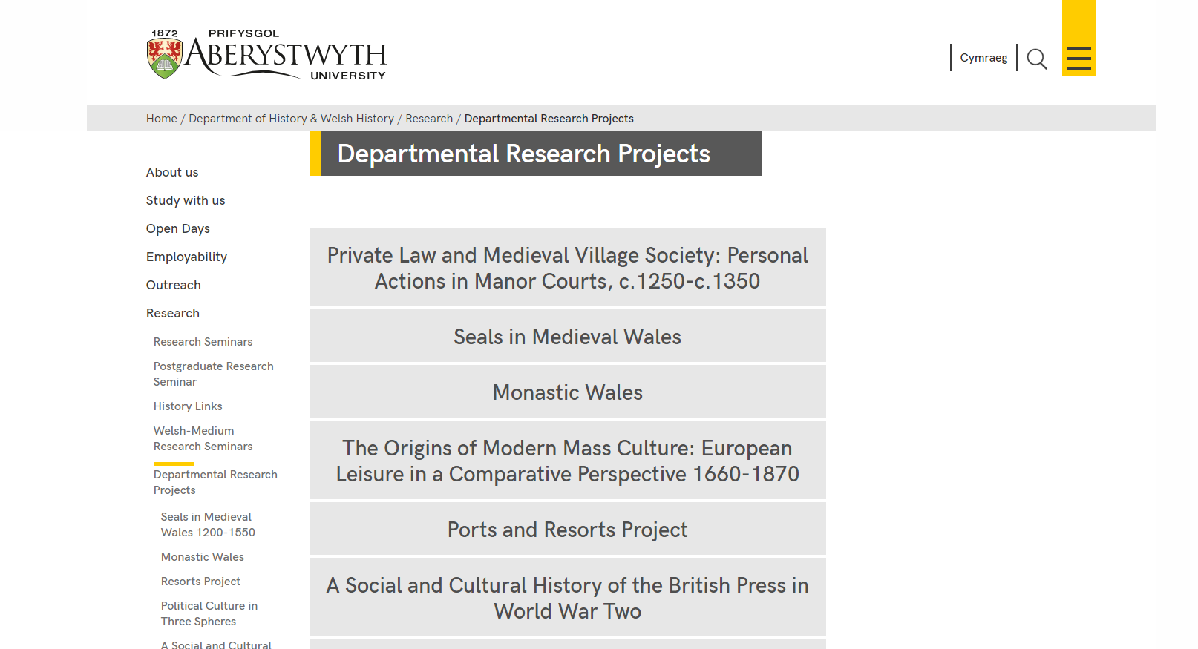
Using the same method as above in part 5A, look at the ‘parent page’ in your web browser and find out where it will be in the site structure. Then in the CMS, expand the appropriate sections in the site structure until you reach the ‘parent page’ section (e.g. the Undergraduate section).
Now, make the new section for your new page by clicking on the Actions on the right of the ‘parent page’ section, e.g. in our example, you would click on the Actions button on the right of the Undergraduate section, and click Create section in the menu that appears.
Fill in the details of the section and click Save changes. If you need more information on how to create a section, read InfoSheet2.0 - Creating a Section.
Once you have added the section, you will need to open it up, click on the Content tab, and add the content that you require.
For more information on adding content please see the following information sheets:
- InfoSheet3.0 - Adding Content
- InfoSheet3.1.1 - Adding General Content
- InfoSheet3.1.2 - Adding a Contact Block
- InfoSheet3.1.3 - Adding Meta Data
- InfoSheet3.2 - Adding Related Links
- InfoSheet3.3 - Reusing Existing Content

For more information on editing content please see the following information sheets:
- InfoSheet4.0 - Editing Content
- InfoSheet4.1 - Editing Content - Formatting Text
- InfoSheet4.2 - Editing Content - Inserting Links
- InfoSheet4.3 - Editing Content - Inserting Images
- InfoSheet4.4 - Editing Content - Inserting Tables
- InfoSheet4.5 - Editing Content - Inserting Links to Documents

7. Changing the Left Menu for your Department (Moderators only)

A. Adding a New Item in the Department’s Left Menu
The left menu on your department website is made up of section names. If a section has the ‘Show in navigation’ tick box ticked, it will automatically appear in the menu. If you want an additional item in the left menu, you will need to add a new section for it, and leave the ‘Show in navigation’ tick-box ticked so that it will automatically be inserted.
If you want the new item in the main menu at the top level of your site, your new sub-section’s ‘parent section’ will need to be the main section (e.g. the section called ‘Department of History & Welsh History’ in our example). If you want the new item to be in one of the sub-menus (e.g. a new item in the menu that shows when you clicked on Current Students, then Undergraduate) your new section’s ‘parent section’ will need to be the Undergraduate section.
Follow the steps in part 6 to create the section.

B. Changing the Order of the Left Menu
You can change the order of items in the left menu by moving them or setting an automatic ordering (e.g. alphabetical order). See InfoSheet8.0 - Reordering a Section (page 3) for more information on how to do this.

C. Adding a link in the Left Menu which goes to a page outside of your Department
To add a link to a page outside your department, you will need to create a ‘Link Section’ rather than a normal section. Work out what the link section’s parent section will be in the same way as in part A above. Add your new section to the parent section using the guidance in InfoSheet2.1 - Creating a Link Section

8. Using the Media Library
Each department has its own category (folder) in the CMS Media Library. You should have been given permission to add or edit media in your department’s category.
Departmental media categories are found within the ‘Departmental’ section that you can see when if you click on the + sign to the left of Categorised:
Expand the ‘Departmental’ section and scroll down through it until you see your department. Once you have found it, you can expand it to see what sub-categories are inside by clicking on the + sign to the left of your department's main category. If you are a moderator you will see the Action cog menus appearing on each folder. These can be used to create new sub-folders. See InfoSheet7.0 - The Media Library (page 3) for more information on creating new sub-categories
Click on the category you wish to browse, or add files to. The contents of the category will be displayed on the right hand side of the screen.
More information on adding and editing items in the Media Library is found in InfoSheet7.0 - The Media Library.
If you will be uploading PDF documents to the Media Library in English and Welsh, you may find the following information sheet useful: InfoSheet18.0 - The Media Library & Bilingualism

9. Ensuring Bilingualism
It is important to remember that when you make changes or add new pages on the English side of your site, you should also be making changes or adding pages on the Welsh side of your site. It is not always possible to make these changes immediately due to translation time, but you should aim to make the equivalent changes as soon as possible. However, don’t be tempted to create the Welsh version of your page before you have your translation ready.

A. Ensuring compliance with the Welsh Language Standards.
Welsh Universities are required to comply with the Welsh Language Standards (No. 6) Regulations 2017. The Welsh Language Standards explain how the University is expected to provide specific services through the medium of Welsh, ensuring that the Welsh language is not treated less favourably than the English language.
The main requirements of the Welsh language standards in relation to webpages is to ensure that all web pages are published in Welsh and that the Welsh web pages are not treated less favourably. The Welsh version must be the same as in terms of the information published, the functionally, formatting and appearance; and importantly – the Welsh web pages must be updated at the same time as the English version is updated. It is essential to ensure when making changes or adding pages on the English side of your site, to also ensure that the changes are made to the Welsh side of your site. Do not publish changes/new webpages in English if the Welsh versions are not ready.

B. Welsh Language Standards Requirements - Websites
- All web pages and online services must be published in Welsh.
- Web pages must be fully functional and published/updated at the same time in Welsh & English. The Welsh / English should include the same information and there must be no delay between updating the Welsh & English versions of the website.
- Each web page must include a ‘Cymraeg’ / ‘English’ link to the equivalent page in Welsh or English. The ‘Cymraeg’/’English’ link must not revert to the homepage or a different webpage.
- Welsh web pages must not be treated less favourably in terms of the information, formatting, design, and appearance.
- Hyperlinks included on Welsh web pages must link to the Welsh version of the that page/website. Hyperlinks to external websites on Welsh web pages should link to the Welsh version of that website if available.
- Links to downloadable documents must be to the Welsh version of that document/form on the Welsh web page. The majority of University documents/forms published are available in Welsh and English, but if the document is not available in Welsh (e.g. external reports / research publication / academic papers) a link should be included to the English version of the document on the Welsh page as well. For further information on the Welsh language standard requirements for documents please contact canolfangymraeg@aber.ac.uk
For further information regarding the Welsh language standards requirements for websites, please see guidance or contact canolfangymraeg@aber.ac.uk should you have any questions.

C. New Pages
If you have created a new page in English, please ensure that you have the Welsh version/translation ready. Please contact the Translation Team translation@aber.ac.uk should you require Welsh translation or proofreading services..

i. Welsh Section Information (Moderators only)
Switch language in the CMS by clicking on the language symbol (a globe) in the black bar at the top and choosing Cymraeg from the menu that appears. View the site structure and find the section that you need to work on. Remember that sections that haven’t been set up in Welsh will be called ‘Not translated’ and you can put your mouse over them to see the English.
Once you have found the right section, click on it and enter the Welsh section name, and the Output URI. See InfoSheet2.0 - Creating a Section (page 2-3) for more details.

ii. Welsh Content
Once you have modified the section with the Welsh details, you will need to modify the content to add the Welsh text. Click on the section you just named and look in the Content tab. Content that hasn’t been set up in Welsh will be called ‘Not translated’ and you can put your mouse over it to see the English name.
Once you know which content is the one you need to edit, click on its name, and the editor will open up. Add your Welsh text in the appropriate boxes. Try and make sure your Welsh page looks approximately the same as the English page, with the same formatting, images, tables etc. Links may need to go to different locations if there is a Welsh version of the page you linked to in the English page.

D. Modifying Existing Pages
When you modify an English page, you should apply the same modification to the Welsh page. This can be tricky if you are not a Welsh speaker as you may not be able to see which part of the Welsh text matches the English text that you changed. If you don’t have a colleague who can help, you should send the part of the English text you have changed to the Translation Unit, clearly marking the change you have made. They can then send you back the Welsh translation so you can slot it in to the Welsh page. Once you have the translation, use the same process as you use in English to edit the appropriate piece of content and insert this change.
Please be mindful that Hyperlinks included on Welsh web pages must link to the Welsh version of the that page/website. Hyperlinks to external websites on Welsh web pages should link to the Welsh version of that website if available.
Links to downloadable documents must be to the Welsh version of that document/form on the Welsh web page. The majority of University documents/forms published are available in Welsh and English, but if the document is not available in Welsh (e.g. external reports / research publication / academic papers) a link should be included to the English version of the document on the Welsh page as well. For further information on the Welsh language standard requirements for documents please contact canolfangymraeg@aber.ac.uk

10. Approval
Remember that changes you make in the CMS will not reach the live site if they are not approved first. When you have finished editing and are ready for your changes to go live, you should ask a Moderator to approve the content, or if you are a Moderator yourself, go to the approval screen and approve the content.
Don’t forget to preview your section before the content is approved so that you can be sure that it looks as expected and works correctly. Please see InfoSheet2.3 - Previewing Sections for more information on previewing your section.
Within departments, you may have arrangements regarding who has responsibility for approval. In some departments there may be one or more central Moderators who check and approve all changes. Other departments have a rule that each Moderator only approves their own content. Make sure that you are aware of any arrangements in your department.
The approval process is quite straightforward. If you need a reminder of how to approve content, please see InfoSheet6.0 - Approving Content (PDF).

11. Understanding When your Changes will be Live
There are 3 steps in the process to get your content onto the live site.
- Your content must be approved in the CMS
- Content is published onto the preview server (e.g. cmspreview.aber.ac.uk/en)
- Content is transferred onto the live server (e.g. www.aber.ac.uk/en)
The normal publish & transfer schedule is as follows:
- Publish from CMS to cmspreview: Every hour, at 10 past the hour (e.g. 8:10am, 9:10am, 10:10am, 11:10am etc)
- Transfer from cmspreview to live site: 9:30am, 11:30am, 2:30pm, 4:30pm

How this affects you
If you need to get some changes live as quickly as possible, you can use this table as a guide to when you need to get your changes completed and approved so that your page will go live quickly. For example if you have your changes completed and approved before 9:10am your changes will be live by about 9:45am, but if you missed that deadline you would have to wait until about 11:45am before your changes would be live.
Days | Approved time: | Live approx:
Monday - Friday | before 9:10am | 9:30am
Monday - Friday | before 11:10am | 11:30am
Monday - Friday | before 2:10pm | 2:30pm
Monday - Friday | before 4:10pm | 4:30pm
Monday - Friday | after 4:10pm | Next day 9:30am

If you have content that needs to be on the live site urgently, please contact us and we can arrange to get this done as quickly as we can

12. Making Big Changes
If you want to make major changes to your website, it’s a good idea to talk to Information Services before trying to make these changes. Sometimes there will be a special template you can use to achieve your aims. Or it may mean that Information Services will need to create a new way of doing things so you can achieve your aims. On some occasions Information Services may need to tell you that what you want to achieve is not possible. We’d prefer to always be able to help but sometimes, due to constraints of the tools we use to create and maintain our website, as well as constraints on our time, it may not be possible. We may be able to advise you on a slightly different approach, so don’t be afraid to ask for our help.
Some examples of non-standard things you can do with your pages are:
- InfoSheet13.0 - Creating Tabbed or Accordion Pages
- InfoSheet14.0 - Using Expanding Content
- InfoSheet15.0 - Creating an Image Menu
- InfoSheet17.0 - Embedding Video
- InfoSheet21.0 - Editing an Image-based Department Homepage
- InfoSheet28.0 - Creating Highlighted Text Blocks
- InfoSheet29.0 - Adding a Page Intro
- InfoSheet30.0 - Preparing Images to Use in the CMS
- InfoSheet32.0 - Creating a Notification of Works
- InfoSheet33.0 - Creating and Editing Timelines/Flowcharts
- InfoSheet34.0 - Creating a Video Wall
- InfoSheet35.0 - Creating a Feature Tile Grid
- InfoSheet36.0 - Adding an Important Notice

