3.1.2 Adding a Contact Block
Note: The Contact Block is likely to be used around your site on many pages – you can use one piece of content in many different places by “mirroring” the content – see Information Sheet 3.3 for more information on reusing content.
- Open the Site Structure and browse to the section you want to add content to. Click on the name of the section to open it for editing.
- The ‘General section details' page appears. Click on the ‘Content’ tab.
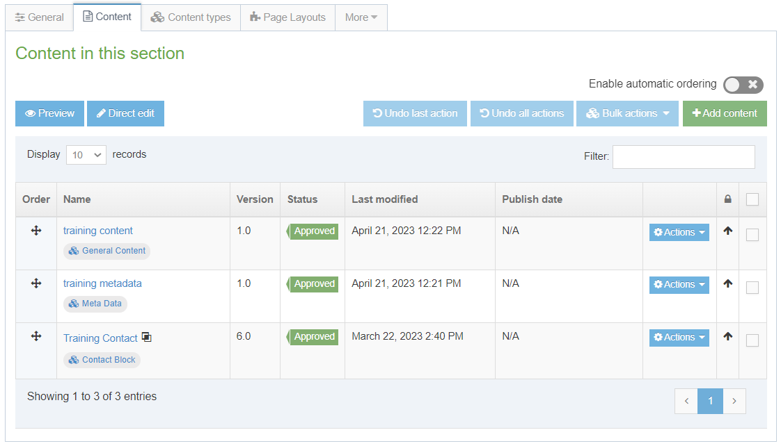
- Click on the ‘Add Content’ button on the right.

- The ‘Choose content type' page appears – click on ‘Contact Block’ in the list that is displayed.
- The Contact Block template will now appear.
- Insert a name for your new content in the Name box. This isn’t seen by people using the web site, but it is important that you choose something that will make sense to other CMS users.
- Fill in as many of the boxes as possible so that you provide users with all the options they need for contacting the department.
- When you have finished adding content click on the 'Save changes' button or click on the small triangle at the end of the button and select 'Save as draft' if you are going to come back to this piece of content later and don't want it to enter the approval process.
- A message will appear at the bottom of the page to tell you that the content has been successfully added:
- You will be returned to the Content tab, where you can see your newly added content listed along with any other content that you have added to this section.
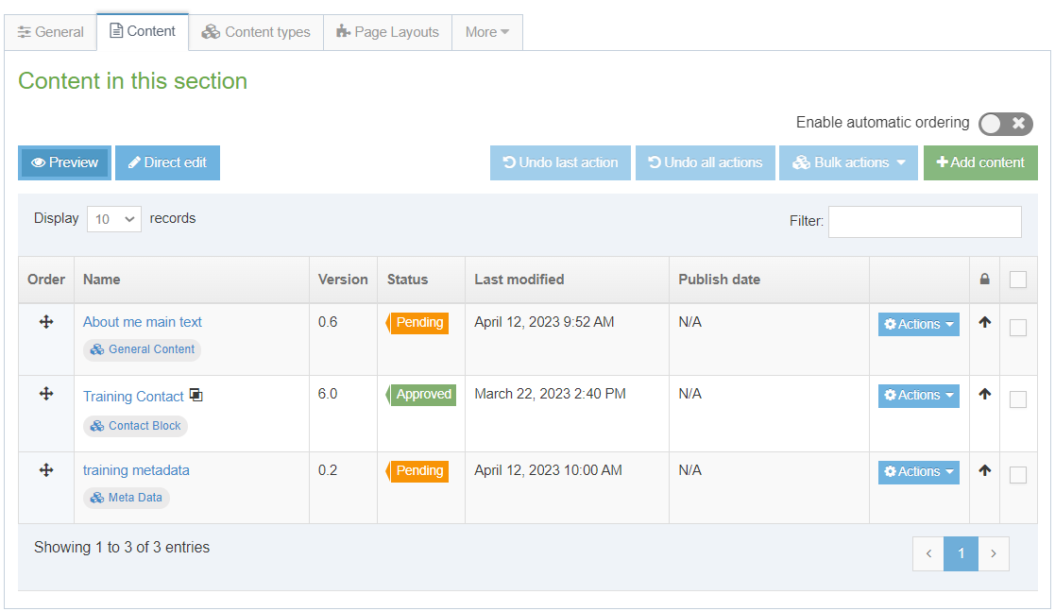
- You will notice that the content appears with the Status ‘Pending’ (or ‘Draft’). Pending content needs to be approved before being published. See Information Sheet 6 for more information on approval (Moderators only). Draft content will not enter the approval process – you can continue to edit it and when you are ready for it to enter the approval process you will be able to click the 'Save changes' button to save it.

Creating the Welsh Version of your Contact Block
Note: You should only create the Welsh version of your content when you have the Welsh text ready. If you have sent your English text to Translation, wait for it to return before creating the Welsh content.
- Click on the 'Site language' button at the top of the screen and select Cymraeg.
- The Welsh version of the section’s 'General section details' page appears. Click on the Content tab.
- The Name of the content appears as 'Not translated', as it hasn’t yet been named in Welsh. Click on the name of the piece of content to modify it.
Note: If there are lots of new pieces of content which haven’t had their Welsh title set, it can be hard to find the right one that you need to work on – move or hover your mouse over the words Not translated and a small box containing the English title of the content will appear.
- Insert a name for your content – this can be in English or Welsh depending on your preference. This isn’t seen by people using the web site, but it is important that you choose something that will make sense to other CMS users.
- Fill in as many of the boxes as possible, in Welsh, so that you provide users with all the options they need for contacting the department.
- When you have finished adding content click on the 'Save changes' button or click on the small triangle at the end of the button and select 'Save as draft' if you are going to come back to this piece of content later and don't want it to enter the approval process.
- A message will appear at the bottom of the page to tell you that the content has been successfully updated:
- You will be returned to the Content tab, where you can see your newly added content listed along with any other content that you have added to this section.
- You will notice that the content appears with the Status ‘Pending’ (or ‘Draft’). Pending content needs to be approved before being published. See Information Sheet 6 for more information on approval (Moderators only). Draft content will not enter the approval process – you can continue to edit it and when you are ready for it to enter the approval process you will be able to click the Update button to save it.

