3.2. Adding Related Links
Related links appear under the left-hand menu on your page and are designed to allow users to quickly access pages which are related to the current page.
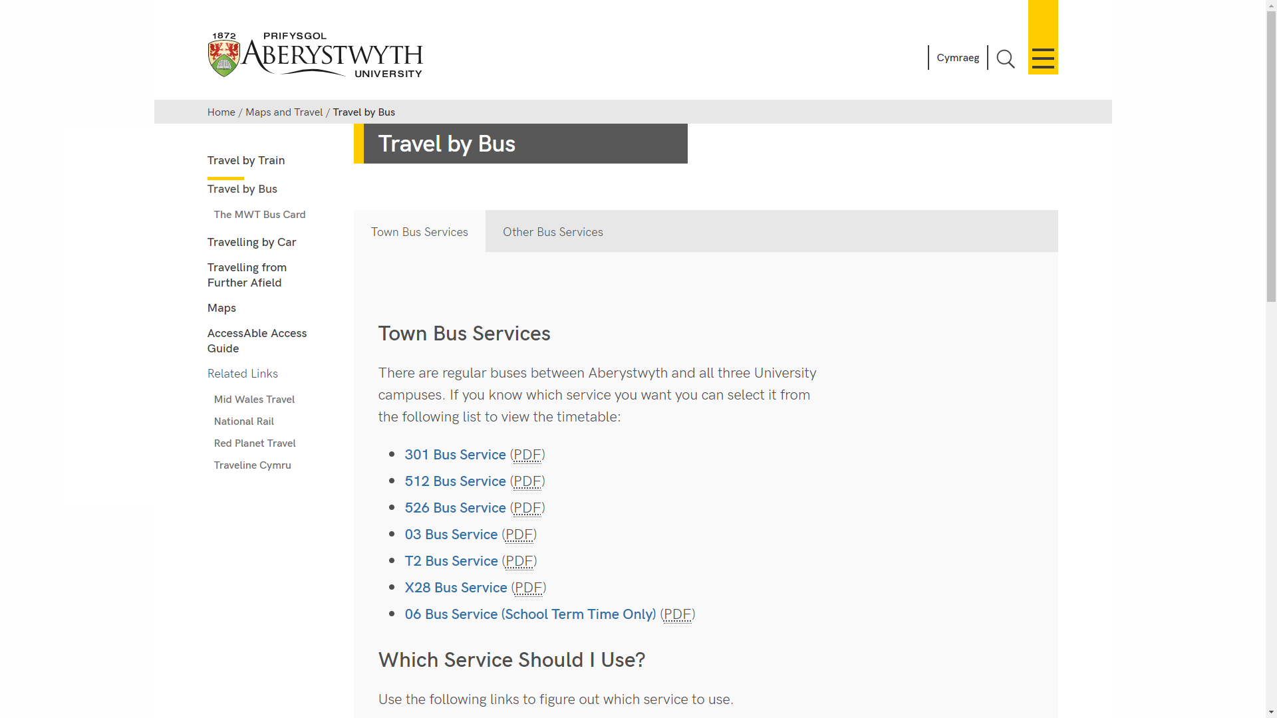
- Open the Site Structure and browse to the section you want to add content to.
- Click on the name of the section to open it for editing.

- The ‘General section details' page appears. Click on the ‘Content’ tab.
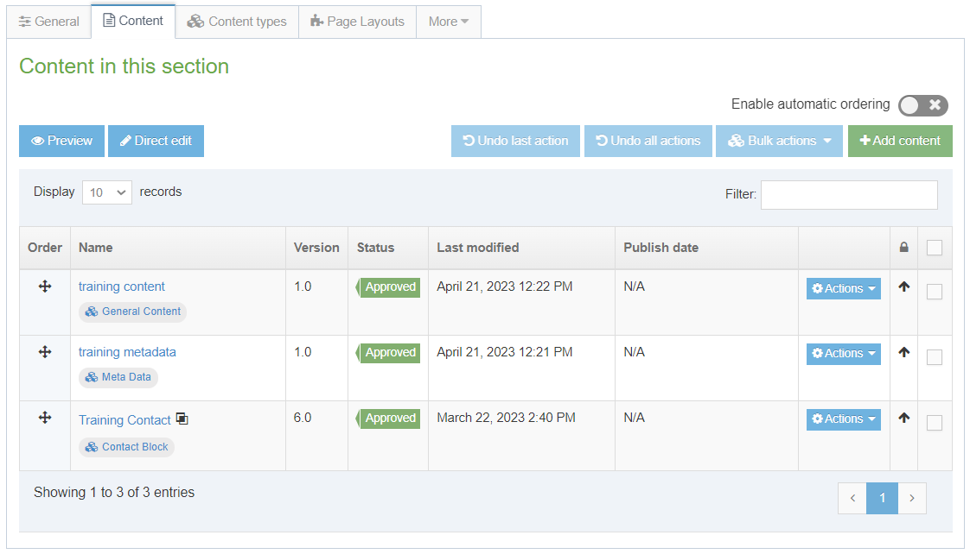
- Click on the ‘Add Content’ button on the right.
- The ‘Choose content type' page appears – click on ‘Related Links’ in the list that is displayed.

- The Related Links template will now appear.
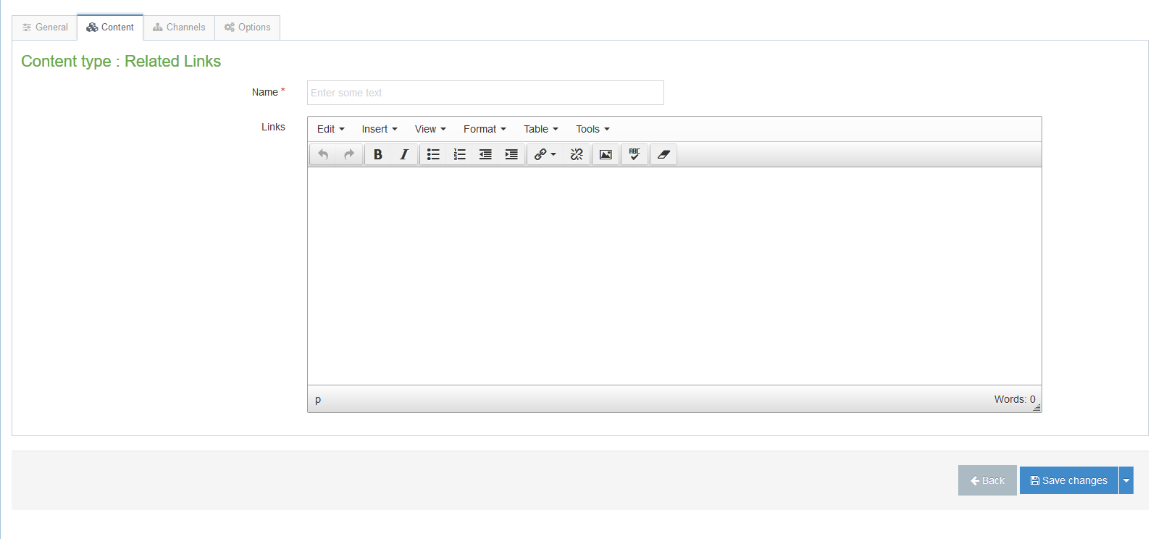
- Insert a name for your new content in the Name box. This isn’t seen by people using the web site, but it is important that you choose something that will make sense to other CMS users.
- In the Links box, create a bulleted list by clicking on the bulleted list button and add the links that you require as bullet points. For more information on adding links, see Information Sheet 4.2.
- When you have finished adding content click on the 'Save changes' button or click on small triangle at the end of the button and select 'Save as draft' if you are going to come back to this piece of content later and don't want it to enter the approval process.
- A message will appear at the bottom of the page to tell you that the content has been successfully added:

- You will be returned to the Content tab, where you can see your newly added content listed along with any other content that you have added to this section.
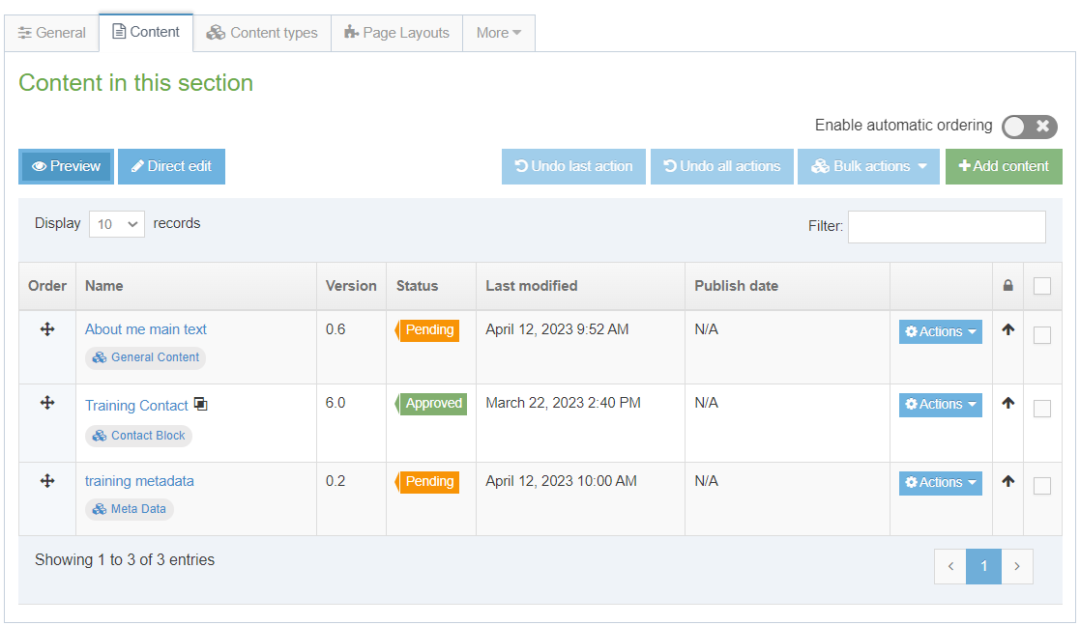
- You will notice that the content appears with the Status ‘Pending’ (or ‘Draft’). Pending content needs to be approved before being published. See Information Sheet 6 for more information on approval (Moderators only). Draft content will not enter the approval process – you can continue to edit it and when you are ready for it to enter the approval process you will be able to click the 'Save changes' button to save it.

Creating the Welsh Version of your Related Links
Note: You should only create the Welsh version of your content when you have the Welsh text ready. If you have sent your English text to Translation, wait for it to return before creating the Welsh content.
- Click on the 'Site language' button at the top of the screen and select Cymraeg.
- The Welsh version of the section’s 'General section details' page appears. Click on the Content tab.
Note: If you are returned to the Site Structure, click on the section you were working on and then click on the Content tab to get back to the list of content.
- The Name of the content appears as 'Not translated', as it hasn’t yet been named in Welsh. Click on the name of the piece of content to modify it.
Note: If there are lots of new pieces of content which haven’t had their Welsh title set, it can be hard to find the right one that you need to work on – move or hover your mouse over the words Not translated and a small box containing the English title of the content will appear.
- Insert a name for your content – this can be in English or Welsh depending on your preference. This isn’t seen by people using the web site, but it is important that you choose something that will make sense to other CMS users.
- Insert the Welsh text you wish to appear as the title of the links column in the Title box – this should be the Welsh translation of the English title.
- In the Links box, create a bulleted list by clicking on the bulleted list button and add the links, in Welsh, that you require as bullet points. For more information on adding links, see Information Sheet 4.2.
- When you have finished adding content click on the 'Save changes' button or click on small triangle at the end of the button and select 'Save as draft' if you are going to come back to this piece of content later and don't want it to enter the approval process.
- A message will appear at the bottom of the page to tell you that the content has been successfully updated:
- You will be returned to the Content tab, where you can see your newly added content listed along with any other content that you have added to this section.
- You will notice that the content appears with the Status ‘Pending’ (or ‘Draft’). Pending content needs to be approved before being published. See Information Sheet 6 for more information on approval (Moderators only). Draft content will not enter the approval process – you can continue to edit it and when you are ready for it to enter the approval process you will be able to click the 'Save changes' button to save it.

