30. Preparing images to use in the CMS
30. Preparing images to use in the CMS 1
Introduction 2
1. Finding Images 3
2. Resizing and Cropping your Image 8
A. Using GIMP 2 9
Crop the image to the correct proportions 9
Resize the image to the correct width and height 11
B. Using Adobe PhotoShop 13
Crop the image to the correct proportions 13
Resize the image to the correct width and height 15
3. Saving the file to a good file size to be used in the CMS 17
A. Using GIMP 2 18
B. Using Adobe PhotoShop 21

Introduction
Depending on where you are using images in the CMS, you may need to prepare them before use.
If you are inserting an image into General Content, you will need to upload it into the Media Library so that you can insert it into your content. You can resize or crop the image in the Media Library using the tools within the CMS. See Information Sheet 7: The Media Library for more details.
In other types of content, you may need to upload the image from your computer directly into the content. In these cases, it is important to prepare your image in advance because you will not be able to use the tools within the CMS to modify the image. Your image will need to be in the correct proportions and will need to have a file size which doesn't go over the limit for the type of content you are using.
Proportions and File Size Limits for Different Content Types
Content Type | Image Proportions | File Size Limit
Background image block (no text) | 336 x 388 px | 50kb
Background image block (no text) (topstory) | 1140 x 585 px | 120kb
Page Intro - Image or Video | 1140 x 585 px | 200kb
Image Menu Item (internal) | 336 x 388 px | 50kb
Image Menu Item (external) | 336 x 388 px | 50kb
News | Up to 200px wide | 1000kb
News version 2 | Up to 1140 x 500 px | 3000kb

1. Finding Images
Your department may have its own supply of suitable images, but if not, you may wish to use the central library of images (Aberystwyth University image library). The image library allows downloads in a variety of sizes, some of which are set to specific proportions required in the CMS.
Note: Although the image library allows you to download an image that is the correct pixel size to use in the CMS, it will need to be re-saved so that the file size is under the limit specified for the content type. See section 3 for details.
If you already have your image, skip to part 2. Resizing and Cropping your Image.
- Visit https://photolibrary.aber.ac.uk/ in your web browser.
- Log in with your usual AU login and password.
- After logging in, browse or search to find the image you would like to use.
- Click on the image to select it and view a larger version.
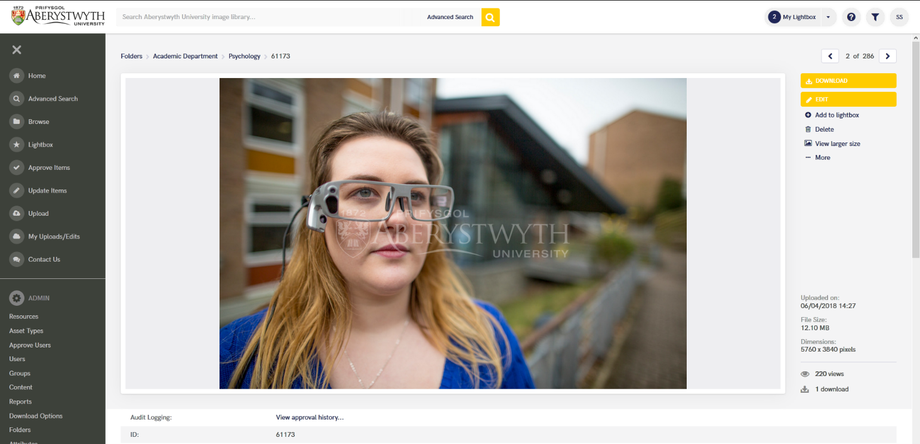
- Click on the DOWNLOAD button at the top right of the image.
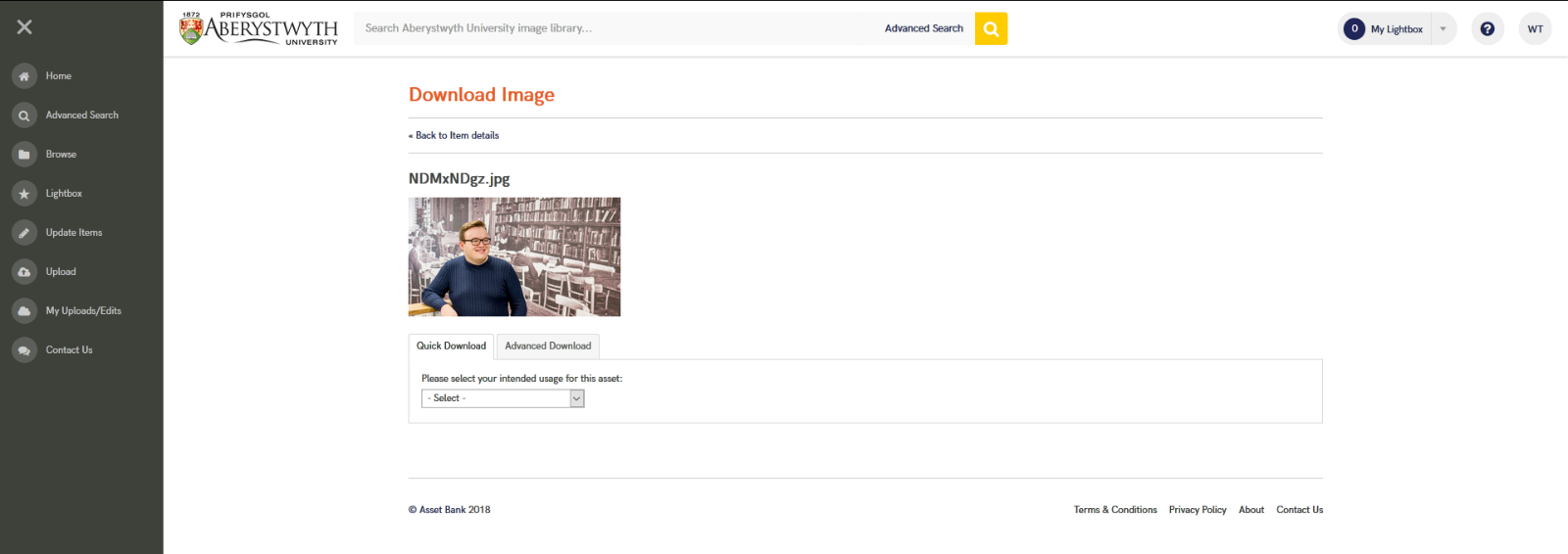
- In the 'Please select your intended usage for this asset' drop-down choose ‘Website’
- Tick the 'I have read and accept the Terms and Conditions' tick box (after reading the Terms and Conditions which can be viewed here: https://photolibrary.aber.ac.uk/asset-bank/action/viewConditionsPopup).
- If you would like the file emailed to you rather than downloaded now, tick the 'Send this file in an email' tick box.
- In the ‘Intended Use’ drop-down choose the appropriate type of image:
  - University Web – Department Homepage Hero: This downloads an image that is the correct size for the large hero images on normal pages on the Aberystwyth University website. This is suitable for use in Background image block (no text) (topstory) or Page Intro - Image or Video. (1140 x 585 px)
  - University Web – Departmental Homepage Tile: This downloads an image that is the correct size to be used in a tile / image block on a normal page of the Aberystwyth University website. This is suitable for use in Background image block (no text), Image Menu Item (internal), or Image Menu Item (external). (336 x 388 px)
  - News Articles: This downloads an image that is the correct size to be used on a news article. This is suitable for use in News Version 2. (1140 x 500 px)
  - University Web – Homepage Main Hero: This downloads an image the correct size to be used on the homepage hero of the Aberystwyth University website (1440 x 690 px)
  - University Web – Homepage Tile: This downloads an image the correct size for homepage tiles on the Aberystwyth University website. (374 x 388 px)
  - University Web – Homepage Event Tile: This downloads an image the correct size for the event tiles on the homepage on the Aberystwyth University website. (179 x 267 px)
  - University Web - Course Hero: This downloads an image the correct size for the large hero images on course pages on the Aberystwyth University website. (1440 x 500 px)
- For most types of download, you can choose the area of the image to be included when the system crops it to the correct proportions.
Note: If you don't do this, the system will crop to the central area of the image, which may mean important parts of the image could be cropped out.

- Click on 'Select crop area…' within the crop box
- A pop-up window showing the image will appear.
- Click and drag to create a shape on the image
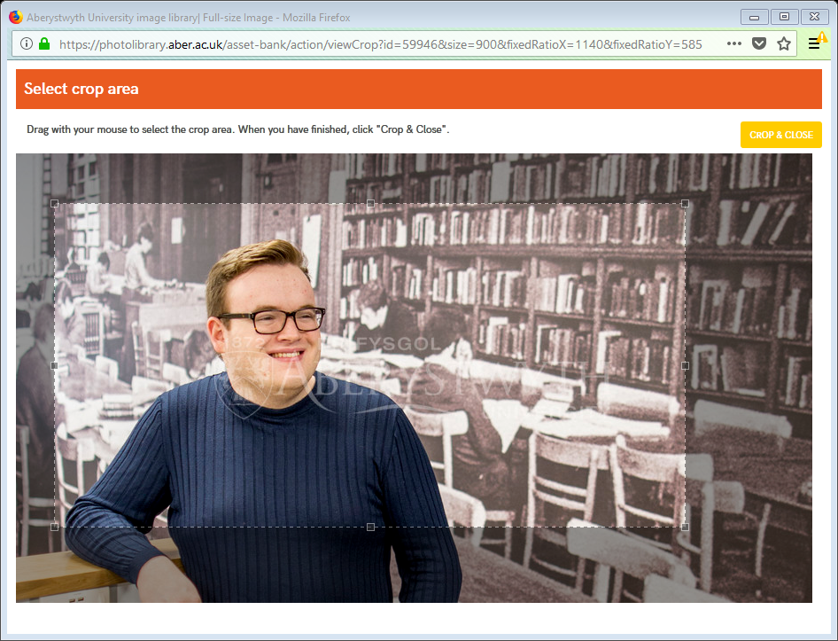
- You can adjust the shape by moving one of the corners or clicking and dragging the whole shape.
- Once you are happy with the crop, click the 'CROP & CLOSE' button in the top right corner.
- Details of your chosen crop area will be shown in the Crop box.
- If you want to check how the preview looks, click on the PREVIEW button.
- When you are ready to finish, click on the DOWNLOAD NOW or EMAIL NOW button that will be displayed depending on what you selected previously.
Note: although you have now downloaded an image that is the correct pixel size to use in the CMS, it will need to be re-saved so that the file size is under the limit specified for the content type. See section 3 for details.

2. Resizing and Cropping your Image
If you have downloaded your image from the AU Image Library in the correct pixel size, skip to part 3. Saving the file to a good file size to be used in the CMS.

Notes:
If you do not have any photo editing software installed, you will first need to download and install GIMP 2.
You should always start with an image that is bigger than the size required. Never use an image that is smaller than required as it will lose quality if you make it larger.

Instructions are provided using GIMP 2 and Adobe PhotoShop.

A. Using GIMP 2
- Open GIMP 2 on your PC.
- Open the original image that you are working with.

Crop the image to the correct proportions
- In the 'Toolbox' panel, click on the 'Rectangle Select Tool'
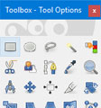
- In the lower 'Tool Options' section of the panel, tick the box to the left of 'Fixed Aspect ratio'.
- In the box beneath, type in the proportions you are aiming to create in the format 1:1. E.g. if you are creating an image to be used in a 'Page Intro - Image or Video' template in the CMS it should be 1140 x 585 px, so type 1140:585
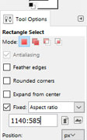
- Click on the image, roughly where you want one of the top corners of the crop to be and drag the rectangle across the screen until it is covering the part of the image you want to use.
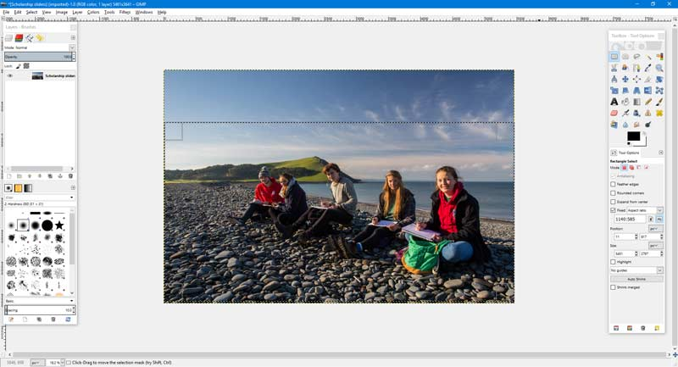
- If you need to adjust the rectangle, you can move it about by clicking in the centre and moving your mouse.
- You can adjust the size by clicking in a corner and dragging it with your mouse.
- When you are happy with the part of the image that the rectangle is covering, click 'Image' in the main window's top menu, and choose 'Crop to selection' from the menu that appears
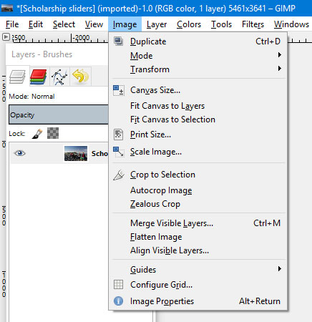
- Your image is now the correct shape to be used, but it may still be too large.

Resize the image to the correct width and height
- Click on 'Image' in the main window's top menu and choose 'Scale image' from the menu that appears
- Edit the Width box to show the width that you were aiming for. E.g. if you are creating an image to be used in a 'Page Intro - Image or Video' template in the CMS it should be 1140 x 585 px, so type 1140 in the width box.
- The height should change to keep the image in the correct proportions.
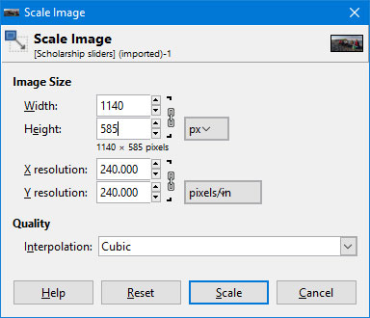
- Click on the 'Scale' button to complete the image resizing.

Notes: Although you now have an image that is the correct pixel size to use in the CMS, it will need to be saved so that the file size is under the limit specified for the content type. See section 3 for details.

B. Using Adobe PhotoShop
- Open Adobe PhotoShop on your PC.
- Open the original image that you are working with.

Crop the image to the correct proportions
- In the 'Tools' panel, click on the 'Rectangular Marquee Tool'
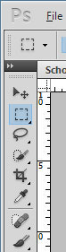
- Across the top of the screen the options for this tool should appear. Click in the 'Style' dropdown and choose 'Fixed Ratio'.
- In the boxes to the right beneath, type in the width and height you are aiming to create. These numbers can't be any higher than 999, so if you are aiming to create a size with 4 figures (e.g. 1140px) you will need to divide your number by 10.
E.g. if you are creating an image to be used in a 'Page Intro - Image or Video' template in the CMS it should be 1140 x 585px - the numbers are too big so divide both by 10 to give 114 x 58.5. So you should type 114 in the Width box and 58.5 in the Height box.
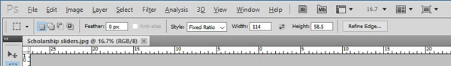
- Click on the image and drag the rectangle across the screen until it is covering the part of the image you want to use.
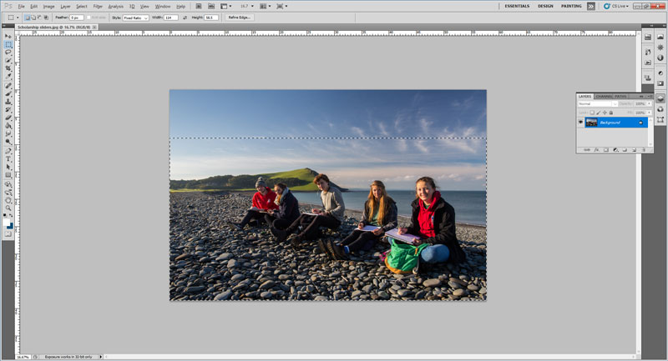
- If you need to adjust the rectangle, you can move it about by clicking in the centre and moving your mouse.
- If it is the wrong size, start again. You may wish to make it use the full width of the original image.
- When you are happy with the part of the image that the rectangle is covering, click 'Image' in the main menu, and choose 'Crop' from the menu that appears
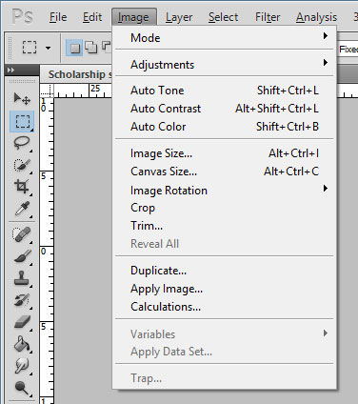
- Your image is now the correct shape to be used, but it may still be too large.

Resize the image to the correct width and height
- Click on 'Image' in the main menu and choose 'Image size' from the menu that appears
- Edit the Width box to show the width that you were aiming for. E.g if you are creating an image to be used in a 'Page Intro - Image or Video' template in the CMS it should be 1140 x 585 px, so type 1140 in the width box.
- The height should change to keep the image in the correct proportions.
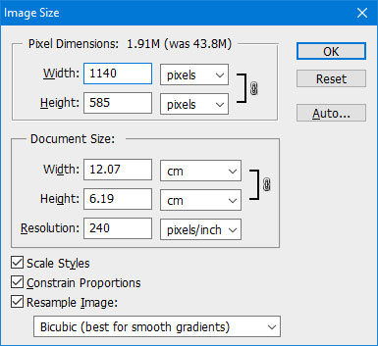
- Click on the 'OK' button to complete the image resizing.

Note: Although you now have an image that is the correct pixel size to use in the CMS, it will need to be saved so that the file size is under the limit specified for the content type. See section 3 for details.

3. Saving the file to a good file size to be used in the CMS
Now that you have an image that is in the correct proportions and the correct pixel size, you need to make sure that it is not too big in terms of file size to be used in the CMS.
Notes: If you do not have any photo editing software installed, you will first need to download and install GIMP 2.
Different types of content have different file size limits so you should check what the limit is for the type of content you are using. See the table on page one for different file size limits for the different types of content.

Instructions are provided using GIMP 2 and Adobe PhotoShop.

A. Using GIMP 2
- Open the file in GIMP 2 (if it is not already open).
- Click on 'File' in the main window's top menu and choose 'Export as' from the menu that appears
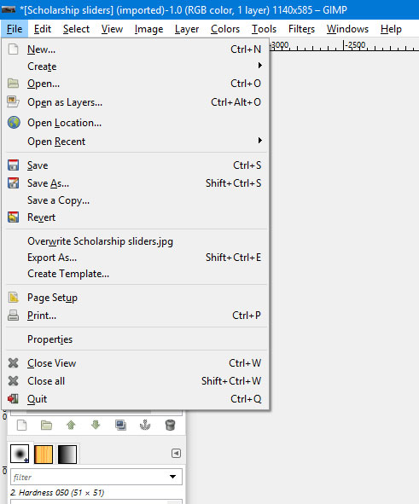
- Check the name box to see that it says .jpg after the filename. If it doesn't, click on 'Select File Type (By Extension)' at the bottom of the screen, and select JPEG image from the list.
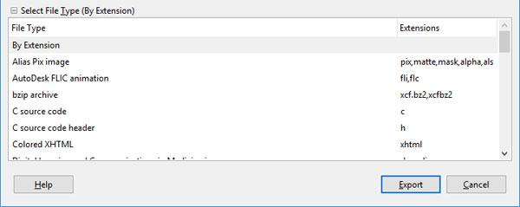
- Change the name of the file so that you don't overwrite the original image
- Click the 'Export' button to save the file.
- The 'Export Image as JPEG' window will appear.
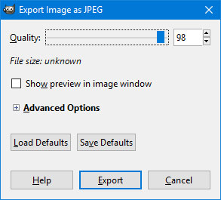
- Adjust the 'Quality' slider to 60, to reduce the size of the file.
- Check the new file size shown in italics beneath the quality slider. E.g. for images used in the 'Page Intro - Image or Video' template, this size should be less than 120kB. If the size is too big, adjust the Quality slider until you reach a suitable size.
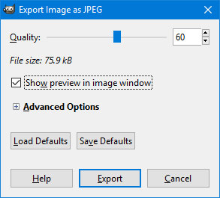
- Click the 'Export' button to finish

B. Using Adobe PhotoShop
- Open the file in Adobe PhotoShop (if it is not already open).
- Click on 'File' in the main menu and choose 'Save for Web & Devices' from the menu that appears
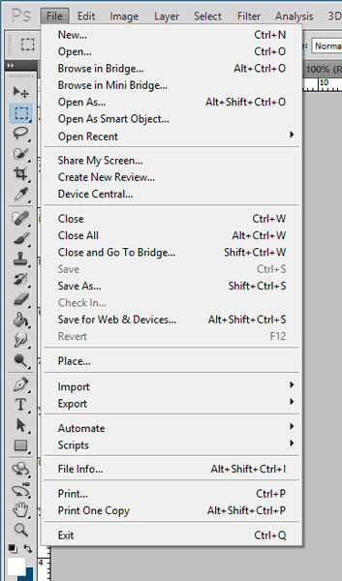
- If it is not already selected, choose JPEG from the dropdown at the top right of the screen
- Choose High from the dropdown just beneath this
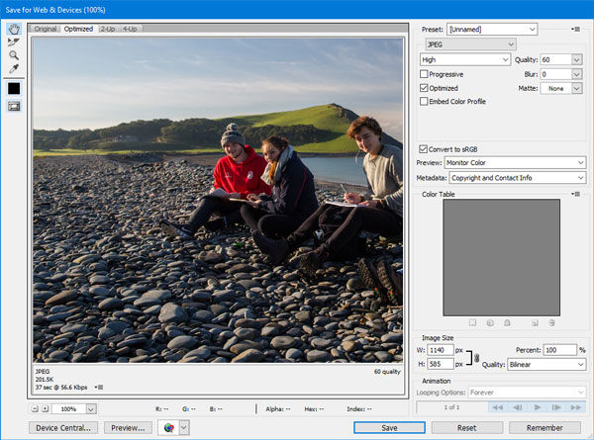
- On the left where the image preview is shown, choose either 'Optimized' or '2-Up' so you can see what the image will look like when saved at this quality. Check the size that is shown underneath the image.
- For images used in the 'Page Intro - Image or Video' template, this size should be less than 120kB. If the size is too big, adjust the value in the Quality dropdown until you reach a suitable size.
- Click the 'Save' button to finish
- Give the file a new name so it doesn't overwrite the original image (or save it in a new location).

