33. Creating and Editing Timelines/Flowcharts

Introduction
The Timeline/Flowchart allows us to display information in blocks along a timeline, or steps in a flowchart.
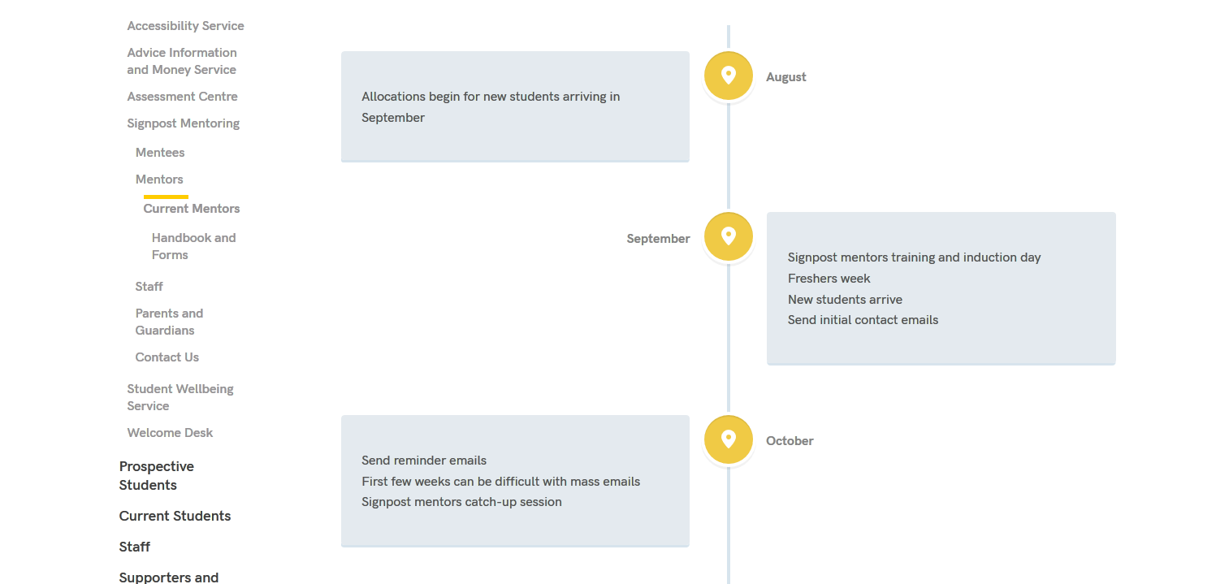
The blocks dynamically appear on the page as the user scrolls through the timeline/flowchart.

Blocks can include text, a link, an image and/or a PDF link.
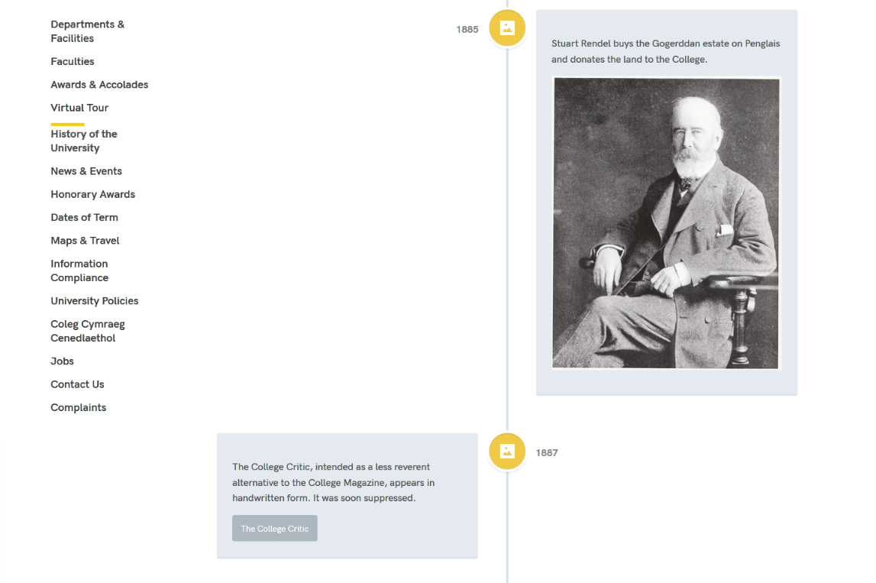

Creating a New Timeline/Flowchart
If you want to create a new timeline/flowchart, you will need initial set up to be carried out by Information Services. Contact us with details of where you want the timeline/flowchart to appear and we will get things started for you. Once the timeline/flowchart has been set up, you can carry on and add the blocks.

Adding a Block to Your Timeline/Flowchart
- Open the section where your timeline/flowchart is going to appear.
- Click on the Content tab.
- You will see that there are 2 pieces of content that you can't edit, using the 'html code' template. They are usually called something like 'pre timeline' and 'post timeline'. These are important for the functioning of the timeline/flowchart.
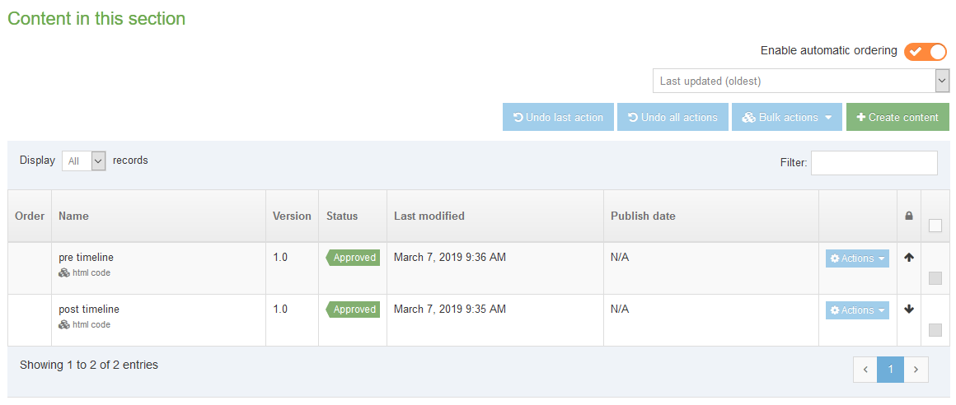
- Click 'Create content' and choose 'Cody Timeline Item'.

- The Cody Timeline Item template will appear:
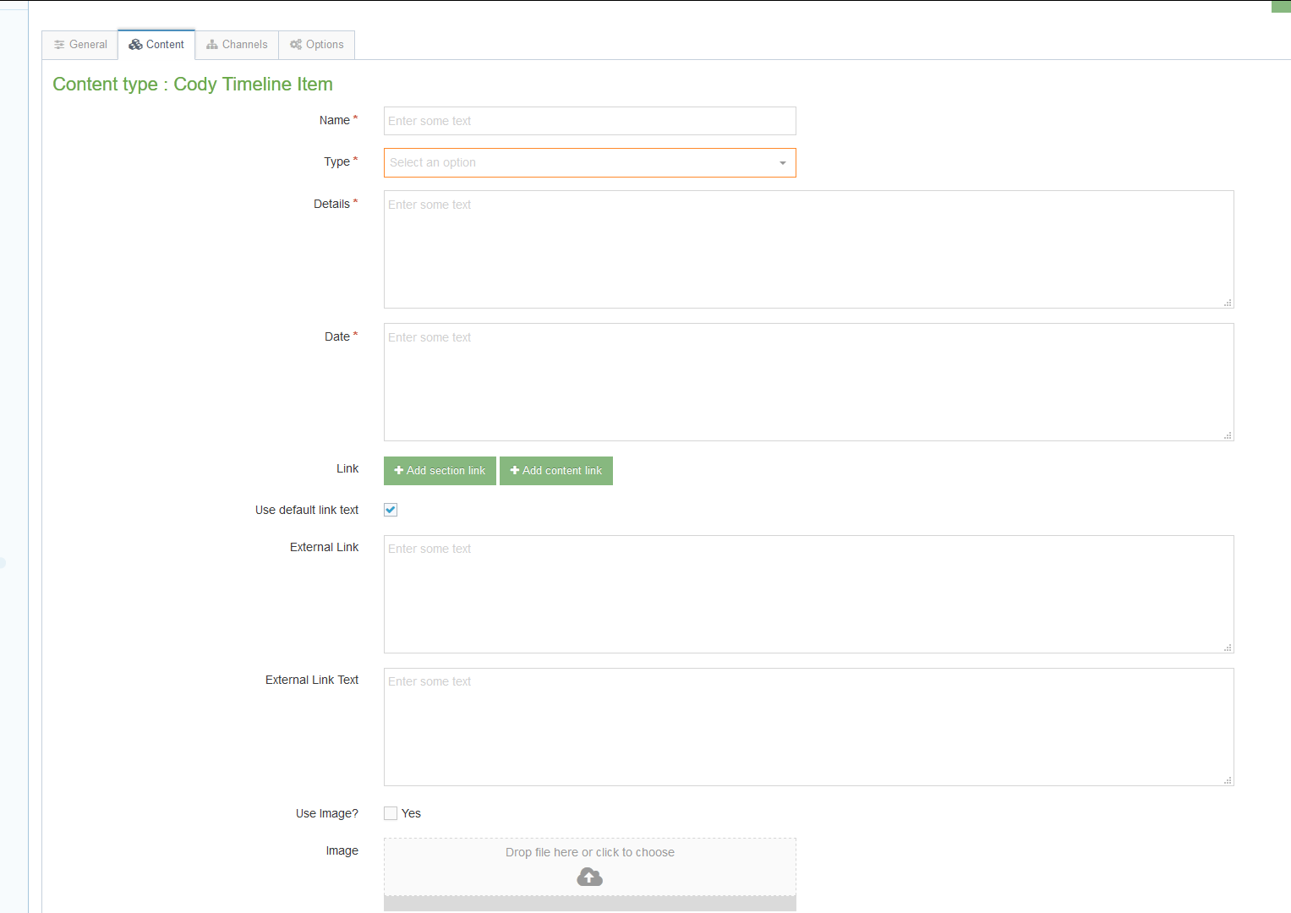
- Give your item a Name.
- Choose the appropriate Type:
  - Location - this is the standard option which uses a location pin icon.
  - Picture - this will change the icon to an image icon.
- Enter the text you want to appear in the block into the 'Details' box.
- Enter the date/step number in the 'Date' box.

- If you want to add a link to the block, there are 2 options depending on whether the link is going to somewhere else in the CMS or externally:
  - CMS Link:
    - Click on the 'Add section link' button and choose the section from the 'Select section' pop-up that appears.
    - If you want to use the name of the section you're linking to as the link text, leave the 'Use default link text' box ticked.
    - If you want to use different text for the link text, untick the 'Use default link text' box and type the text you want to use in the 'Enter custom link text' box.
  - External Link:
    - Type or paste the web address you want to link to into the 'External Link' box. Remember to make sure you include the http:// or https:// part of the web address.
    - Type the text you want to use for the link text in the 'External Link Text' box.
- If you want to add an image to the block:
  - Tick the 'Use Image?' tick box.
  - Click in the box next to 'Image' and find the image you want to use from your computer.

- If you want to add a PDF link to the block:
  - Tick the 'Use PDF?' tick box.
  - Click in the box next to 'PDF' and find the PDF file you want to use from your computer.
  - Type the text you want to use for the link to the PDF in the 'PDF Text' box.
- Click the 'Save changes' button to finish.
- Repeat the process for each item you need to add.
- Remember that all the content you have created will need to be approved before it will appear on the website.

Editing a Block in Your Timeline/Flowchart
- Open the section where your timeline/flowchart appears.
- Click on the Content tab.
- Click on the name of the item you want to edit.
- Make the necessary changes, using the information on the previous page to help you make the edits.
- Click the 'Save changes' button to finish.
- Repeat the process for each item you need to edit.
- Remember that all the content you have created will need to be approved before it will appear on the website.

Finishing Off
After you have added all the items you want to have on your timeline/flowchart, you will need to make sure that they are in the right order, and that the pre and post timeline items are in the right place. You should have 'pre timeline' at the top of the list, followed by the blocks you have created, with 'post timeline' at the bottom of the list. If you are unable to get the pre and post timeline items into the correct location, please contact Information Services for assistance.
Information on reordering content is available in Information Sheet 8.

