36. Adding an Important Notice

Introduction
Important notices can be added to department homepages and other webpages in special circumstances. These should not be used routinely but only when there is a situation that requires special information to be given to users, such as during the coronavirus pandemic.
When used on a department homepage, the notice will appear under the image slider, or if there is no image slider it will appear under the main heading.
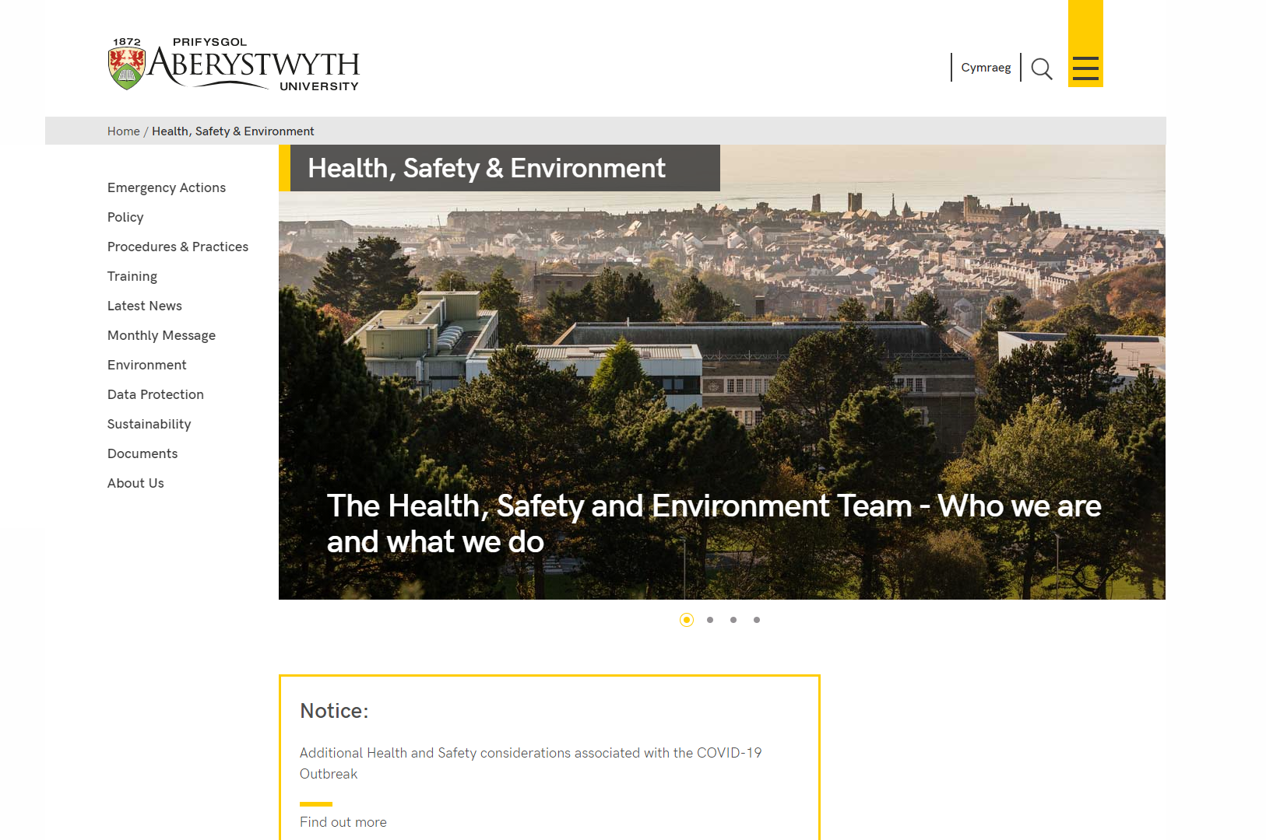
Figure 1: Example of a notice on a department homepage with an image slider
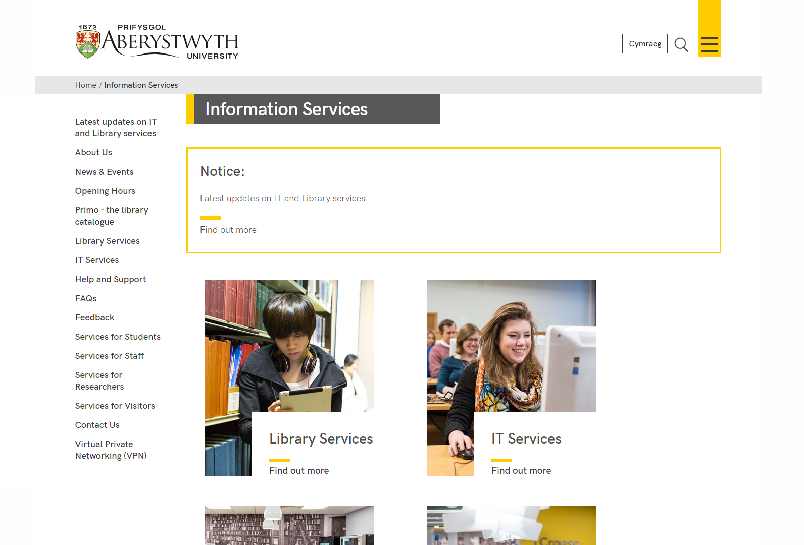
Figure 2: Example of a notice on a department homepage which doesn't have an image slider
On a normal page, the notice will appear at the point within the page where it is placed.
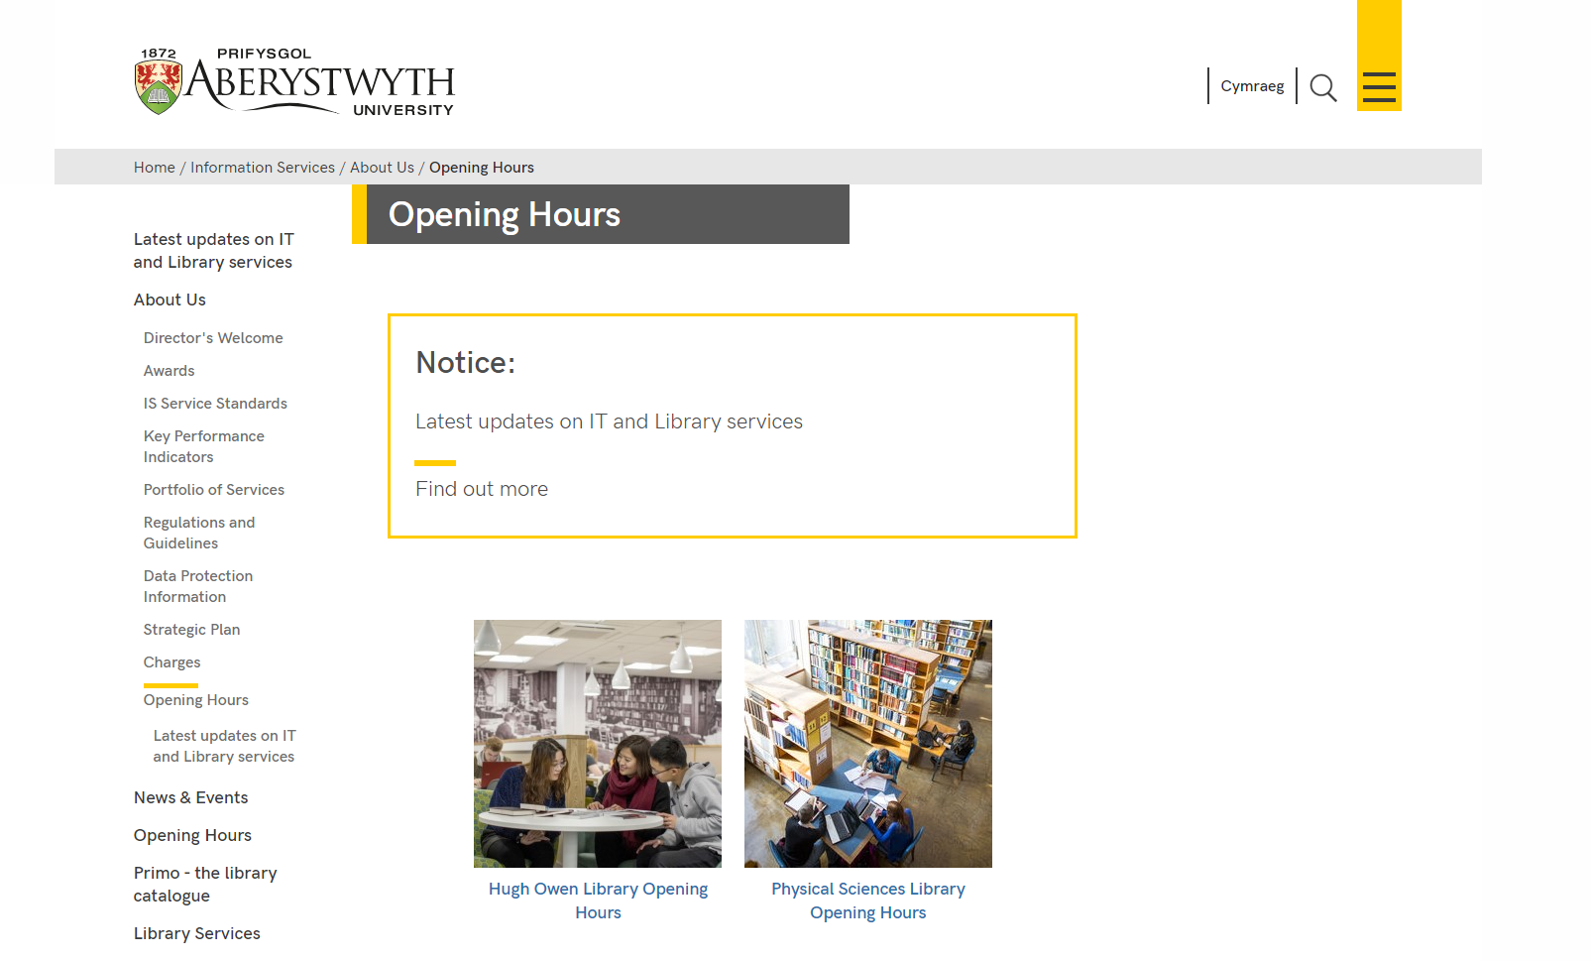
Figure 3: Example of a notice on a normal page

Adding an Important Notice

Department Homepage
- Open your department’s ‘top story’ section in the CMS.
- Click on the Content tab.
- Click Add content and choose ‘Dept Important Notice’.
- The ‘Dept Important Notice’ template is displayed:
- Give the piece of content a name.
- Type or paste the text you want displayed on the notice into the ‘Text’ box.
- If you want the notice to link to a page, type or paste the full web address into the Link box.
- If your department homepage has a slider, leave the ‘No Slider?’ tick box empty.
- If your department homepage does not have a slider, tick the ‘No Slider?’ box.
- Click the ‘Save changes’ button to finish.
- If required, you may need to order the content in your section so that your notice appears beneath your slider. See Information Sheet 8 for further information on reordering content.

Normal page
- Open the section in the CMS where you want the notice to appear.
- Click on the Content tab.
- Click Add content and choose ‘Dept Important Notice’.
- The ‘Dept Important Notice’ template is displayed:
- Give the piece of content a name.
- Type or paste the text you want displayed on the notice into the ‘Text’ box.
- If you want the notice to link to a page, type or paste the full web address into the Link box.
- Leave the ‘No slider?’ tick box empty.
- Click the ‘Save changes’ button to finish.
- If required, you may need to order the content in your section so that your notice appears in the correct point in the page. See Information Sheet 8 for further information on reordering content.

Check how the notice looks
- When you have finished adding your notice, return to the Site Structure.
- Click on the Actions button for the location where the notice will be shown. Note that for a notice on a department homepage, this will be the main section of the department, rather than the ‘top story’ section.
- Check that the notice appears as you would like it to.
- Remember that you will need to approve the content that you have created in order for the notice to be displayed on the live webpage.

