4.1. Editing Content – Formatting Text
Open the content you wish to edit. Any boxes in content which can be edited using the HTML Editor will have a toolbar displayed above the editing area. The buttons and menus are like those used in Microsoft Word and other text editing software, but there are some elements that are specific to the CMS.

Buttons
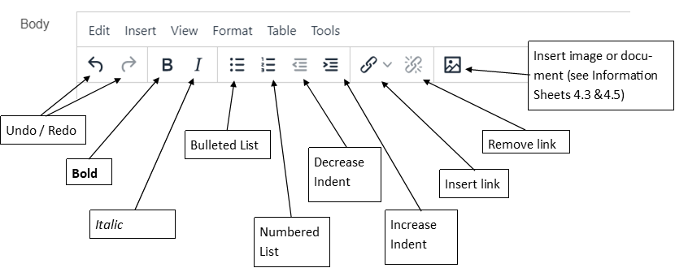

Menus

Edit Menu
The Edit Menu allows you to use the following tools:
- Undo - undo the most recent change (also available as a button on the toolbar, or keyboard shortcut Ctrl+Z)
- Redo - redo the most recent undo (also available as a button on the toolbar, or keyboard shortcut Ctrl+Y)
- Cut - copy and remove the text that is currently selected (also available as keyboard shortcut Ctrl+X)
- Copy - copy the text that is currently selected (also available as keyboard shortcut Ctrl+C)
- Paste - paste the text that has been cut or copied (also available as keyboard shortcut Ctrl+V)
- Paste as text - strip out any formatting in the text that you are about to paste in to the content.
- Select all - select all of the contents of the editing window (also available as keyboard shortcut Ctrl+A)
- Find and replace - find a word and replace it with an alternative word (also available as keyboard shortcut Ctrl+F):
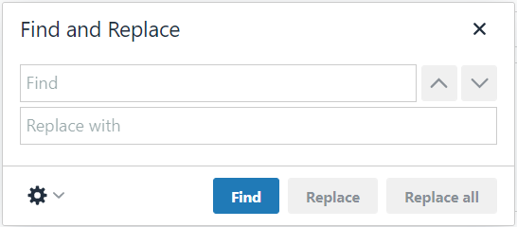

Insert Menu
The Insert Menu allows you to use the following tools:
- Insert link
  - Insert section link - insert a link to another section within the CMS - see Information Sheet 4.2, for more details.
  - Insert content link - insert a link to a specific piece of content within another section in the CMS - this can allow you to link to a particular point in the page CMS - see Information Sheet 4.2, for more details.
  - Link to external site - insert a link to a webpage that is not within the CMS, e.g. an external site, or an internal system such as Primo, which is not within the CMS, a link to an email address, or a link to an anchor in this page - see Information Sheet 4.2, for more details.
  - Insert anchor - insert an anchor point somewhere in the content so you can link to this specific point in the page from a link at the top of the page - see Information Sheet 4.2, for more details.
- Insert file link or image – insert a file or image from the Media Library – see Information Sheets 4.3 and 4.5 for more details.

View
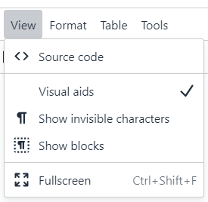
The View Menu allows you to use the following tools:
- Show blocks - highlights blocks of text within the content, such as paragraphs, useful if you want to be able to see where one block ends and another starts.
- Show invisible characters - highlights where there are invisible characters such as 'non breaking space' characters which may be causing the text to appear in unexpected ways, e.g. extra spacing.
- Visual aids - not currently functional.
- Fullscreen - allows the editing window to use the full size of the screen, enabling you to see more of the content you are working on. The menus and editing buttons remain visible at the top of the page. Click on the option again to return to the normal view.
- Source code - view the HTML code generated by the editor.

Format
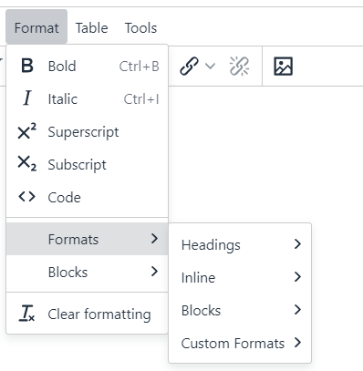
The Format Menu allows you to use the following tools:
- Bold - make the currently selected text bold (also available as a button on the toolbar, or keyboard shortcut Ctrl+B)
- Italic - make the currently selected text italicised (also available as a button on the toolbar, or keyboard shortcut Ctrl+I)
- Superscript - make the currently selected text superscript (small text raised above the height of other text, e.g. 21st)
- Subscript - make the currently selected text subscript (small text lowered below other text, e.g. H₂O)
- Code
- Formats
  - Headings - make the currently selected text into the heading of your choice.
  - Inline - an alternative method of making the currently selected text bold, italic, superscript or subscript.
  - Blocks - switches the style of the currently selected text to a paragraph - useful if you have changed your mind about a heading. Other options in this menu should be ignored.
  - Custom Formats (Note: These styles only work for the type of text or object noted – if you try and apply them to other items, they won’t work.)
    - table-overflow – allows you to mark a table as too wide for mobile, so that it is styled to allow the user to swipe left and right to view the whole table.
    - split-left – allows you to make sure your paragraph clears the previous one so that images do not overlap
    - notification – allows you to encase your paragraph in a noticeable shaded box
    - notification-centre – allows you to encase your paragraph in a noticeable shaded box with the text centred
    - image-menu-large – allows you to mark your bulleted list as an image menu which uses large images (250px wide)
    - image-menu-small – allows you to mark your bulleted list as an image menu which uses small images (120px wide)
    - box-container – allows you to put your paragraph in a box outline
    - BTN – allows you to mark a link to be displayed as a button
    - centre – allows you to centre your image
    - float-left – allows you to make your image float left with the text flowing around it
    - float-none – allows you to make your image sit within the text on a new line
    - curve-box – allows you to put your paragraph in a box with a grey background
    - clearfix – allows you to make sure your image clears the previous paragraph so that images do not overlap
- Clear formatting - remove all formatting (also available as a button on the toolbar).

Table
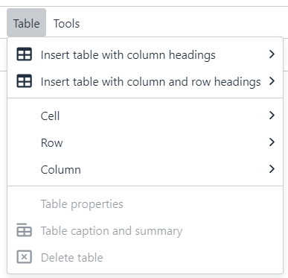
The Table Menu allows you to work with tables. For more information on using tables, see Information Sheet 4.4.
- Insert table with column headings - create a new table with a header row across the top. You can choose the number of rows and columns by selecting squares in the grid:
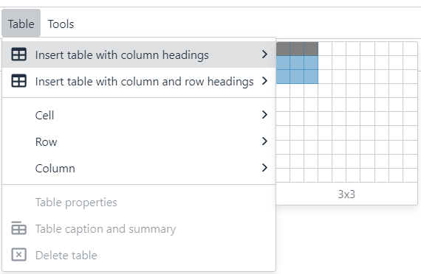
- Insert table with column and row headings - create a new table with a header row across the top and a header column on the left (e.g. for a timetable). You can choose the number of rows and columns by selecting squares in the grid:
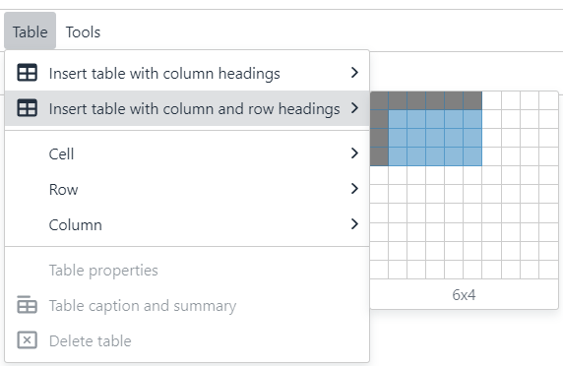
- Table properties - access the properties of the table (greyed out unless your mouse cursor is currently in a table). Note: please do not make any changes here, other than Alignment.
- Table caption/summary - add a caption and/or summary to the table (greyed out unless your mouse cursor is currently in a table). Captions help users to find a table and understand what it's about. They are the primary mechanism used by screen readers to identify tables. A summary gives information about how a table is organized and provides information on how to navigate through its data.
- Delete table - remove the table (greyed out unless your mouse cursor is currently in a table)
- Cell - access cell options:
  - Cell properties
  - Merge cells
  - Split cells
- Row - access row options:
  - Insert row before
  - Insert row after
  - Delete row
  - Row properties
  - Cut row
  - Copy row
  - Paste row before
  - Paste row after
- Column - access column options:
  - Insert column before
  - Insert column after
  - Delete column
  - Cut column
  - Copy column
  - Paste column before
  - Paste column after

Tools
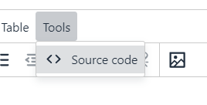
The Tools Menu allows you to use the following tools:
- Source code - view the HTML code generated by the editor

