4.5. Editing Content – Inserting Links to Documents
Note: Before inserting a link to a document, it must be in the Media Library. If you want to use a new document that is not already in there, see Information Sheet 7 for details of how to upload an document to the Media Library.
- Place your mouse in the position on the page where you want the link to the document to be.
- Click on the Add an image or link to a file from the Media Library button:
- The Select media window pops up:
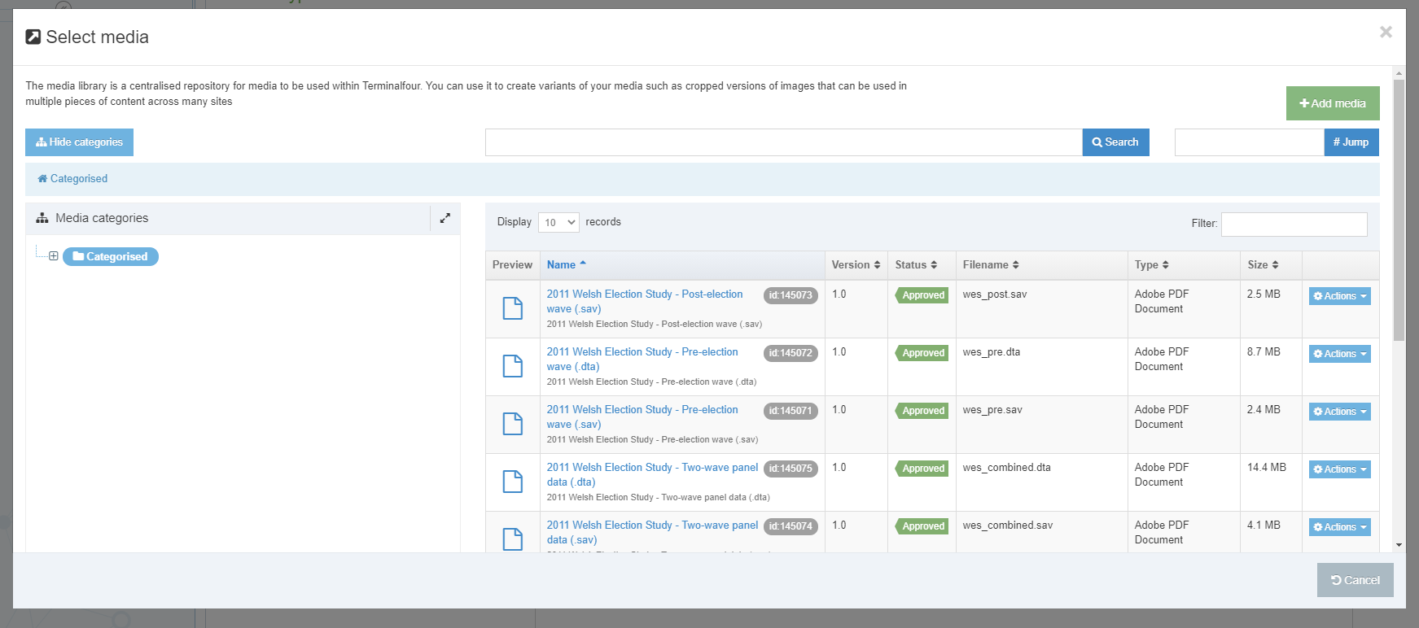
- Browse through the categories on the left to find the appropriate area of the Media Library. Most departmental documents are stored within the appropriate section under the 'Departmental' category.

- Before selecting your document, check that it has a description. This will be displayed underneath the name of the document in the Name column:
Note: If the document you insert doesn’t have a description, the link will not work - see Information Sheet 7 for more information on adding description text to media items.
- Click on the item and a link to the document will be inserted in your page.
- The link to the file will now be displayed in the Content Editor page, using the description as the link text.

