9. Editing Departmental Homepages
  - Departmental homepages are different from other pages in the department and should be treated differently. They are known as “special menu” pages. The organisation of a special menu is quite complex, and you should be very careful when editing content in them.
A special menu page is made up of several parts:
- The top-level section of the department, which usually contains a Contact Block and may contain a ‘News Chooser’
- Several additional sub-sections:
  - column 1
  - column 2
  - departmental colours
- Depending on the department there may also be:
  - column 3
  - top story
All the sub-sections should be set to not appear in the navigation.
You should not attempt to add or remove the different parts of the special menu, but you may edit some of the content using the skills you have learnt in previous information sheets. Please see the following pages for further details of each part of the special menu.

Top Level Section Content
Within your top-level section you should find the Contact Block and you may find a ‘News Chooser’. For example, in the following Departmental top level section:
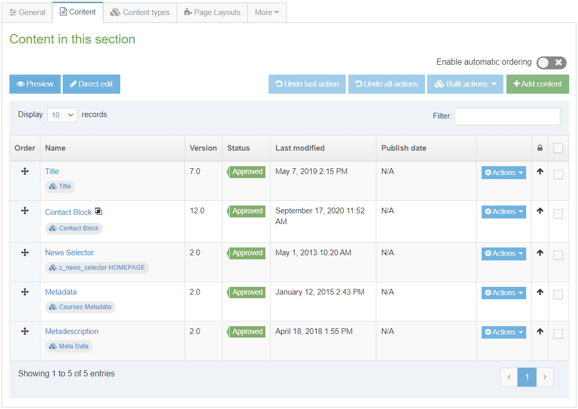
The Metadata content at the bottom of the list is special metadata related to the names of courses that are taught by the department. It can only be edited by administrators.

Contact Block
The contact block is just a standard contact block like on any other page. It will be a general departmental contact rather than being a specific contact that you might have on pages related to a specific area. It is likely to be mirrored content that is used in many pages within the department. See Information Sheet 3.1 for more information on Contact Blocks.

News Chooser
The News Chooser is a special type of content that enables the departmental news to show at the bottom the Department home page. If you have the news system enabled for your department, you will see this piece of content, but should not attempt to edit it. See Information Sheet 10 for more information.

Sub-Sections

column 1
This is the first column on the page. For example:
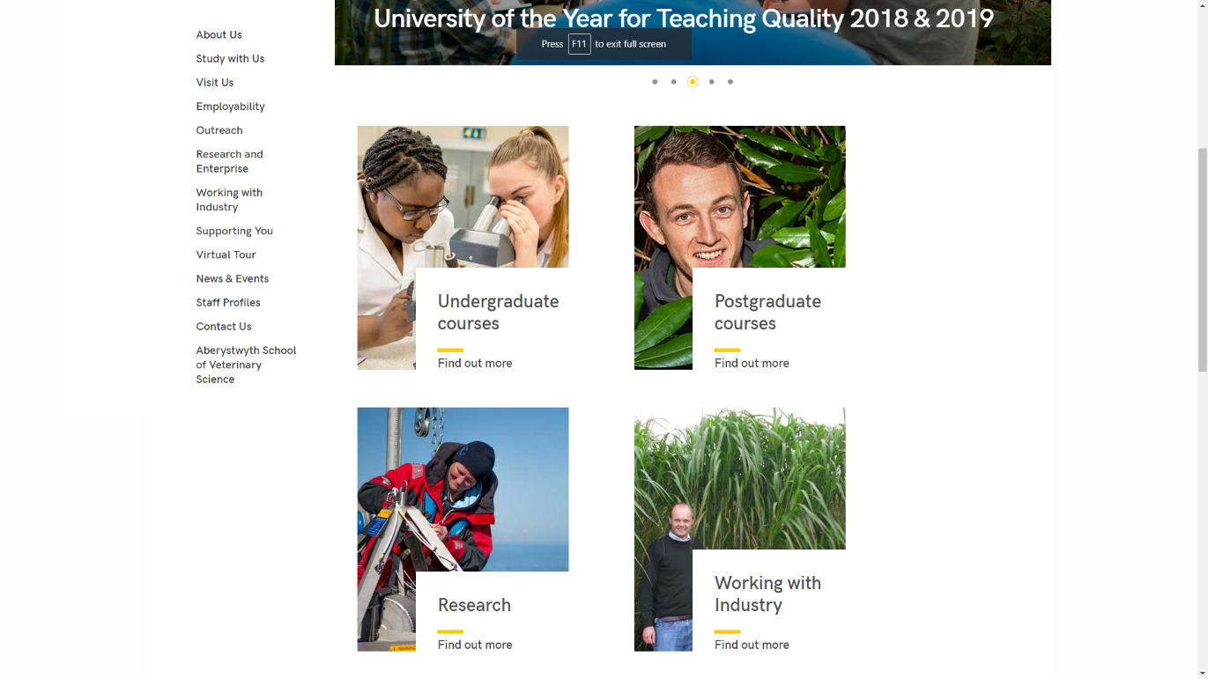
Some departments do not have the double width block (top story sub-section) at the top and just have columns. For example - Hospitality:
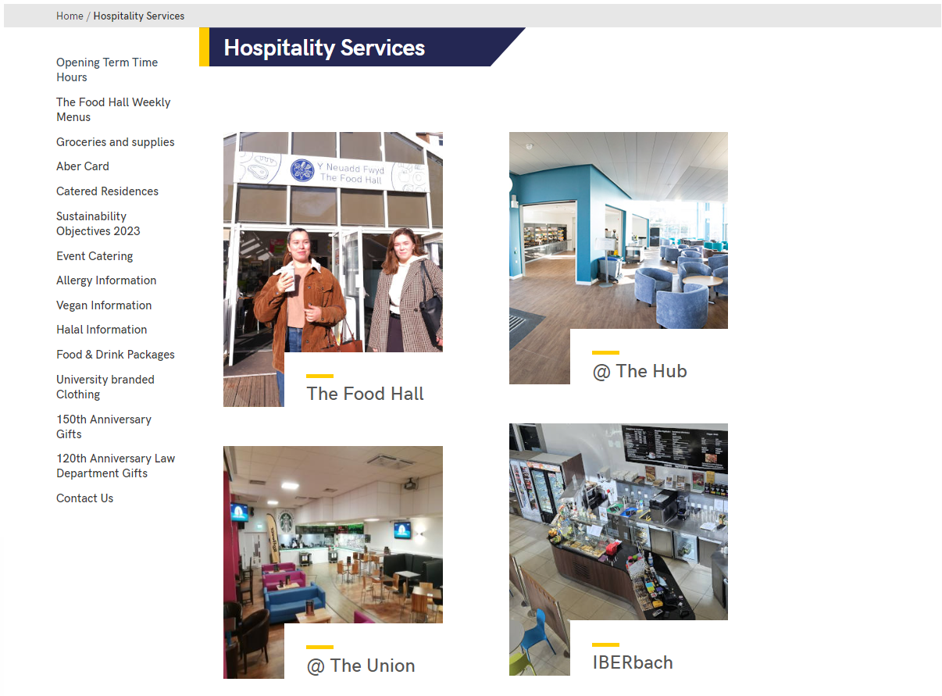
Within the column 1 subsection, there will be one or more pieces of content:
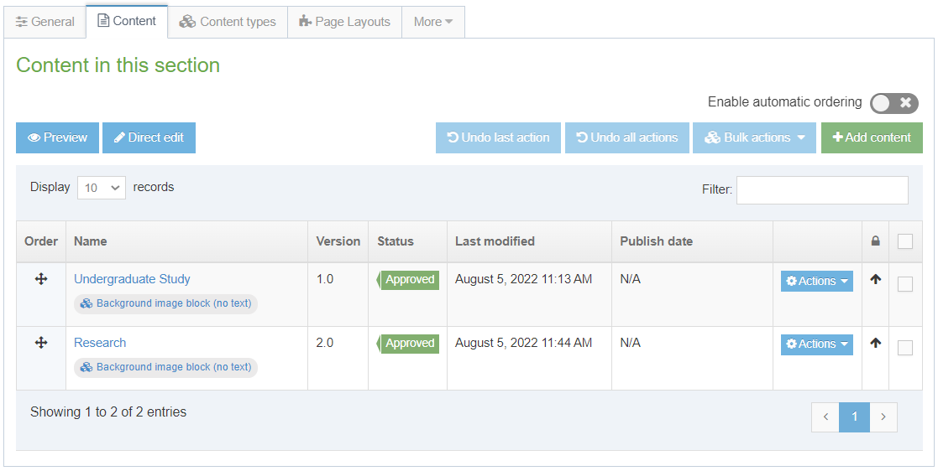
Most departments have columns made up of image blocks (tiles), so you will see several pieces of content using the content type ‘Background image block (no text)’.
If you need to edit an image block, take a look at Information Sheet 21 for more details.
If you need to edit general content, edit it in the same way as usual making sure to be aware that headings should be within the content using heading 2, rather than being in the Title field.

column 2
This is the second column on the page.
The structure of column 2 is very similar to column 1.
Within the column 2 subsection, there will be one or more pieces of content:
Most departments have columns made up of image blocks (tiles), so you will see several pieces of content using the content type ‘Background image block (no text)’.
If you need to edit an image block, take a look at Information Sheet 21 for more details.
If you need to edit general content, edit it in the same way as usual making sure to be aware that headings should be within the content using heading 2, rather than being in the Title field.

column 3
If your department is using the News System, column 3 may not be present, but if it is in use the items in it will appear underneath the news feed.
The structure of column 3 is very similar to columns 1 and 2.
Within the column 3 subsection, there will be one or more pieces of content:
Most departments have columns made up of image blocks (tiles), so you will see several pieces of content using the content type ‘Background image block (no text)’. These are displayed differently in column 3 compared with columns 1 and 2. Some departments may have blocks of General Content containing text & links, as well as Social Media Links content containing links to Twitter, Facebook, etc.
If you need to edit an image block, take a look at Information Sheet 21 for more details.
If you need to edit general content, edit it in the same way as usual making sure to be aware that headings should be within the content using heading 2, rather than being in the Title field.

top story
Not all departments have this sub-section. It is a 2 column-width block at the top of the special menu. For example, in the Department of Life Sciences:
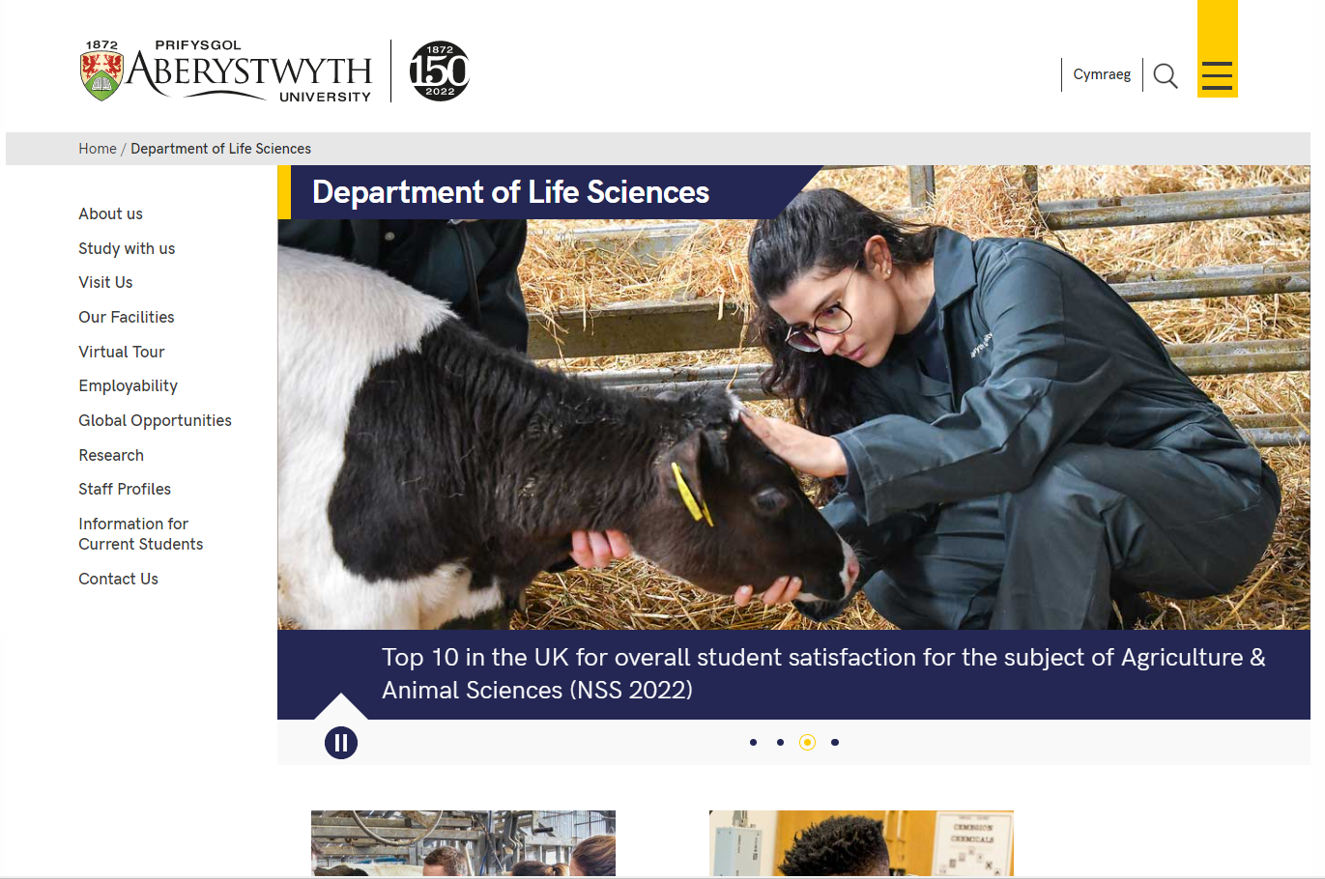
The top story sub-section could contain one of 3 different types of content:
- Background image block (no text) (topstory) – this is similar to the image blocks which are often used in the columns. This one is larger, so it fills the double column width.
- Image Gallery or Slideshow Import – this is a piece of content which pulls in an ‘image slider’ that automatically cycles through several images with associated text and links across the bottom.
- General content - this is not widely used, but if it is present it can contain text and links.
If you need to edit an image block, take a look at Information Sheet 21 for more details.
If you need to edit an image slider, please contact Information Services for assistance.
If you need to edit general content, edit it in the same way as usual making sure to be aware that headings should be within the content using heading 2, rather than being in the Title field.

departmental colours (Not to be edited)
The departmental colours section controls the header for your department. You should NOT edit this section.

