SharePoint Training – Administrators
Last Updated: August 2023
Contents
SharePoint Training – Administrators 1
Exercise 1 – Setting up your SharePoint Site 3
A. Access your site 3
B. Edit your site’s homepage 4
Exercise 2 – Creating and Customising a Document Library 8
A. Create the Document Library 8
B. Add a document 10
C. Customise the columns 12
D. Update the Document Code for your document 14
E. Change the Default View 16
F. Create an alert on the library 18
Exercise 3 – Creating a Calendar 20
A. Create the Calendar 20
B. Customise the Category column 23
C. Add Events to the Calendar 26
Exercise 4 – Creating a Task List 27
A. Create the Task List 27
B. Set the Task List to Notify Task Owners 30
C. Customise the Columns 32
D. Add a Task to the Task List 34
E. Add Tasks to the Timeline 35
Exercise 5 - Updating the SharePoint Site Homepage 36
A. Return to your homepage and Start Editing Mode 36
B. Add your Document Library 37
C. Add your calendar 38
D. Add your task list 40
E. Rearrange the Web Parts and view your page 41
F. Tidy up the page by removing unused web parts. 43
G. Remove unused Items from the left menu 44
Exercise 6 – Setting Permissions 46
A. Access Site Permissions 46
B. Set permissions on your document library 48
Exercise 7 – Creating a Sub-site 52

Training Evaluation Form:
https://www.aber.ac.uk/en/is/it-services/web/training-evaluation/

Exercise 1 – Setting up your SharePoint Site
Before setting up your site you should consider its purpose and how it will be used. You will edit the site homepage to provide information about the site.

Access your site
- Open SharePoint by opening a browser and typing sharepoint.aber.ac.uk into the address bar.
- Log in.
- Navigate to your training site:
  - Click on ‘SharePoint Help’ in the left menu
  - Click on ‘Training Area’ under Sites in the left menu of the new page
  - Click on 'Site Contents' in the left menu of the new page
  - Look under 'Subsites' in the main area of the new page
  - Scroll down and click on the appropriate Training Site, e.g. ‘Suzy Shipman’.
- You will see a freshly made SharePoint site:
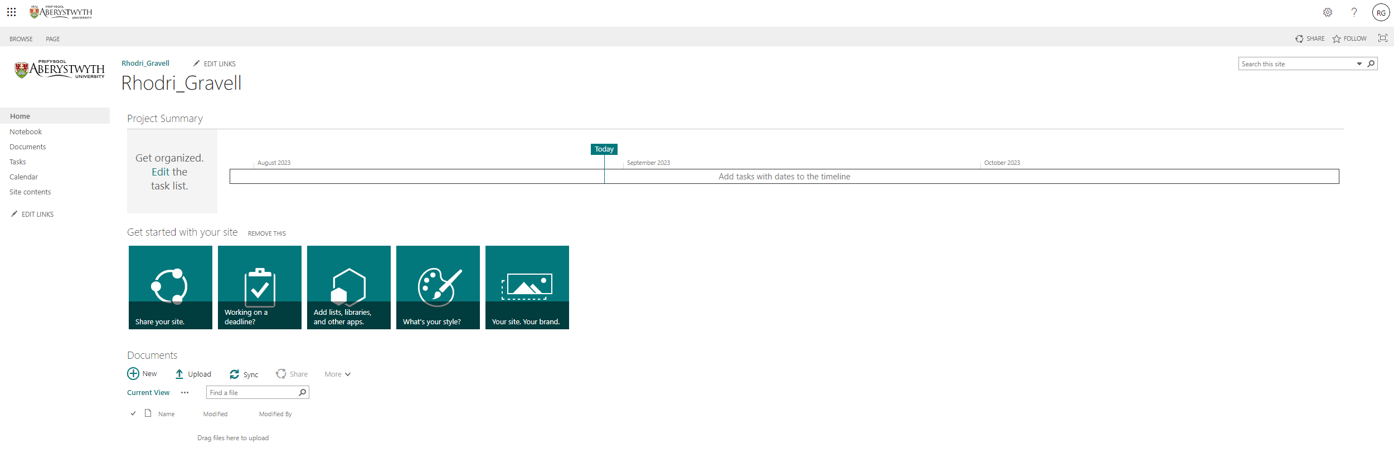

Edit your site’s homepage
- Click on Page at the top left of the screen and select ‘Edit Page’. The page editing screen will appear:
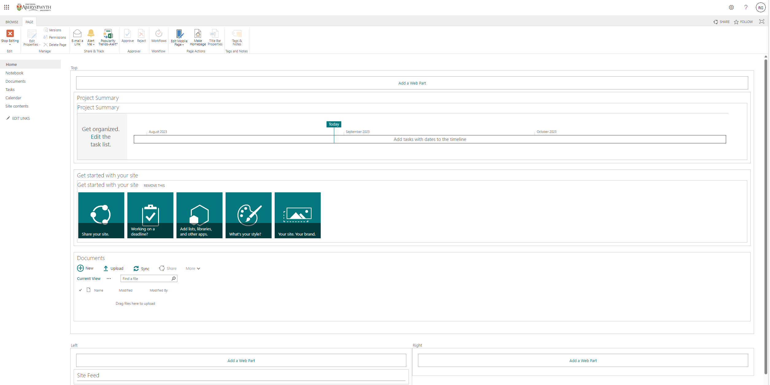
- Click on ‘Add a Web Part’ in the middle of the screen - the list of available web parts will appear:
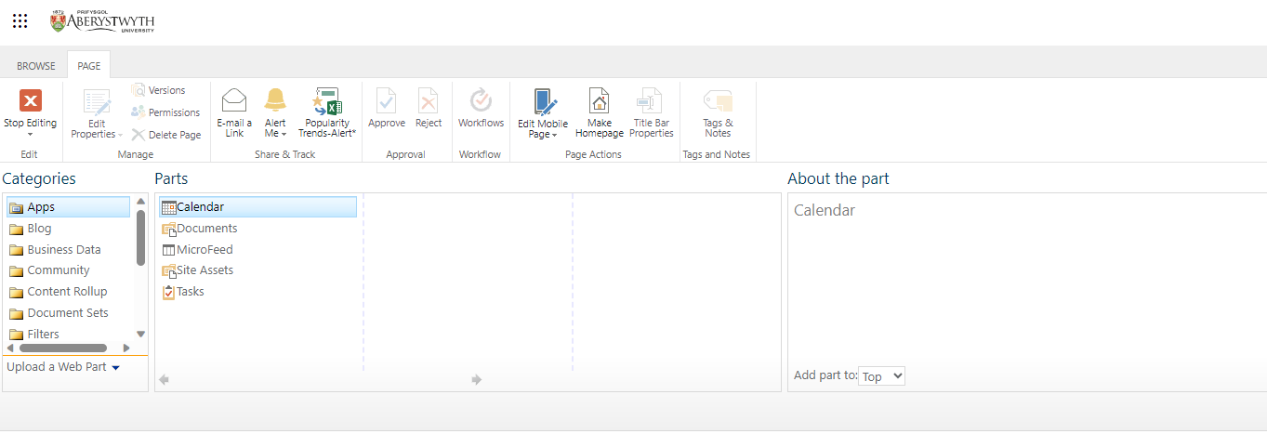
- Scroll down and click on ‘Media and Content’ in the Categories menu on the left, to display the web parts in that category.
- Select ‘Content Editor’ from the 'Parts' menu and click the Add button (far right) to add this web part.
- The Content Editor web part will now display on the screen:
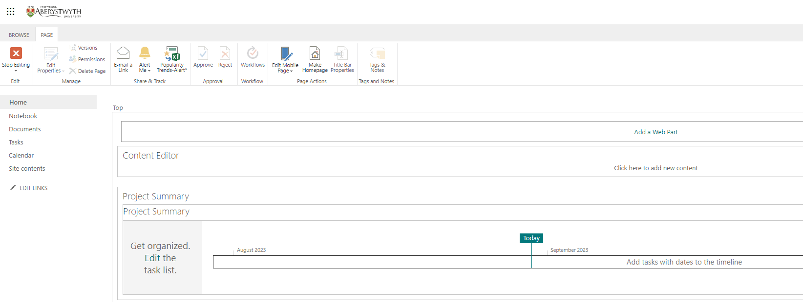
- Click on ‘Click here to add new content’ and type some text as an introduction to your site.
- To change the heading of the web part, move your mouse to the top right corner of the Content Editor box and click on the very small triangle next to the check box.
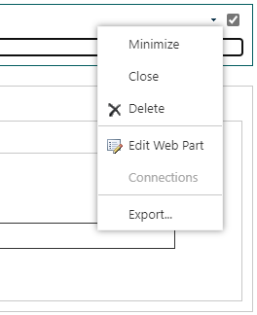
- Choose ‘Edit Web Part’ from the menu that appears.

- The Web Part properties bar will appear down the right of the screen.
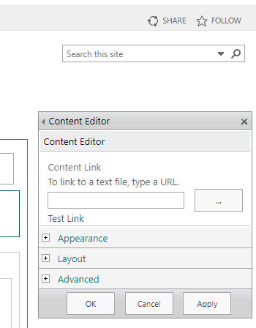
- Expand the ‘Appearance’ section.
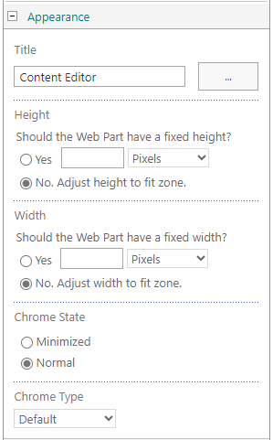
- Edit the ‘Title’ box and replace the text ‘Content Editor’ with the name of your Site. Scroll down and click OK to finish.
- Now that your site has a heading and introductory text, finish editing the page by clicking on the Page tab and then the Stop Editing button at the top left of the screen. 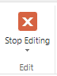
- Click on the Browse tab at the top of the screen to view your page as others will see it.
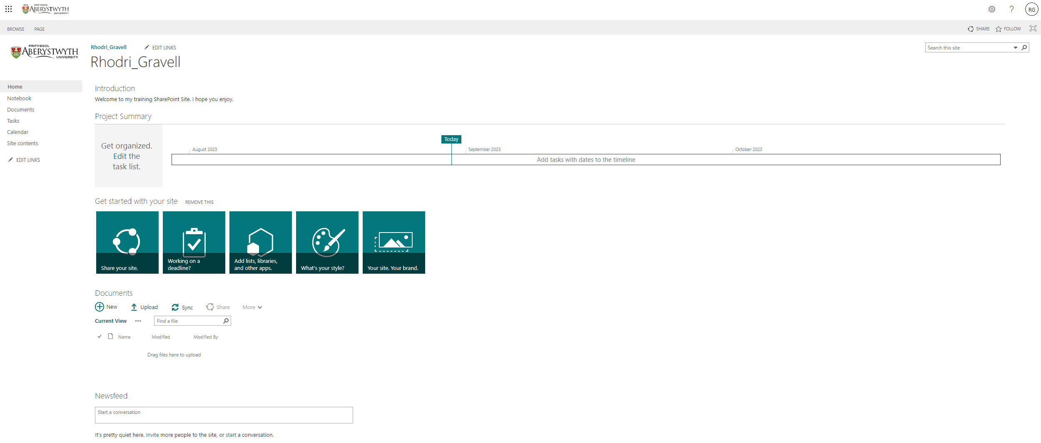

Exercise 2 – Creating and Customising a Document Library
Document Libraries are used to store documents so that they can be accessed by yourself and other users. You will create a new document library for your site. You will customise the columns and the default view and create an alert on the library. You will also open the document library in explorer.

Create the Document Library
- Click on the cog symbol at the top right of the screen and select ‘Add an App’. The ‘My apps’ screen will appear.
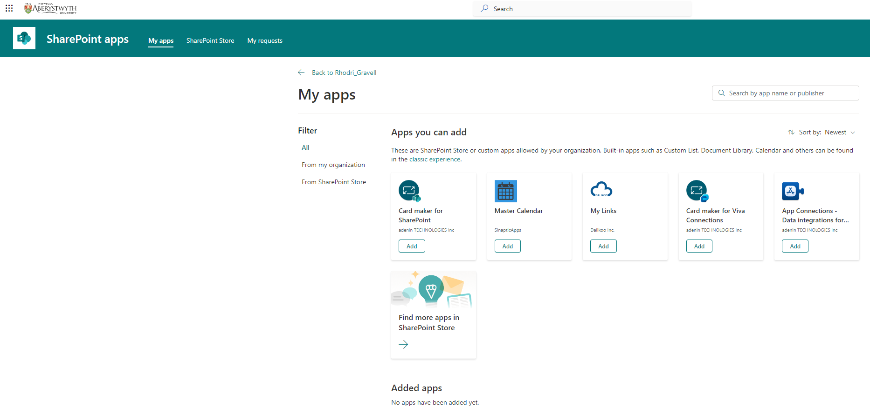
- To add a built-in app such as a Custom List, Document Library and Calendar, click on the link to the ‘Classic Experience’.
- The ‘Your Apps’ screen will appear:
- Click the Document Library option.
- Type the name of your document library in the Name box (e.g. Suzy’s Document Library)
- Click the ‘Create’ button.
- You will be sent to the Site Contents page where you will see your new document library listed:
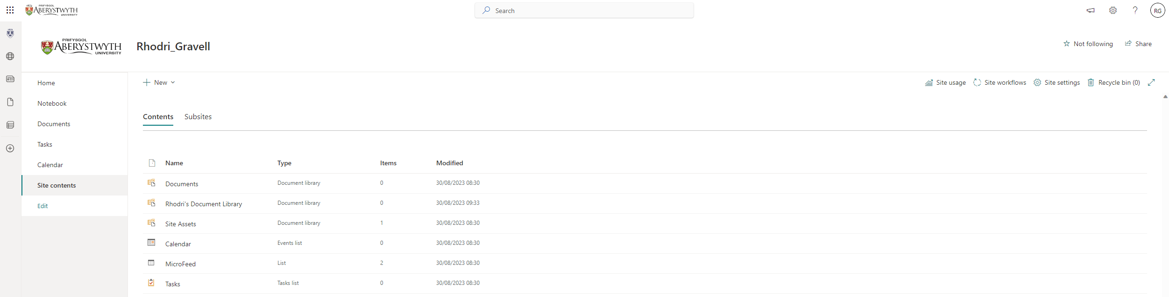

Add a document
- Click on your document library in the Site Contents view.
- Click on ‘New’ at the top of the page
- Choose ‘Word document’ from the menu that appears:
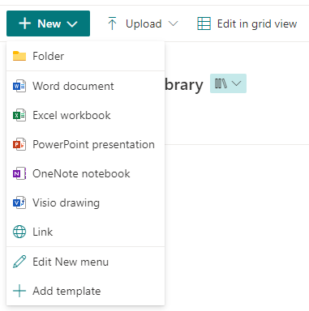
- Your new document will open in Word Online.
- Write some text in the document.
- Click on 'Document' in the blue bar at the top of the screen and give your document a sensible name e.g. Suzy's Lovely Document. Click Enter to save the new name.
- Wait until the ‘Saving’ text at the top of the screen has changed to ‘Saved’
- Close your current tab to return to the document library in SharePoint.
- Your new document will be listed in your library:
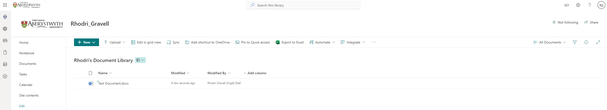

Note:
Your document library will automatically have version control switched on so every time you edit a document the system will store it as a new version. You will be able to roll back to a previous version of a document if required.

Customise the columns
- Click on '+ Add column' at the right of the column headings, select the type of column you wish to add (e.g. Number), then click ‘Next’.
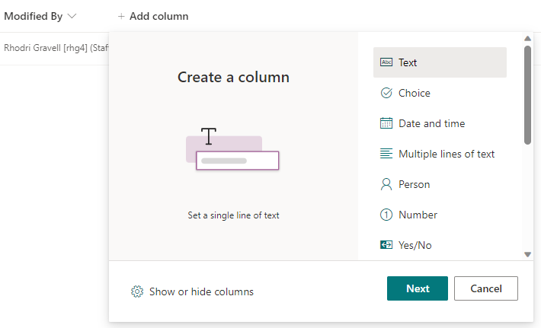
- Type the name of the new column in the ‘Name’ box in the 'Create a column' panel that appears on the right (e.g. ‘Document Code’)
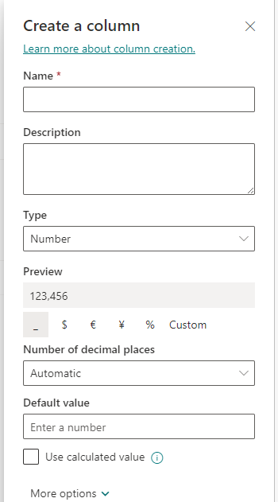
- Click the Save button.
- Your new column will be displayed in the column headings along with the existing columns
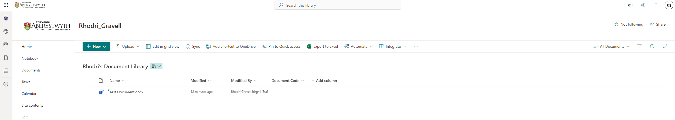

Update the Document Code for your document
- Click to the left of your document’s name so that a green tick appears:
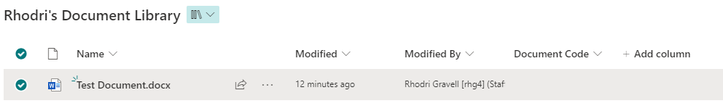
- Click on the ‘i’ symbol on the right-hand side of the screen to open the details pane.
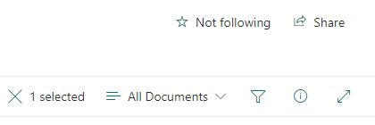
- Information about the document will be shown in a panel on the right of the screen:
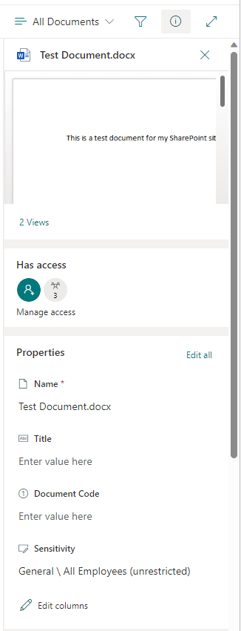
- Click on ‘Enter value here’ beneath ‘Document Code’.
- Type the code and press enter to finish.
- You will see a ‘Saving’ message and then the code will be saved, and will also appear in the document list:
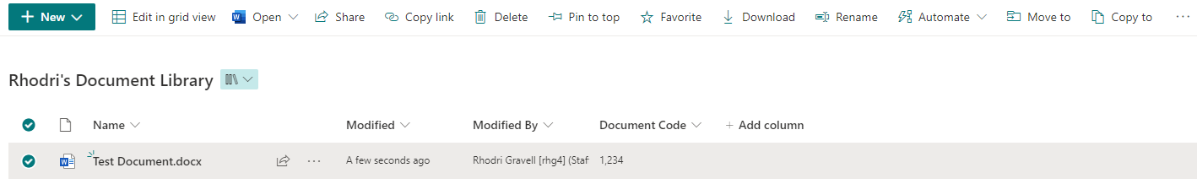

Change the Default View
- Click on ‘All Documents’ (at the top right of the screen) and select ‘Edit current view’.
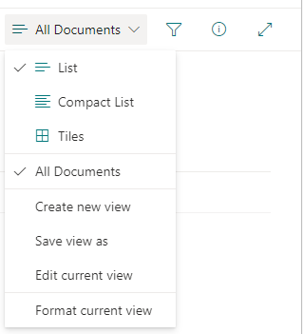
- The Edit View screen will be displayed:
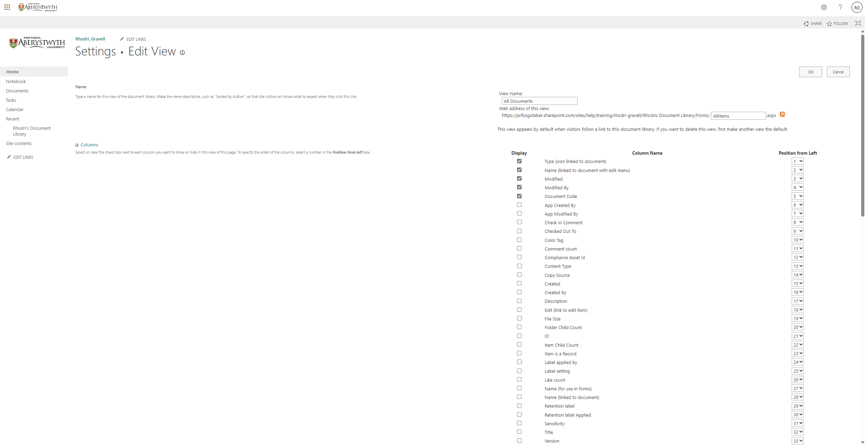
- Make the Version column show up in the default view by ticking the box to its left.
- Move it so that it appears as the first column on the left by changing the number to its right to 1.
- Scroll down and click OK to save.
- Your document library will now be displayed, showing the version column being displayed on the left:
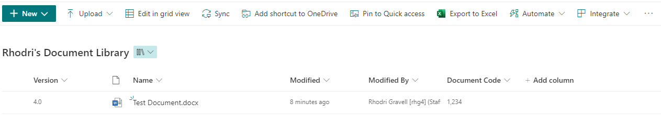

Create an alert on the library
- Click on the … in the grey bar across the top of the page and select Alert me.
- The ‘Alert me when items change’ pop-up will appear:
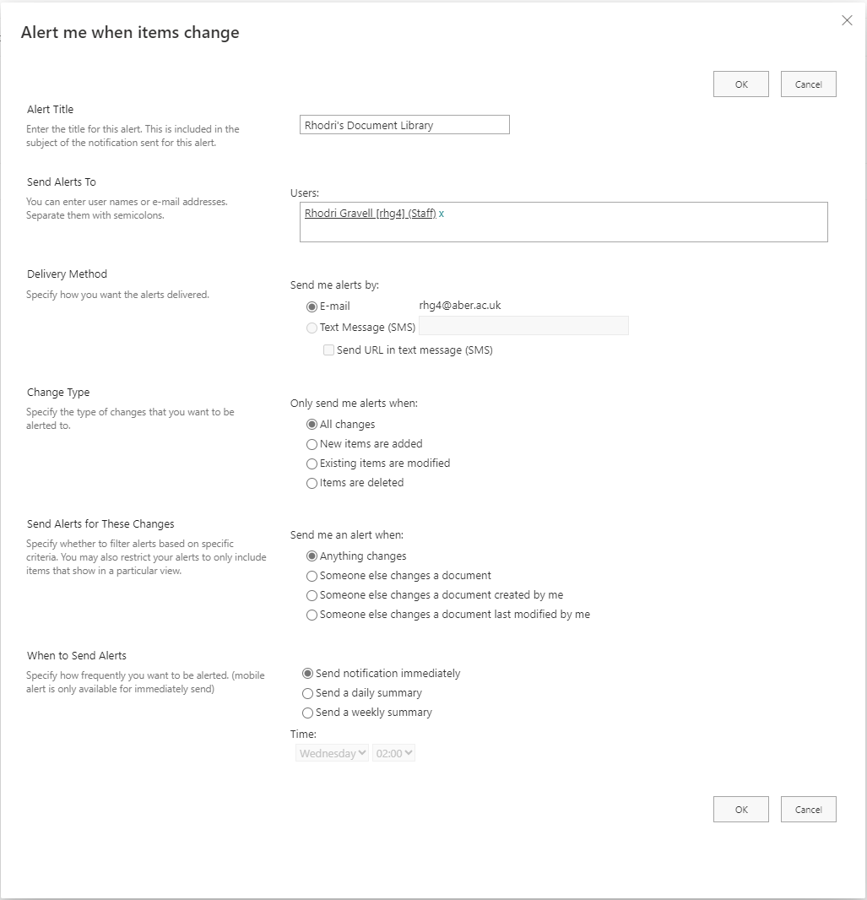
- The alert will be given a title – you can change this to suit you (e.g. ‘Change in Suzy’s Document Library’)
- Leave the rest of the settings as they are and click OK to finish.
- You will now be emailed when anything changes in the document library.

Note:
Your document library will automatically have version control switched on so every time you edit a document the system will store it as a new version. You will be able to roll back to a previous version of a document if required.

Exercise 3 – Creating a Calendar
Calendars are used in SharePoint to store events related to a group, so that they can be accessed by all the members of the group. The group could be a team, department or project group or even the whole of the university. You will create a new calendar for your site and customise the columns.

Create the Calendar
- Click on the cog symbol at the top right of the screen and select ‘Add an App’.
- The ‘My apps’ screen will appear.
- To add a built-in app such as a Custom List, Document Library and Calendar, click on the link to the ‘Classic Experience’.
- The ‘Your Apps’ screen will appear:
- Click the Calendar option.
- Type the name of your calendar in the Name box (e.g. Suzy’s Calendar).
- Click the ‘Create’ button.
- Your calendar will be created and listed in the Site Contents:
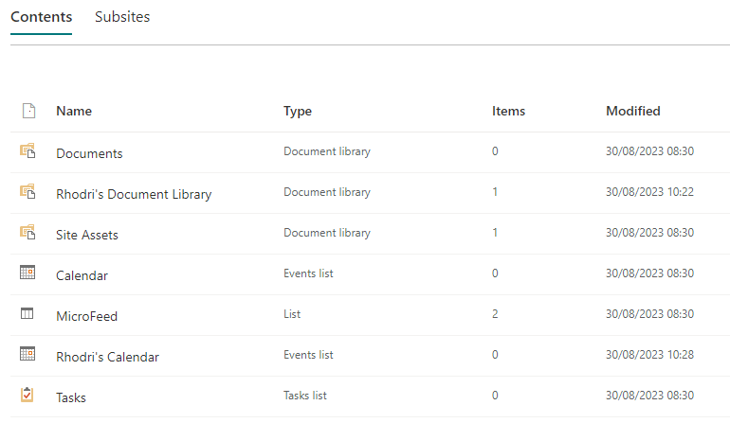
- Click on your new Calendar to view it.
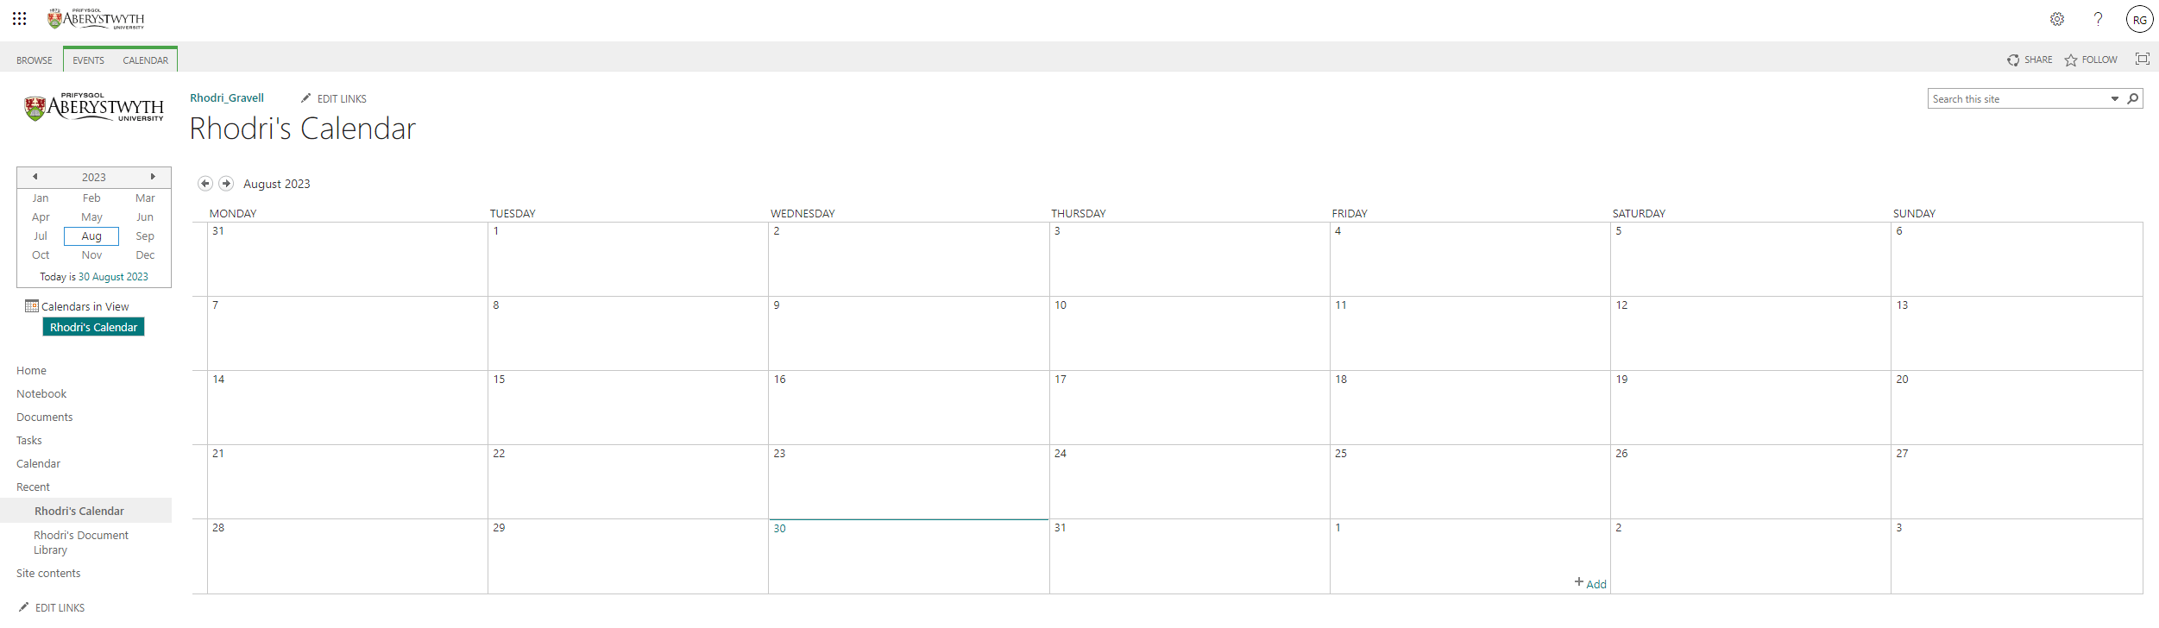

Customise the Category column
- Click on the ‘Calendar’ tab at the top left of the page.
- The Calendar menu will appear across the top of the screen:
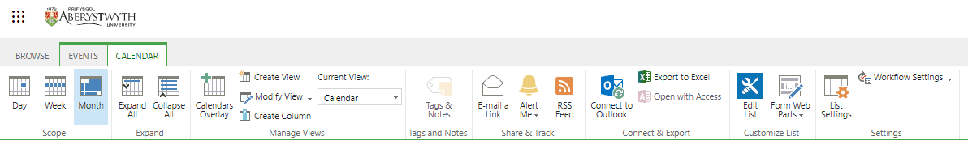
- Click on List Settings towards the right of the menu.
- The List Settings screen will be shown:
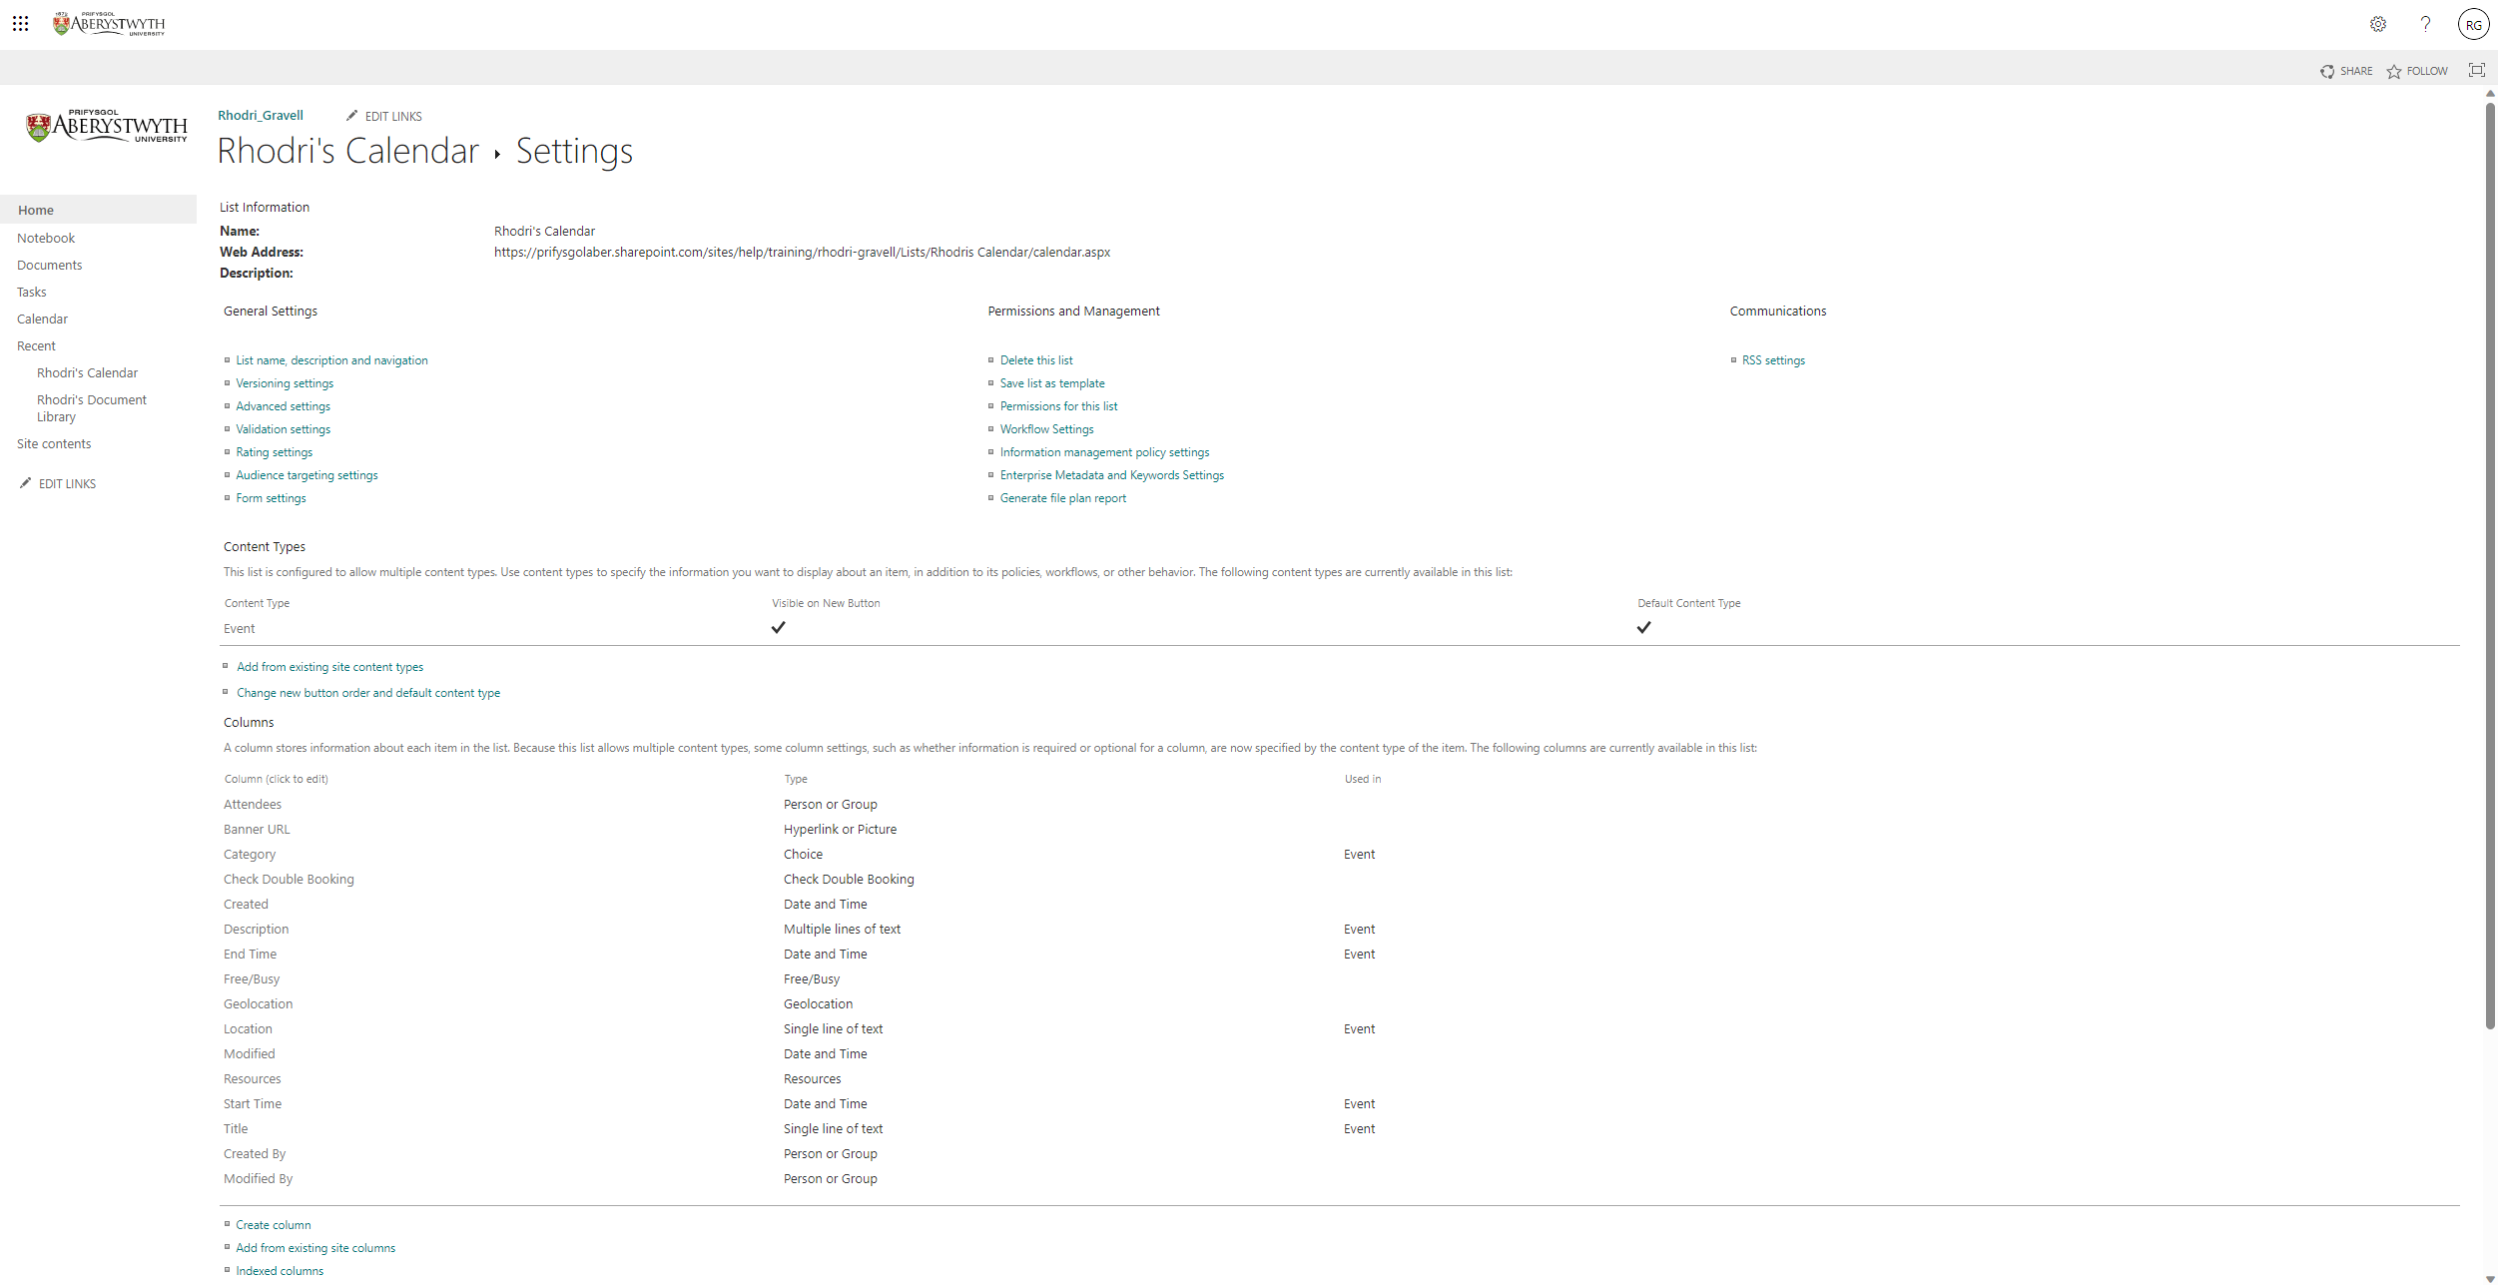

- Scroll down to view the Columns section on the page
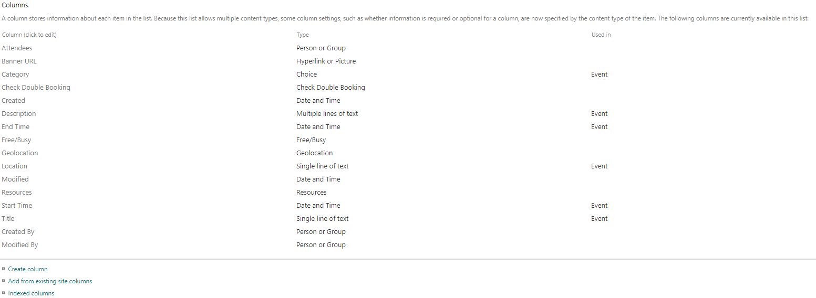
- Click on Category – the Change Column screen appears:
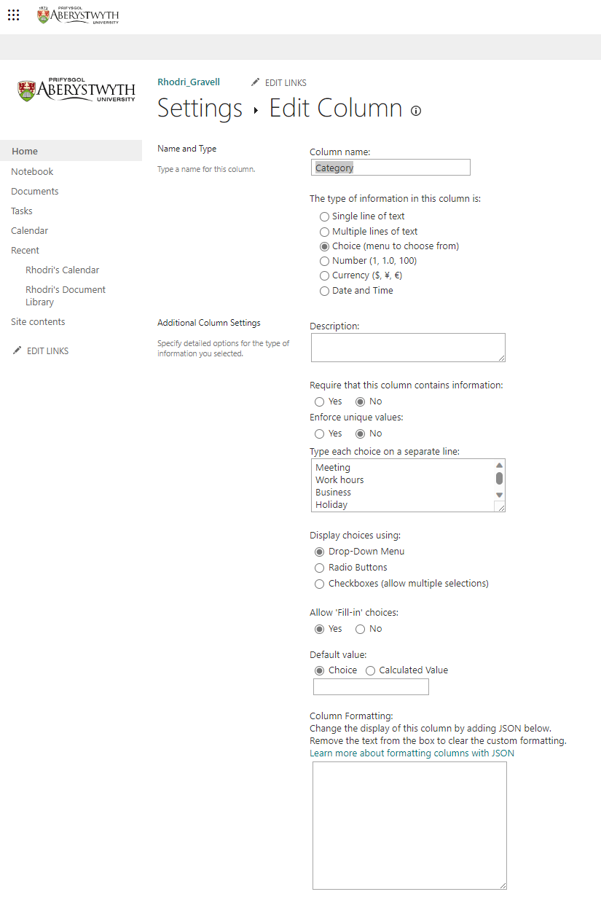
- In the Additional Column Settings section, edit the ‘Type each choice on a separate line:’ box to show your choice of categories e.g. Staff, Student, All.
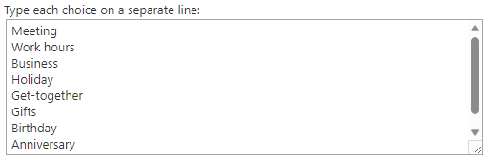
- Change the Allow ‘Fill-in’ choices to No so that users can only choose from the options you’ve added.
- Click OK to save.
- You will be returned to the Calendar Settings page.

Add Events to the Calendar
- Return to your calendar by clicking on its name at the top of the screen – e.g. click on ‘Suzy’s Calendar’
- Click on ‘Events’ at the top of page and the Events menu will appear across the top of the screen:
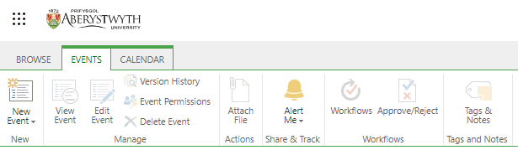
- Click ‘New Event’
- The ‘New Item’ screen will appear:
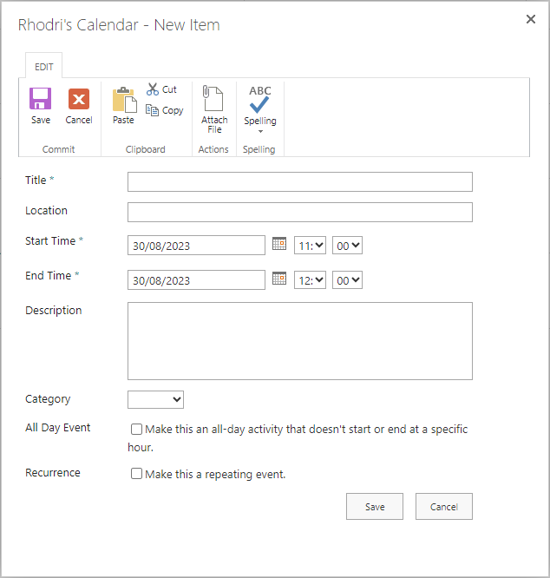
- Add the details of a new event and click Save to finish.

Exercise 4 – Creating a Task List
Task Lists are used in SharePoint to store tasks related to a group, so that they can be accessed by all the members of the group. You will create a new task list for your site, make sure that it will alert users when tasks are assigned to them, and customise the columns. You will also add tasks to the timeline.

Create the Task List
- Click on the cog symbol at the top right of the screen and select ‘Add an App’.
- The ‘My apps’ screen will appear.
- To add a built-in app such as a Custom List, Document Library and Calendar, click on the link to the ‘Classic Experience’.
- The ‘Your Apps’ screen will appear

- Click the Tasks option.
- Type the name of your Task List in the Name box (e.g. Suzy’s Task List).
- Click the ‘Create’ button.
- Your Task List will be created and listed in the Site Contents:
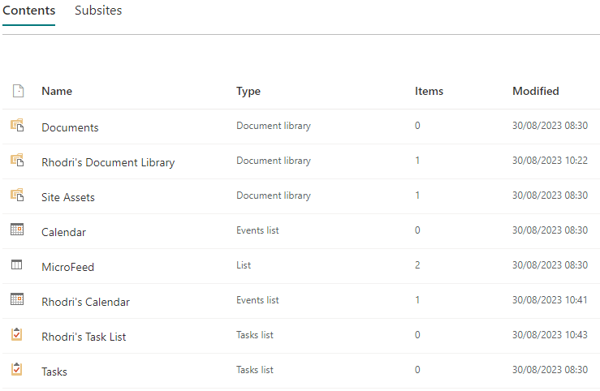
- Click on your Task List to view it.
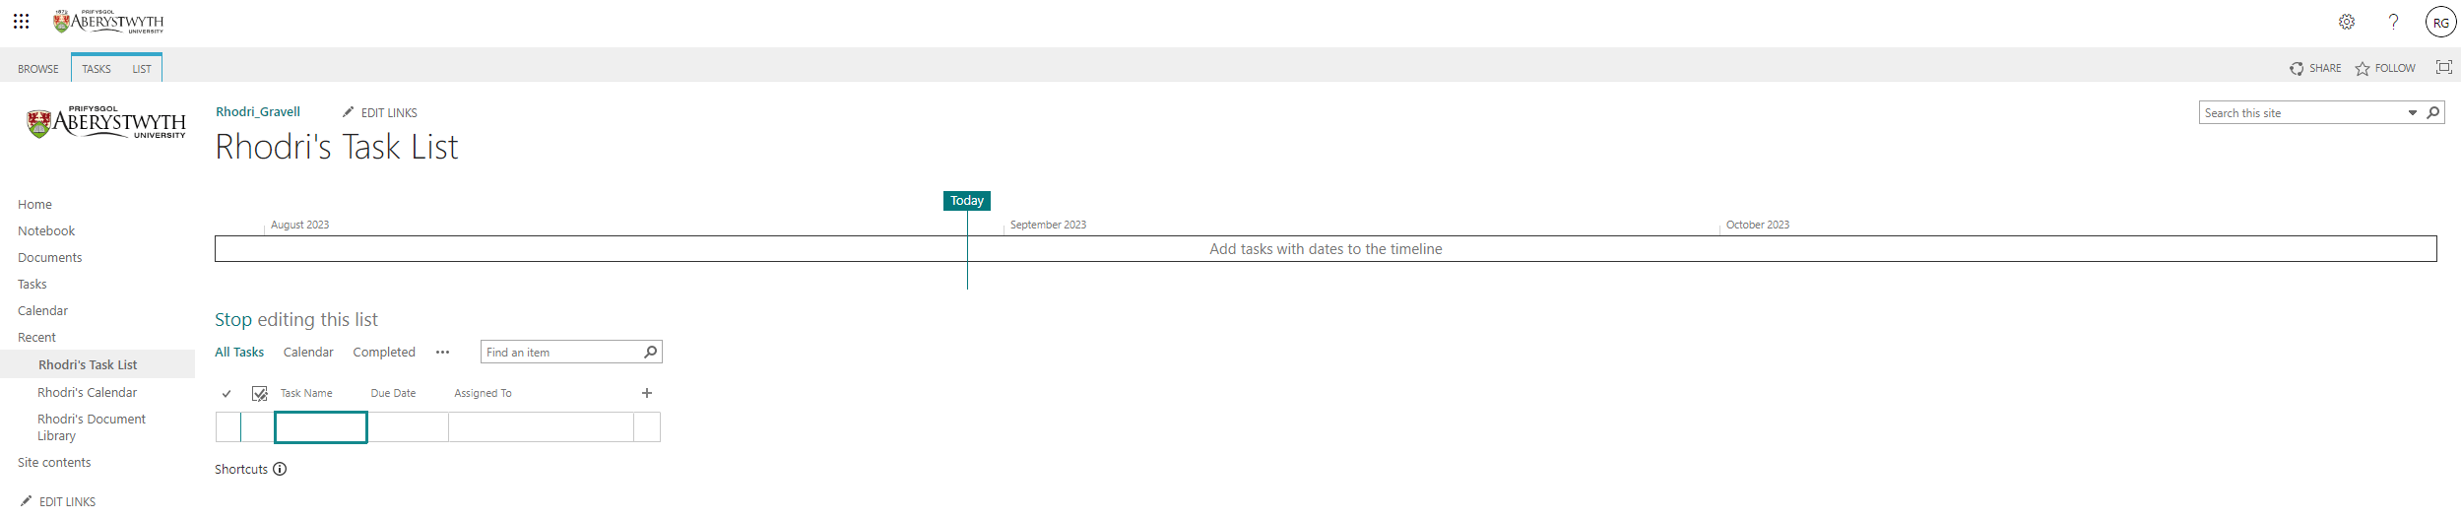

Set the Task List to Notify Task Owners
- Click on the ‘List’ tab at the top left of the page.
- The List menu will appear across the top of the screen:
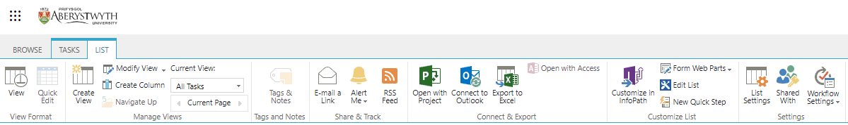
- Click on List Settings towards the right of the menu.
- The List Settings screen will be shown:
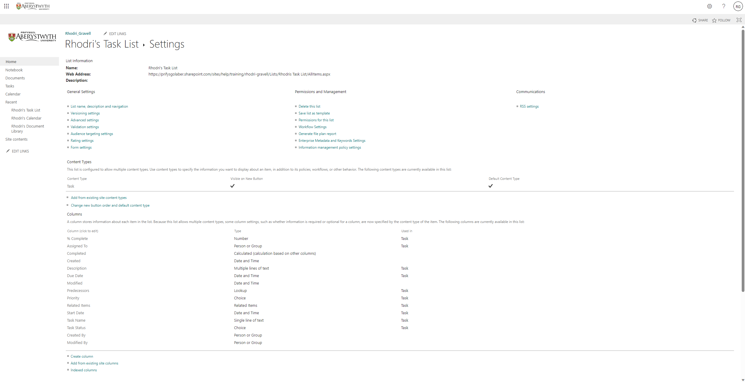
- Click on ‘Advanced Settings’ in the ‘General Settings’ column. The advanced settings screen will appear.
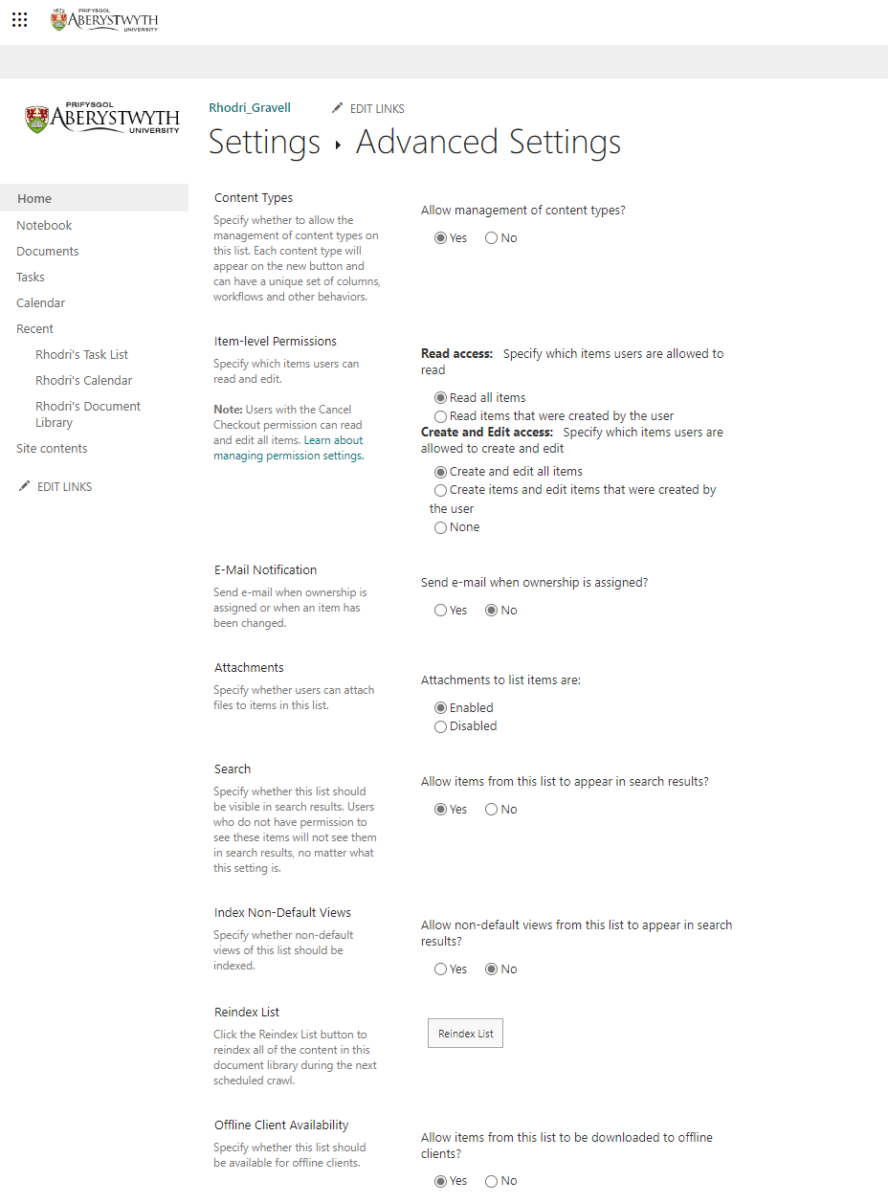
- In the ‘E-Mail Notification’ block, set ‘Send e-mail when ownership is assigned?’ to ‘Yes’.
- Scroll down and click the ‘OK’ button to save the change.

Customise the Columns
- Return to your new task list by clicking on its name in the left menu – e.g. click on ‘Suzy’s Task List’.
- Click on the + sign at the right of the task list.
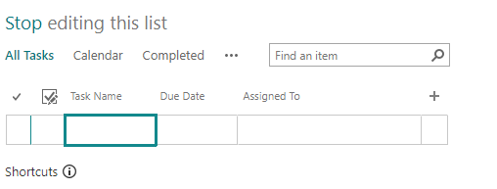
- In the menu that appears, choose ‘Text’.
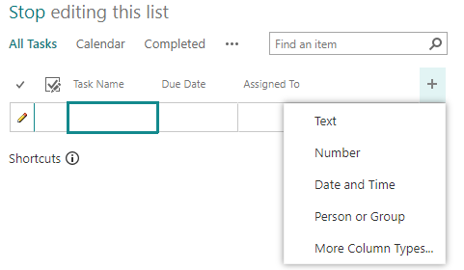
- Type the name of the new column (e.g. Project) in the highlighted box and press enter to save.
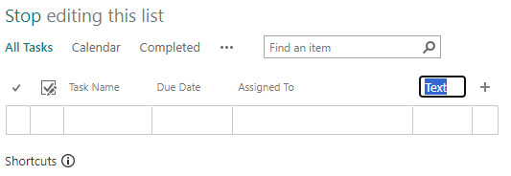
- Your task list will now be displayed, showing the new column on the right:
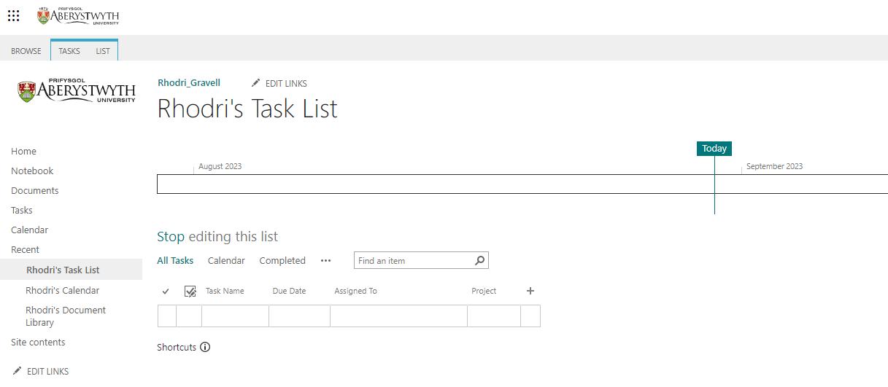

Add a Task to the Task List
- Click into the Task list under ‘Task Name’ and type the name of your task:
- Click into the ‘Due Date’ box and use the date picker to pick a date.
- Click into the ‘Assigned To’ box and type the userid of the person you want to assign the task to. Choose the correct person from the list of suggestions.
- Click into the ‘Project’ box and type the name of the project, e.g. Project X.
- Press enter to save.
- Your first task will automatically be added to the timeline.
- Create a 2nd task in the same way.

Add Tasks to the Timeline
- Click on the ‘…’ to the right of the title of your 2nd task (the one that is not yet in the timeline).
- The Task preview will appear:
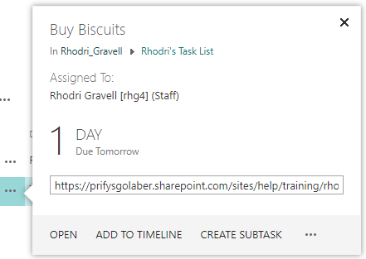
- Click on ‘ADD TO TIMELINE’ to add the item to your timeline.
- Your timeline will now display both of your tasks:

Exercise 5 - Updating the SharePoint Site Homepage
Your Site homepage can include information from libraries and lists within the site to give users a snap-shot of the information within them. You will add web parts to display items from the document library, the calendar and the task list. You will also make changes to the navigation on the left.

Return to your homepage and Start Editing Mode
- Click on Home in the left menu.
- Click on Page at the top left of the screen and select ‘Edit Page’. The page editing screen will appear:
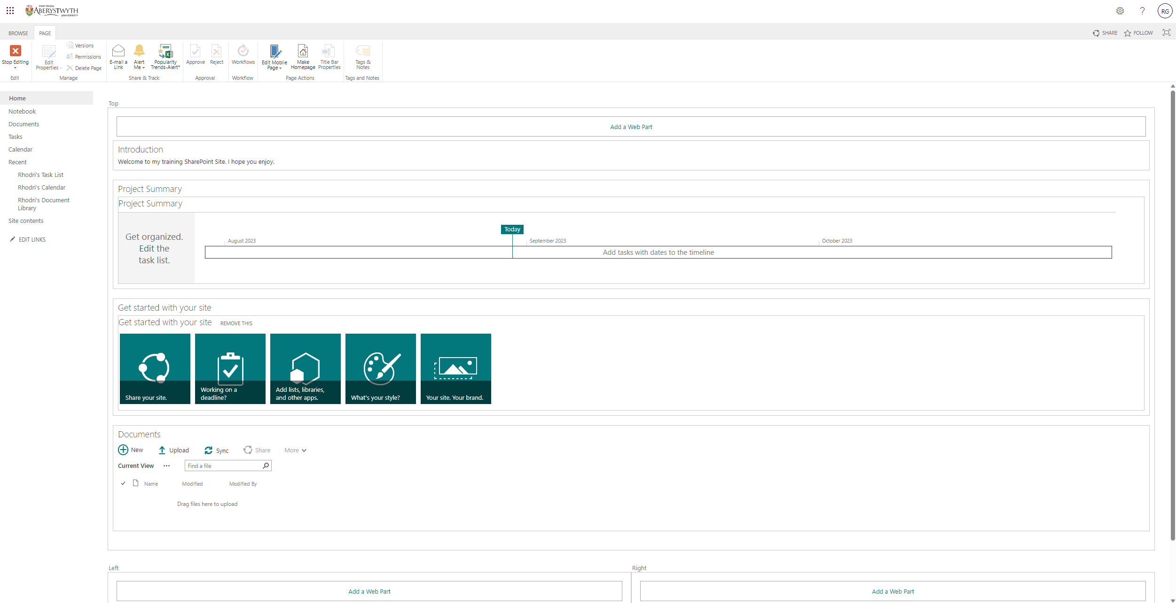

Add your Document Library
- Click on ‘Add a Web Part’ in the middle of the screen - the list of available web parts will appear:
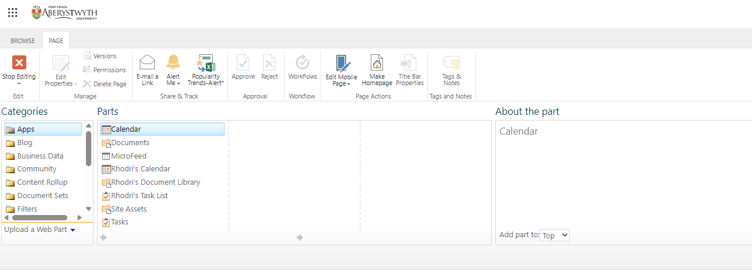
- Select your document library from the list of Apps (e.g. Suzy’s Document Library) and click the Add button to add this web part.
- Your document library will be displayed within the page:
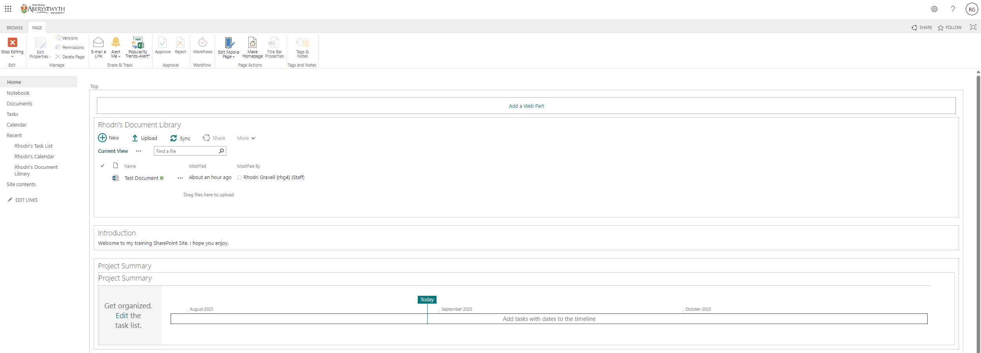

Add your calendar
- Click on ‘Add a Web Part’ again
- Select your calendar from the list of Apps (e.g. Suzy’s Calendar) and click the Add button to add this web part.
- Your calendar will be displayed within the page:
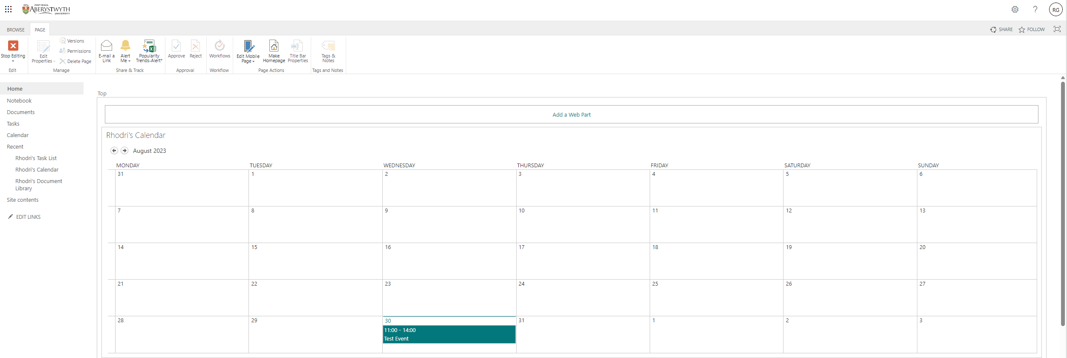
- Displaying the calendar in full takes up too much room.
- Click into the calendar and then click on the very small triangle next to the tick box in the top right corner.
- Choose ‘Edit Web Part’ from the menu that appears.
- The web part properties bar will appear on the right of the screen:
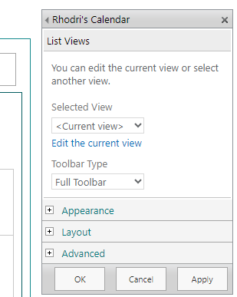
- Click on the drop-down menu under ‘Selected View’ and choose ‘<Summary View>’.
- A warning will appear, click OK to dismiss it.
- Click OK in the properties bar to apply this change.
- Your calendar will now display a list of upcoming events:
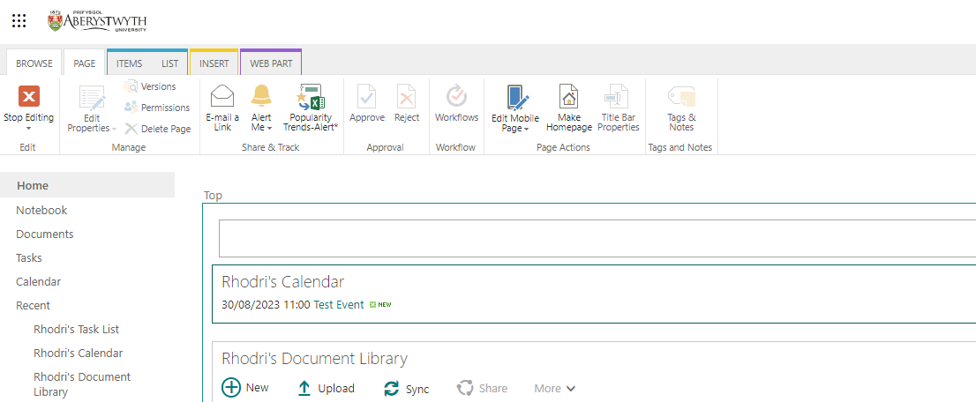

Add your task list
- Click on ‘Add a Web Part’ again.
- Select your task list from the list of Apps (e.g. Suzy’s Task List) and click the Add button to add this web part.
- Your task list will be displayed within the page:
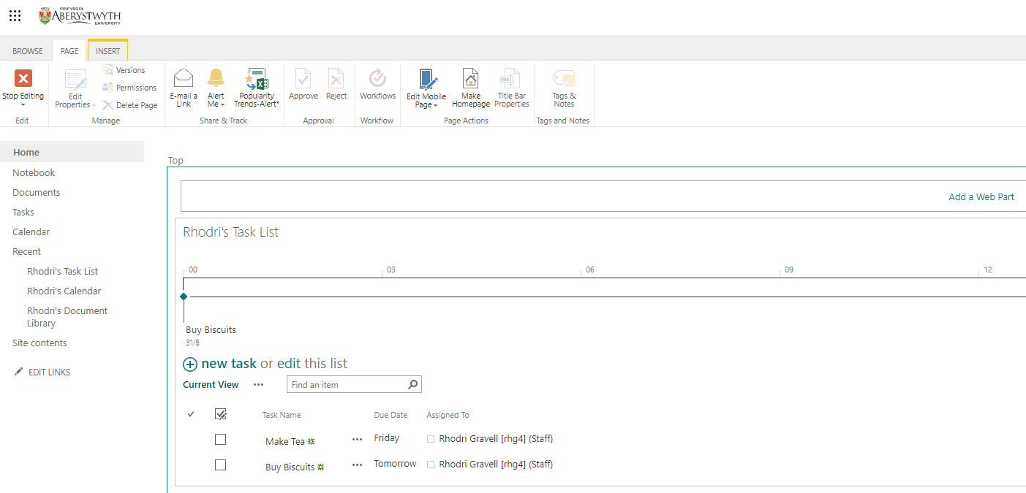

Rearrange the Web Parts and view your page
- Scroll down to the text web part you made at the beginning of the session:
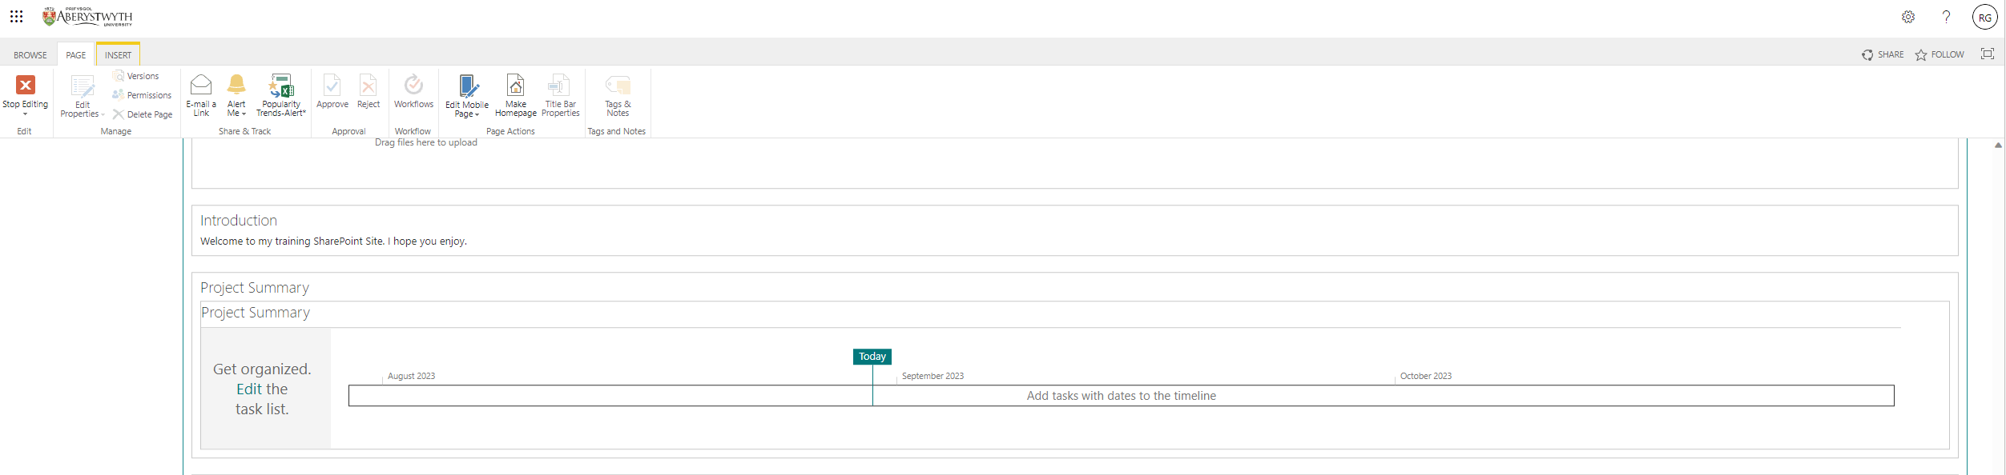
- Click into the web part, then move your mouse to the top right corner and click on the very small triangle next to the check box.
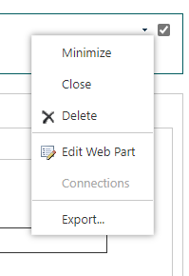
- Choose ‘Edit Web Part’ from the menu that appears.
- The Web Part properties bar will appear down the right of the screen. You may need to scroll up to see it.
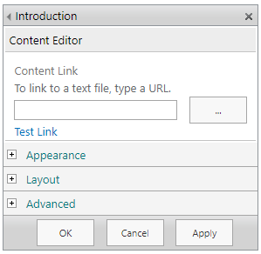
- Click on Layout
- Change the 'Zone Index' to 0 and click the OK button. This will bring the web part to the top of the area:
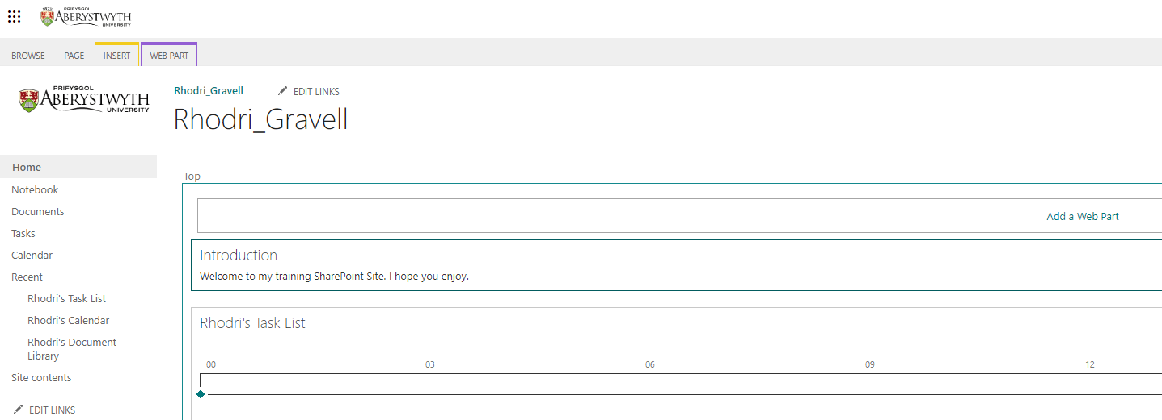
- Move your new web parts into the Left or Right section at the bottom of the screen by opening the web part properties bar for each one and choosing Left or Right in the Zone drop-down menu. If you want to adjust their order in the new area of the page, you can also change their Zone Index.

Tidy up the page by removing unused web parts.
- Scroll down to the Project Summary web part.
- Click into the web part, then move your mouse to the top right corner and click on the very small triangle next to the check box
- Choose Delete from the menu.
- Repeat the process to remove any other items you do not need.
- View the page as it will be seen by others by exiting edit mode - click the Page tab at the top left, then click on the red Stop Editing button.
- Click ‘Browse’ at the top left of the page. You can now see your page as it will be seen by others:
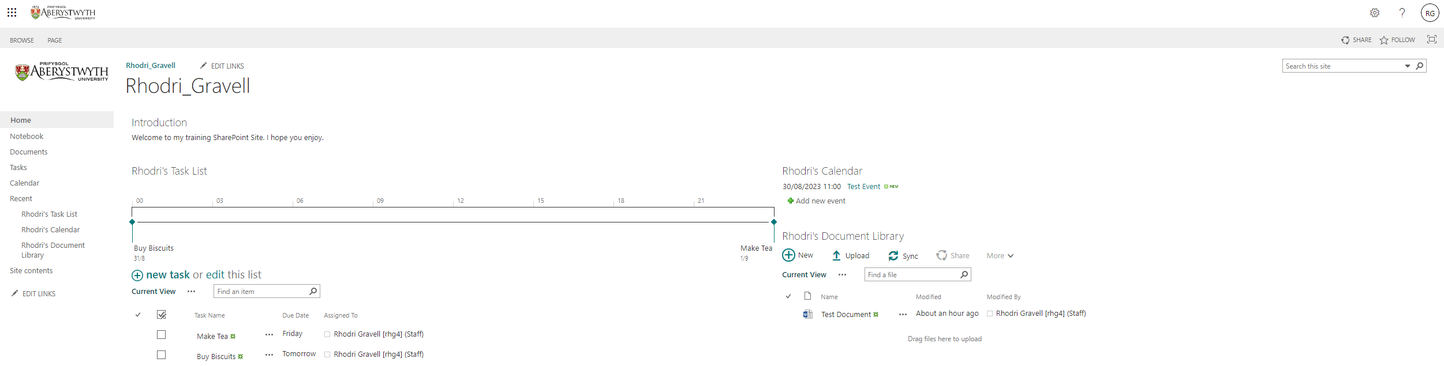

Remove unused Items from the left menu
- Click EDIT LINKS under the left menu
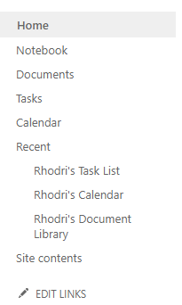
- The menu will now be in ‘editing mode’
- Click on the X to remove any items you don’t want showing in the left menu
- Drag the items you want into the correct order.
- Click the Save button to finish. The menu should now show as you require:
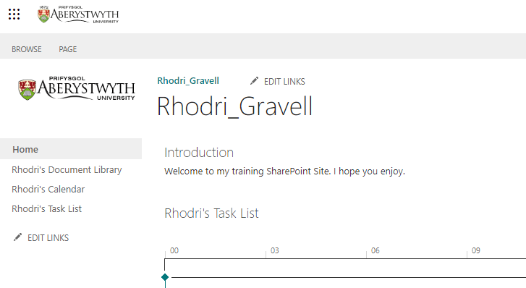

Exercise 6 – Setting Permissions
Your site can only be accessed by the staff that have the correct permissions set. You will add staff to the appropriate permission group so that they can access your site. Permissions can also be set on individual libraries or lists. You will set different permissions on your document library to restrict it further.

Access Site Permissions
- Click on the cog symbol at the top right of the screen and select ‘Site Settings’. The Site Settings screen will appear:
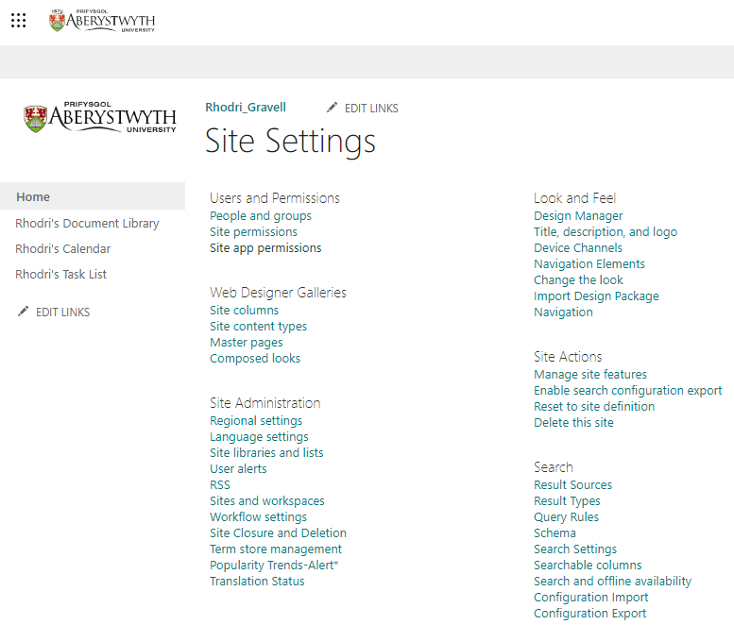
- Click ‘Site Permissions’ in the first column under ‘Users and Permissions’.
- The permissions for your site will be shown:
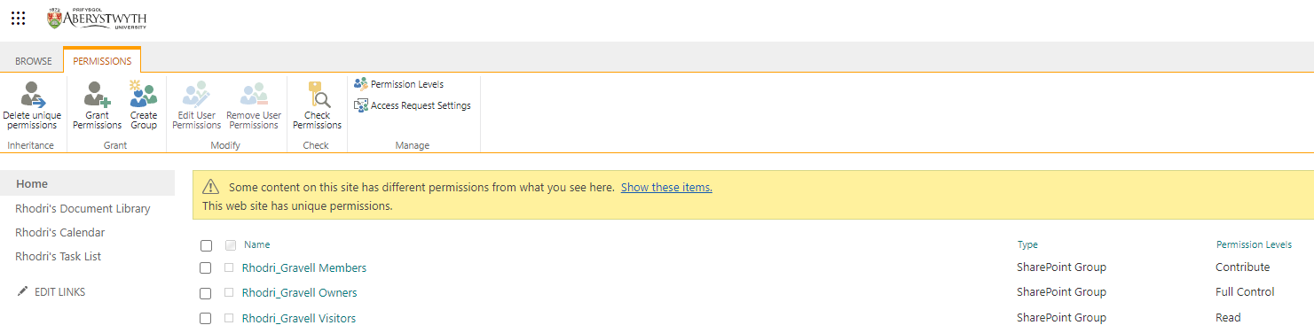
- Add an additional user to your Members group so that they can access your site and contribute:
  - Click on the Members group to open it and view the current members of the list.
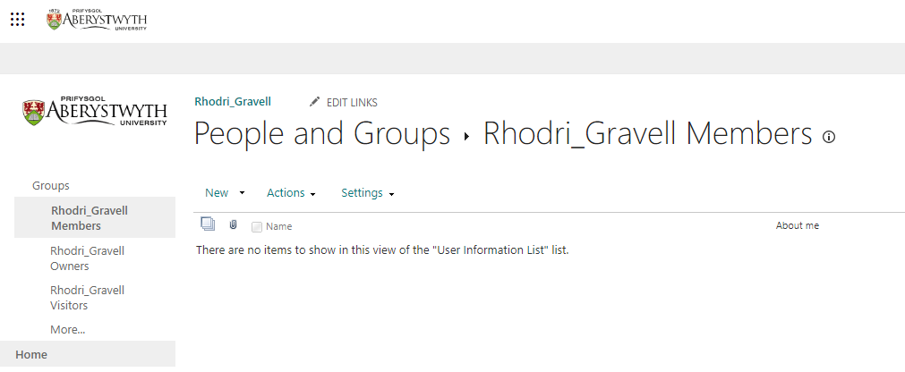
  - Click New at the top of the list of members
  - Type the user’s name (e.g. Suzy) or userid (e.g. sfs) in the first box - choose the correct person from the list of names that appears.
  - When you're finished, click SHOW OPTIONS and untick the 'Send an email invitation' tick box.
  - Click Share to finish.
- You should now see the additional user showing in the group list.

Set permissions on your document library
- Return to your document library by clicking on its name in the left menu – e.g. click on ‘Suzy’s Document Library’
- Click on the cog symbol at the top right of the screen and select ‘Library Settings’.
- On the pop-up menu which appears, click on ‘More library settings’.
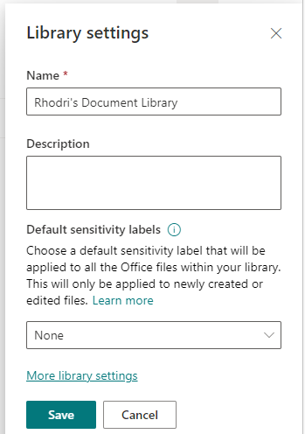
- The Library Settings screen will appear.
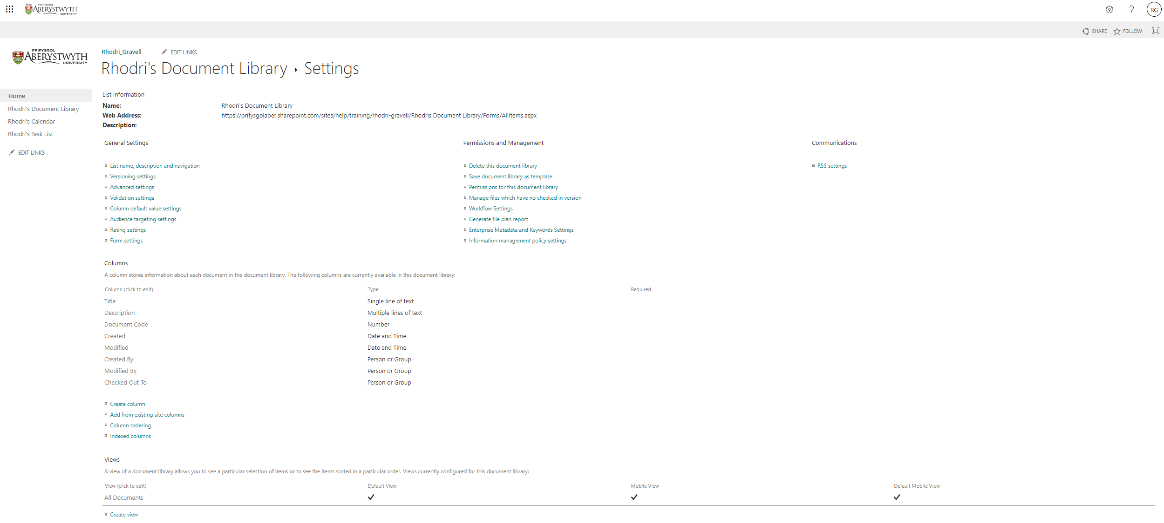
- Click on ‘Permissions for this document library’ in the 2nd column under ‘Permissions and Management’.
- The Library permissions page will be displayed:
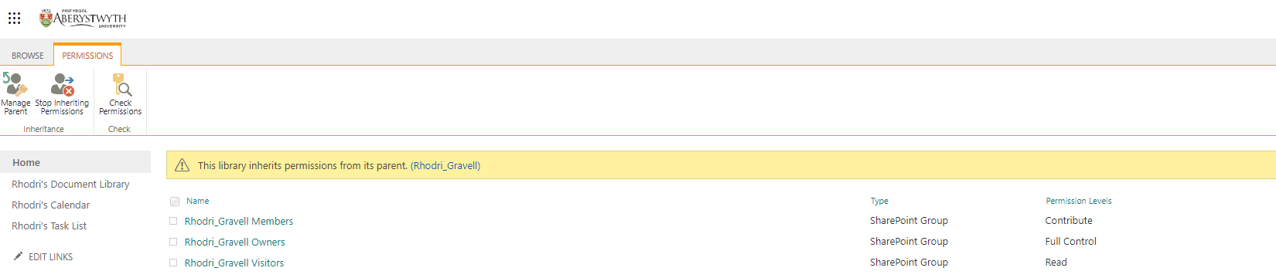
- The document library is inheriting permissions from its parent – this needs to be changed. Click ‘Stop Inheriting Permissions’ in the top left corner.
- A warning message will appear:
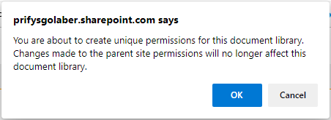
- Click OK to proceed.
- You will now see the message 'This library has unique permissions' in the yellow bar at the top of the screen.
- Let's say that this document library should only be visible to people in the Members group, and not the Visitors group, and you want to add an additional individual.
- Remove the Visitors group:
  - Tick the box to the left of the Visitors group.
  - Click on Remove User Permissions in the menu across the top:
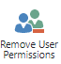
  - A warning will pop-up - click OK to confirm.
  - The Visitors group will no longer be visible in the permissions list.
- Add a new individual:
  - Click on Grant Permissions in the menu across the top:
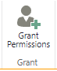
  - The Sharing pop-up will be displayed.
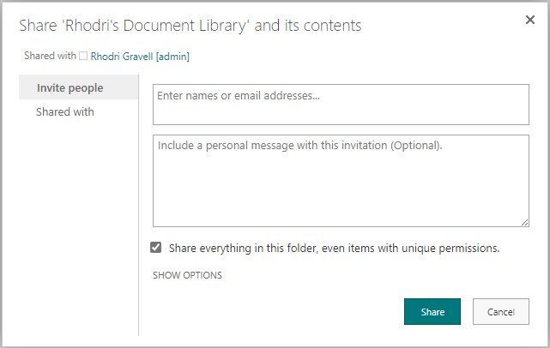
  - Type the user’s name or userid in the first box (‘Enter names or email addresses’) and pick the right name from the list that appears.
  - Click ‘SHOW OPTIONS’
  - Untick ‘Send an email invitation’
  - Select the appropriate permission level in the ‘Select a permission level’ drop down menu, e.g. Contribute or Read.
  - Click Share to finish.
- Refresh your page to see your additional user showing in the permission list.

Exercise 7 – Creating a Sub-site
On occasion you may be required to create a sub-site. Before creating it you should consider carefully whether it is required – for example, could the requirements be met by creating a new document library with specific permissions instead? You will consider the requirements that might be met with a sub-site, and learn how to create one.
- Return to your site’s homepage by clicking Home in the left menu.
- Click on the cog symbol at the top right of the screen and select ‘Site Contents'.
- Click on New at the top of the page:
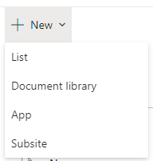
- Choose Subsite from the menu that appears.
- The ‘New SharePoint Site’ screen will be displayed:
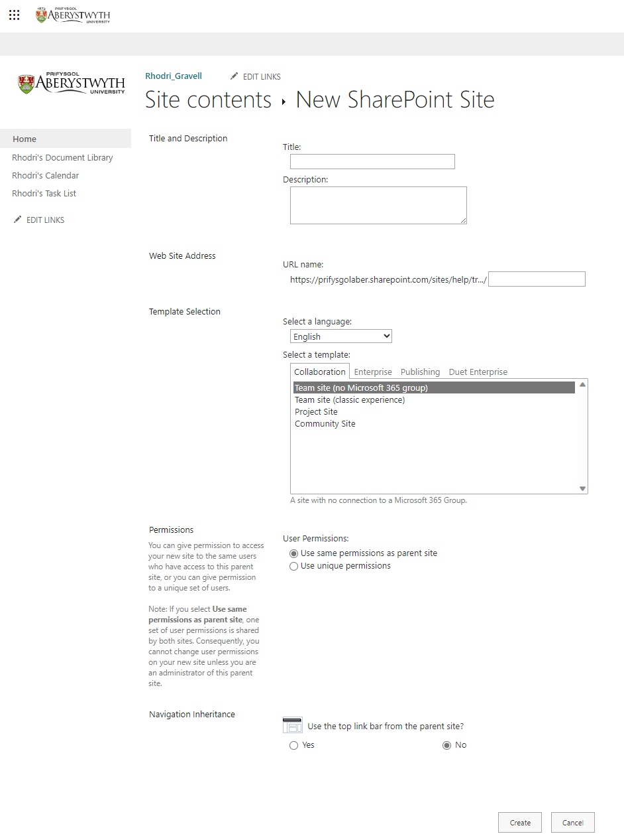
- Give your sub-site a Title (e.g. Suzys’s Sub-Site) and a Description (e.g. Suzy’s Sub-Site made in training session).
- Give your sub-site a Web Site Address by typing into the box – you just need the end of the web address as it knows the rest e.g. suzy-sub.
- Click on ‘Project Site’ in the ‘Select a template’ box.
- Choose ‘Use unique permissions’ for ‘User Permissions’.
- Choose Yes for ‘Use the top link bar from the parent site’.
- Click Create to proceed.
- You will see the ‘Set Up Groups for this Site’ page:
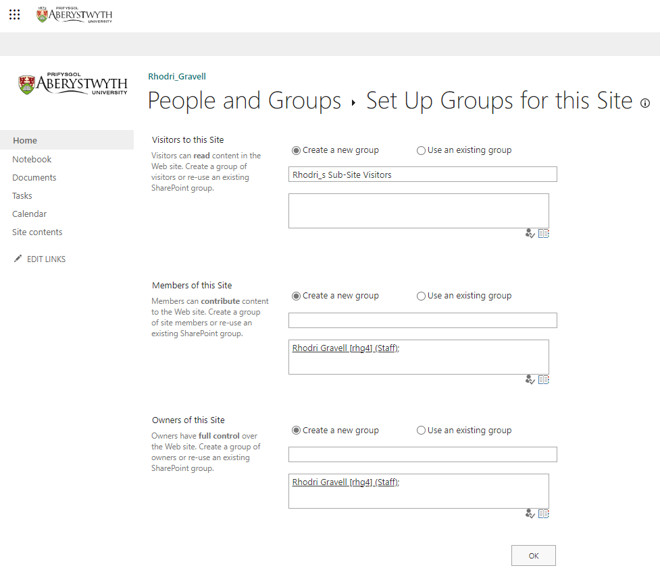
- Add a person to your Members group and Owners group
- Click OK to proceed.
- You now have a new sub-site which you can set up as you like.

