SharePoint Training – Using SharePoint
Last Updated: August 2023
Contents
SharePoint Training – Using SharePoint 1
Exercise 1 – Accessing SharePoint 2
Exercise 2 – Using the Document Library 4
Open and Edit a Document 4
Create a New Folder 6
Add a Document into the Folder 8
Exercise 3 – Using Calendars 10
Access the calendar and create an event 10
Edit a Calendar Event 11
Exercise 4 – Using Task List 13
Access the task list and create a task 13
View tasks that have been assigned to you 16
Edit a Task that has been assigned to you 17

Training Evaluation Form:
https://www.aber.ac.uk/en/is/it-services/web/training-evaluation/

Exercise 1 – Accessing SharePoint
Before you can make use of SharePoint you need to know how to access it – you will access the site and navigate to the training area.
- Open a browser
- Type sharepoint.aber.ac.uk into the address bar.
- Log in with your usual username and password.
- You will see the main SharePoint page:
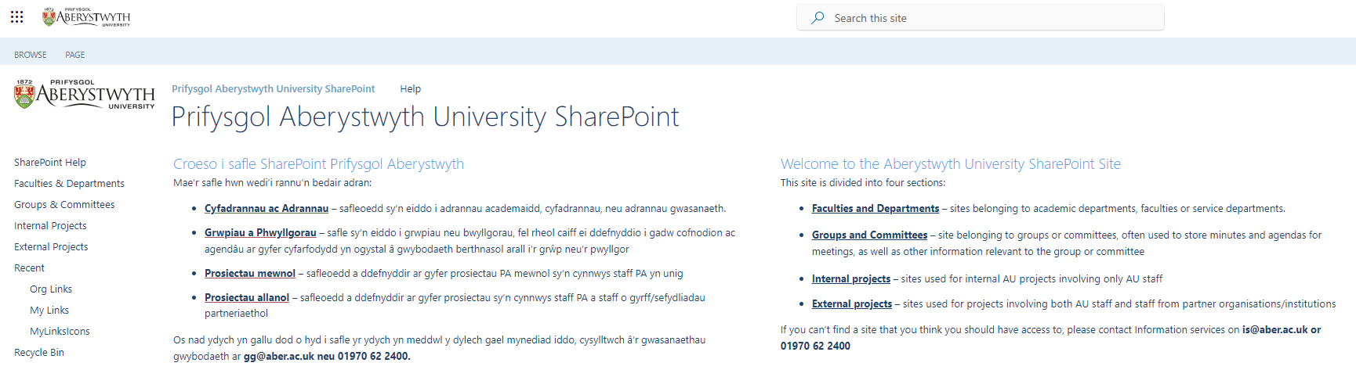
- Find and click on “SharePoint Help” in the left menu
- You will now see the Help & Training area:
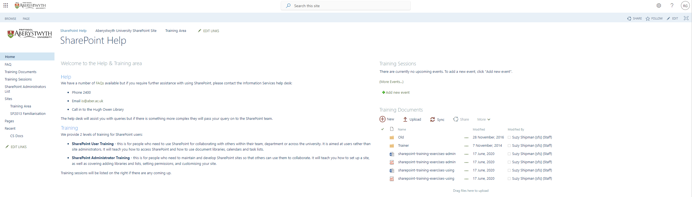
- Find and click on “Training Area” in the left menu (under Sites)
- You should now see the Training Area:
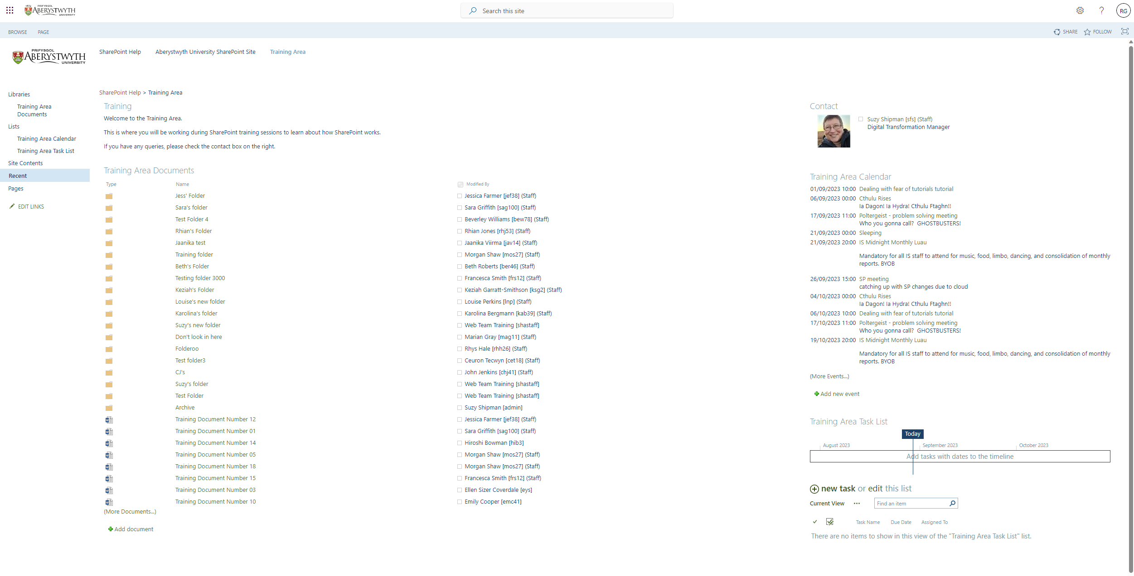

Exercise 2 – Using the Document Library
Document Libraries are used to store documents so that they can be accessed by yourself and other users. Depending on permissions these documents could be shared within a team or department, or with all SharePoint users. You will access a document library, view and edit a document, create a folder and add a document to it. You will also test out opening a document library in explorer.

Open and Edit a Document
- Click on “Training Area Documents” in the left menu (under Libraries) - the Training Area Documents document library will be displayed:
- Pick whichever document you like and click on its name.
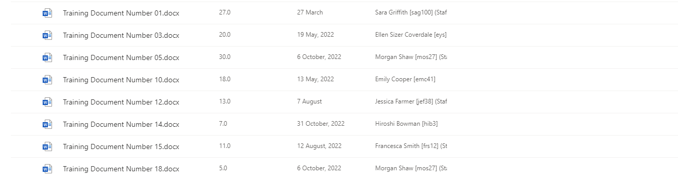
- The document will open in Word Online:

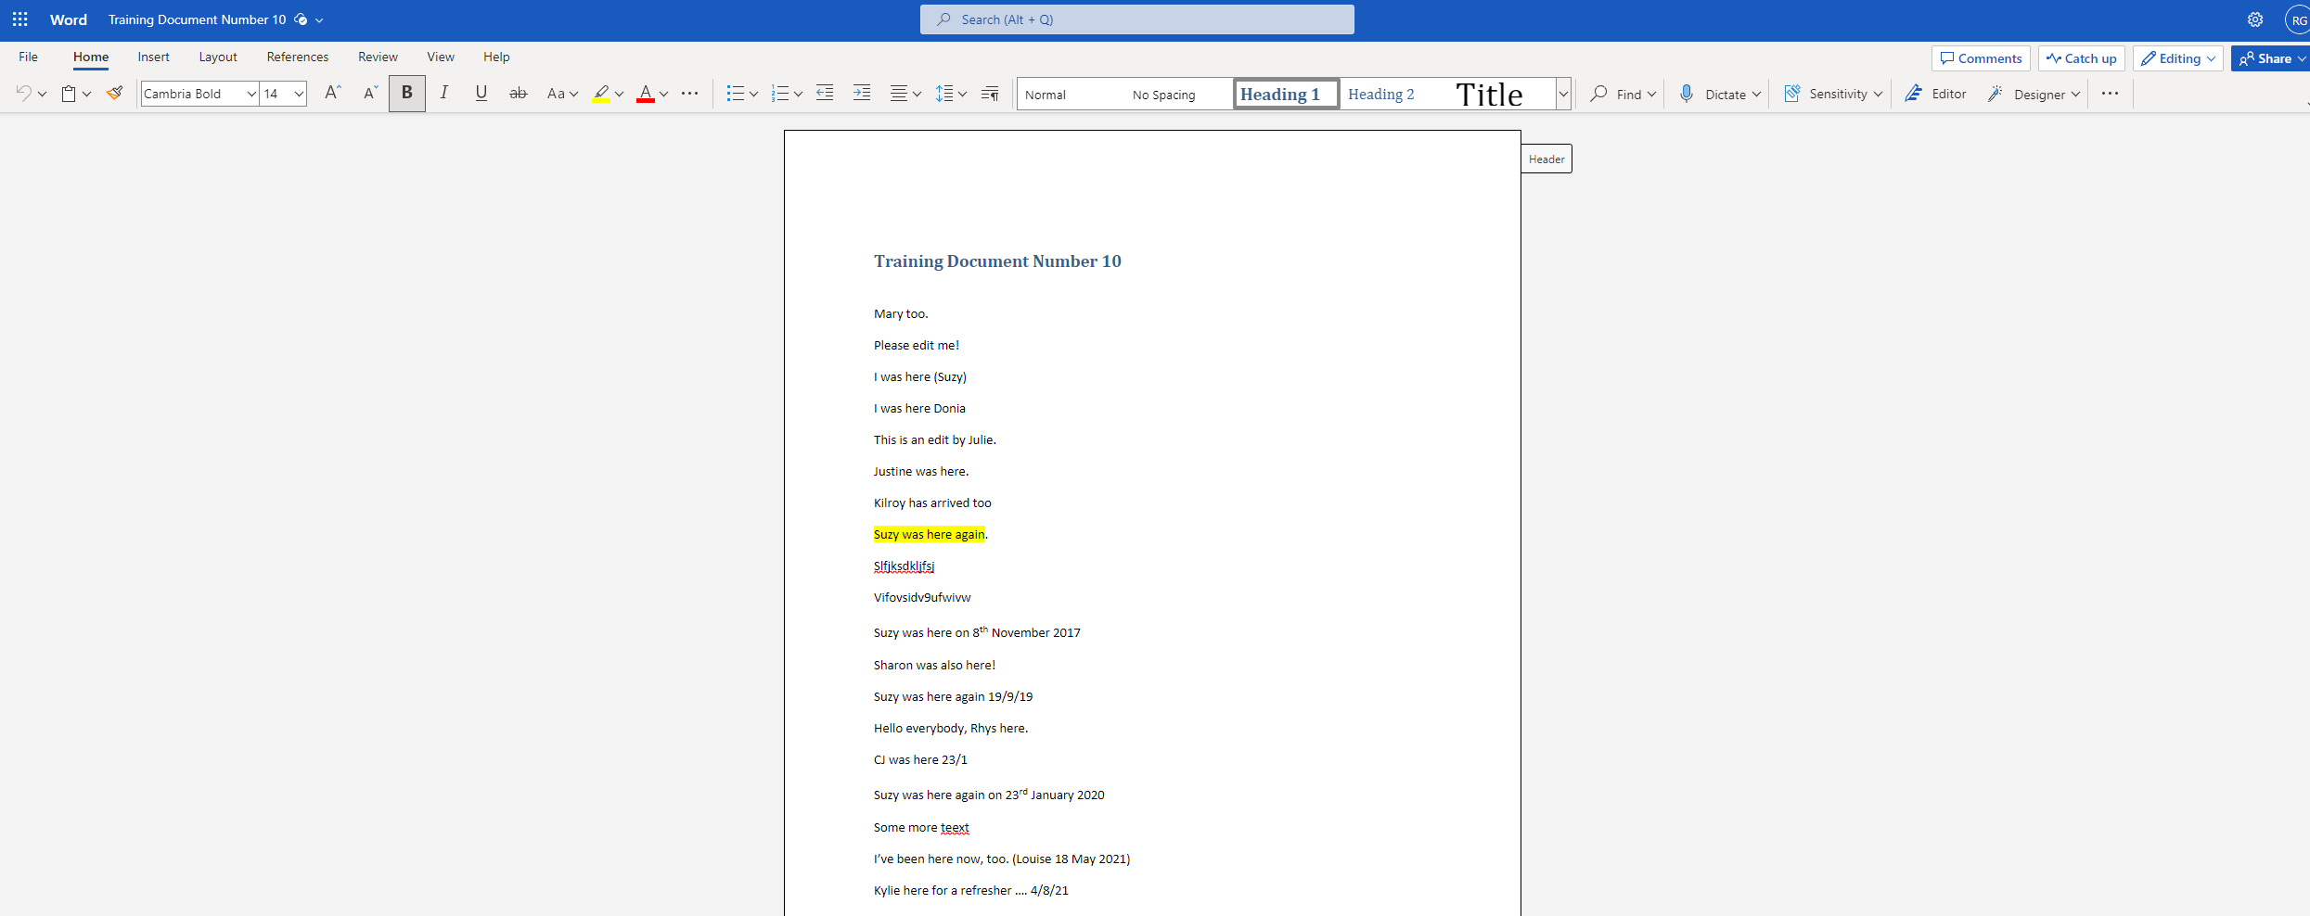
- Make a change to the document by typing a line of text e.g. “This is an edit by Suzy”
- Wait until the ‘Saving’ text at the top of the screen has changed to ‘Saved’
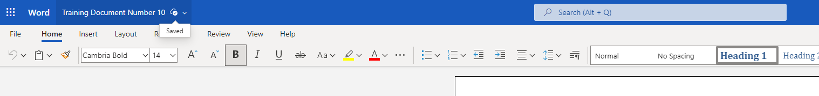
- Close your current tab to return to the document library in SharePoint.

Create a New Folder
- Click on New at the top of the page
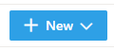
- Choose Folder from the menu that appears:
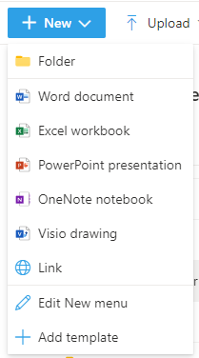
- A pop-up will appear asking for the name of the new folder:
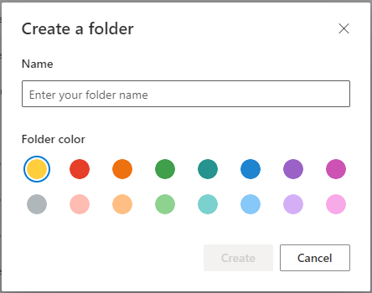
- Type the name of the new folder in the box e.g. “Suzy’s Folder” and click Create
- Your new folder will appear in the document library:
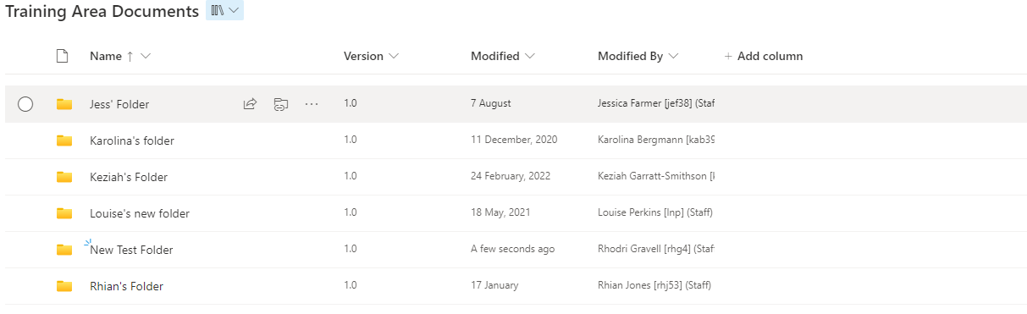

Add a Document into the Folder
- Click on the name of the folder you created to open it
- Click on ‘New’ at the top of the page
- Choose ‘Word document’ from the menu that appears:
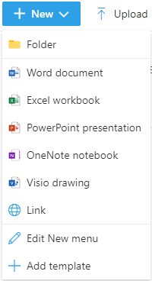
- Your new document will open in Word Online.
- Write some text in the document.
- Click on 'Document' in the bar at the top of the screen and give your document a sensible name e.g. Suzy's Lovely Document. Click Enter to save the new name.
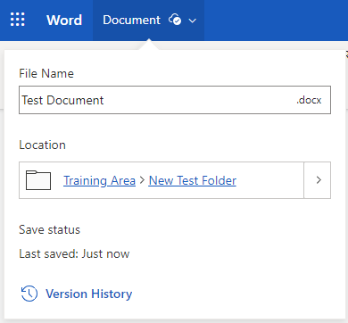
- Wait until the ‘Saving’ text at the top of the screen has changed to ‘Saved’
- Close your current tab to return to your folder in the document library in SharePoint.
- Your new document will be listed in your folder:
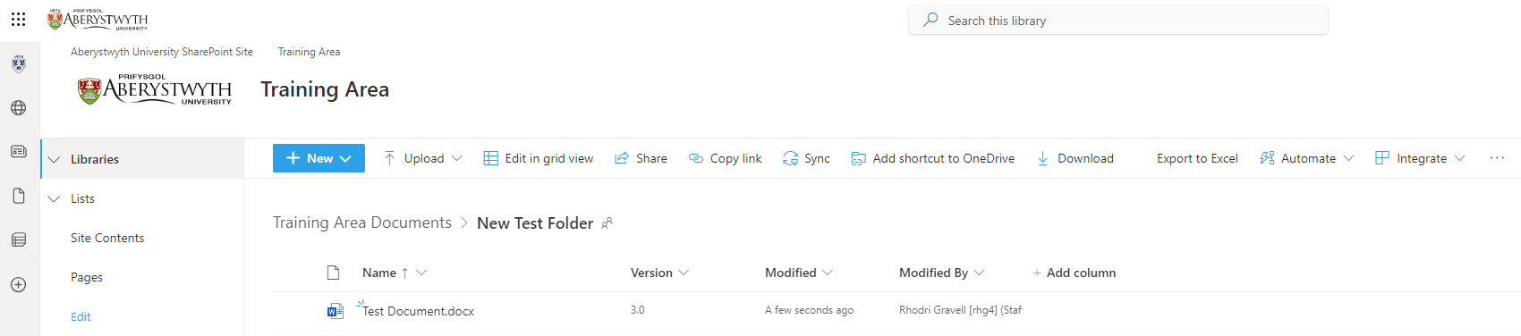

Exercise 3 – Using Calendars
Calendars are used in SharePoint to store events related to a group, so that they can be accessed by all the members of the group. The group could be a team, department or project group or even the whole of the university. You will access a calendar, create an event and edit a different event.

Access the calendar and create an event
- Click on “Training Area Calendar” in the left menu (under Lists) - the Training Area Calendar will be displayed:
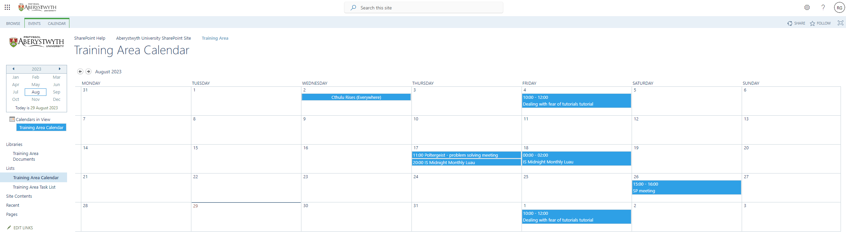
- Choose a date to add your event to and place your mouse in its box. The Add link will appear
- Click on the Add link
- The New Item pop-up will appear:
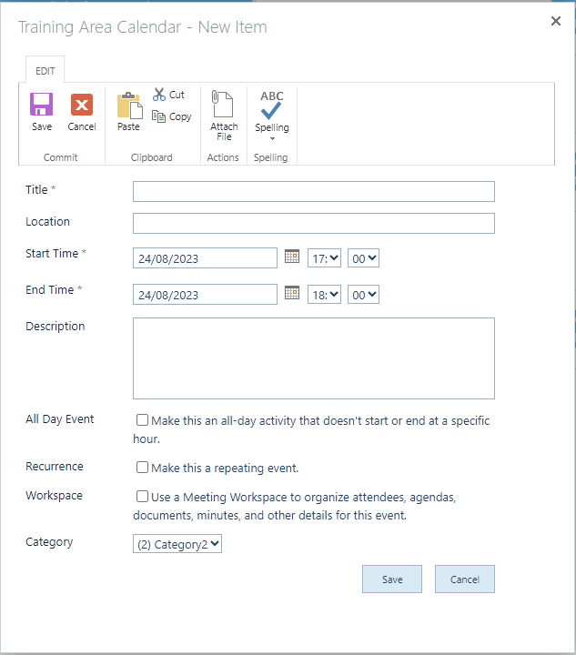
- Fill in the details of your event. It must have a title, a start time and an end time (unless you tick the “All Day Event” box). You can also add a description of the event to give further details.
- Click the Save button to finish.
- You should now see your event in the calendar:

Edit a Calendar Event
- Pick one of the events that someone else has added to the calendar and click on it.
- Information about the event will appear:
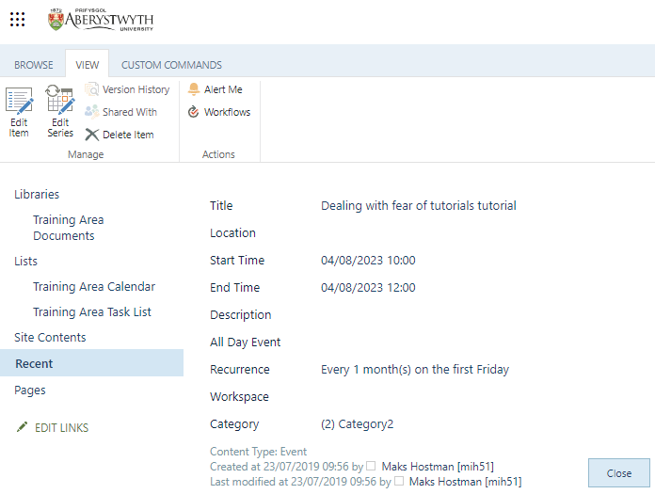
- Click the Edit Item button (top left).
- The event editor will appear:
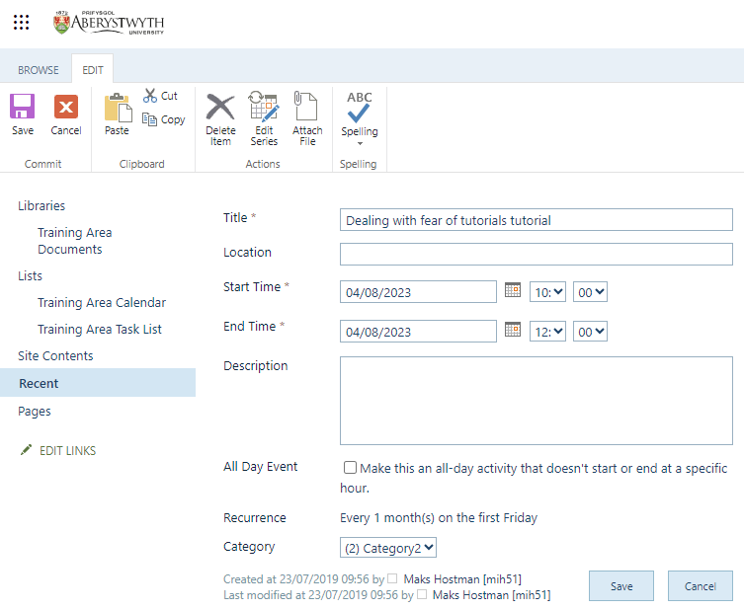
- Edit the Date of the event. Click Save to finish.
- The event will now be displayed on the new date in the calendar.

Exercise 4 – Using Task List
Task Lists are used in SharePoint to store tasks related to a group, so that they can be accessed by all the members of the group. Each task can be allocated to a specific person so that they can keep track of the tasks they need to complete. You will access a task list, create a task for another member of the group and edit a task that has been assigned to you.

Access the task list and create a task
- Click on “Training Area Task List” in the left menu (under Lists) - the Training Area Task List will be displayed:
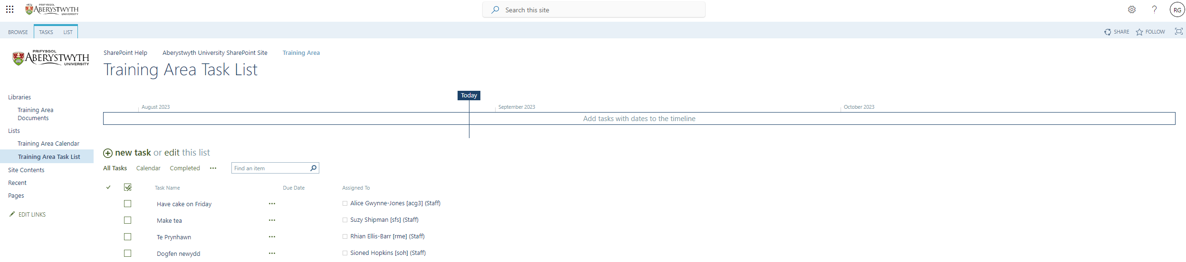
- Click on ‘new task’ at the top of the list 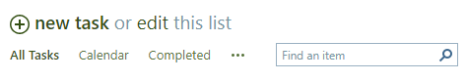
- The New Item screen will appear:
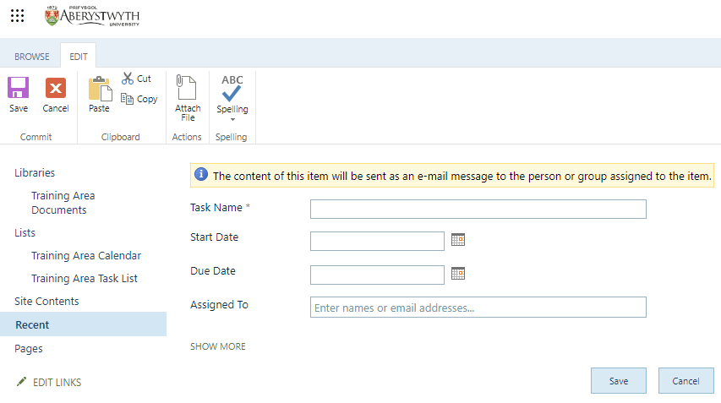
- Click ‘SHOW MORE’ to see all the options.
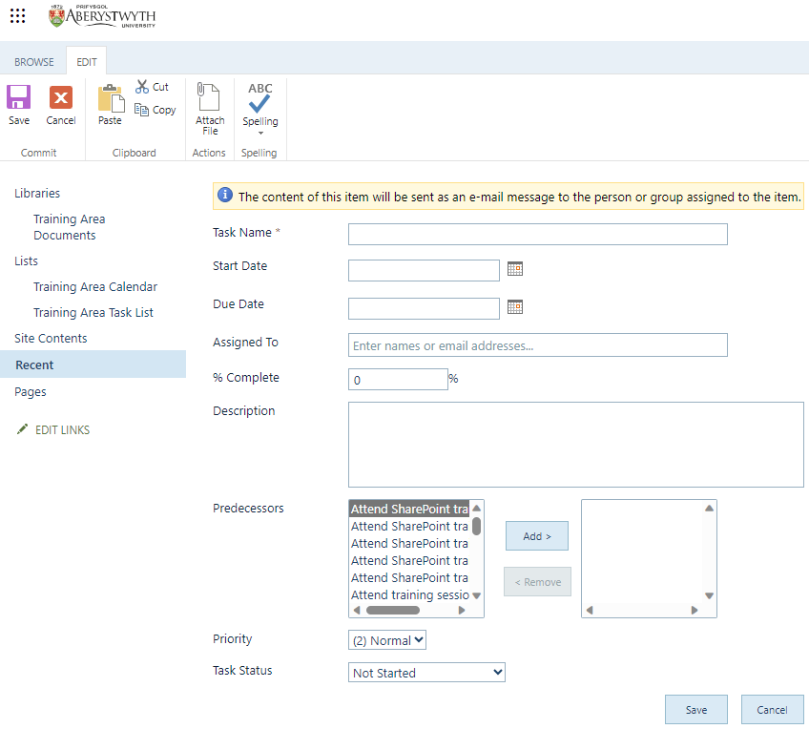
- Enter the details of the task:
  - Give the task a name
  - Give the task a start date and due date.
  - Assign the task to the person next to you, by typing their name or userid in the Assigned To box and choosing them from the list that appears.
  - Add a description of the task if required.
  - You can choose a ‘predecessor’ if required – this is a task that needs to have been done before this task can be started.
  - Choose a priority for the task.
- Click Save to finish.
- Your new task will now appear in the Task List:
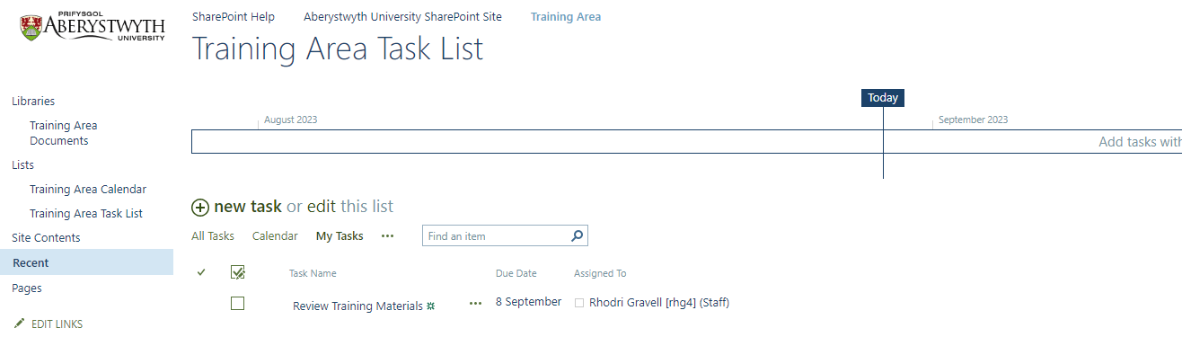

View tasks that have been assigned to you
- Click on the … at the top of the task list (next to All Tasks Calendar Completed) and choose ‘My Tasks’:
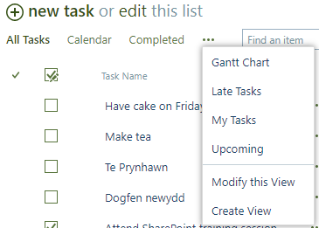
- Only the tasks that are assigned to you will be displayed:

Edit a Task that has been assigned to you
- Click on the name of a task to open it:
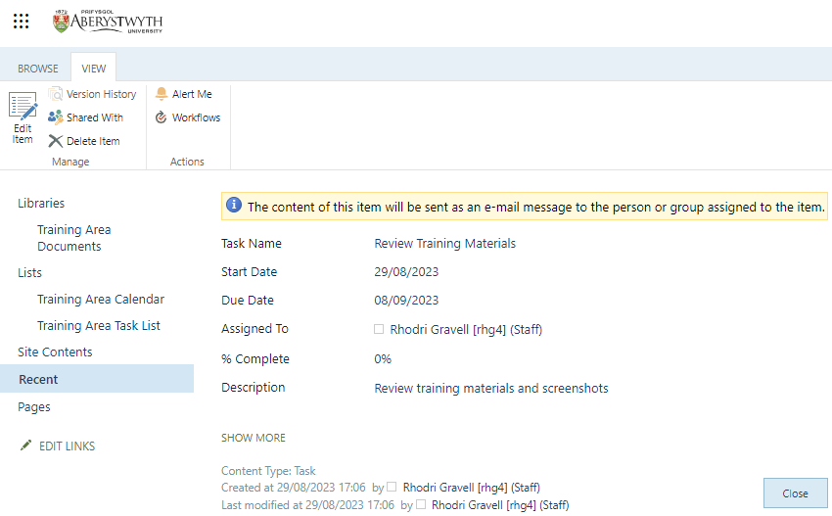
- Click the Edit Item button (top left).
- The Edit item screen will appear:
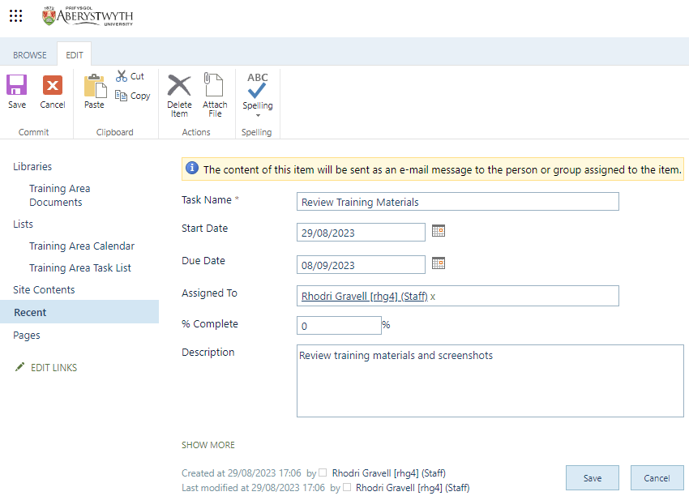
- Mark the task as completed by clicking ‘SHOW MORE’ then selecting ‘Completed’ from the Task Status drop-down list.
- Click Save to finish. The task will now show as crossed though.

