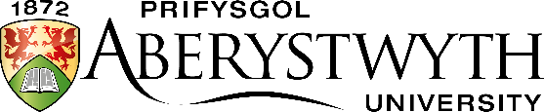 | Entrance Examination  May 2021
ART – PORTFOLIO

Submission Instructions

If you are applying to a degree scheme including Fine Art, you must submit a portfolio of your original artworks as one of your Entrance Exams. We are looking for work that shows a variety of media, techniques and subject matter, a strong aptitude for observational drawing and/or painting, and a wider interest in fine art through the study of art and artists, historical and contemporary.
A PowerPoint file of up to 20 of your self-selected best art works should be submitted to: Professor Robert Meyrick, rtm@aber.ac.uk, clearly marked ‘Entrance Scholarship Portfolio’ and including your full name and UCAS number. The submission deadline is 24 May 2021 & late submissions will not be accepted. PowerPoints may be sent by email attachment, or submitted online via Dropbox, WeTransfer or equivalent, or alternatively uploaded onto a personal webpage or Blog.
Please contact the School of Art with any submission queries: 01970 622460 / artschool@aber.ac.uk

