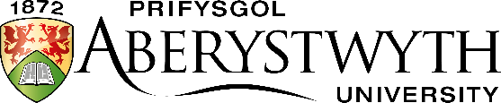 | Entrance Examination  May 2021
EDUCATION AND CHILDHOOD STUDIES

Time allowed: 1.5 hours (90 minutes)

Answer TWO questions

- There is no need for a curriculum for children under the age of 6. Discuss this statement.

- People who work in early years education and care often say that ‘there is no bad weather, there is only poor clothing’. What do you think this means? How true do you think it is?

- In the National Curriculum for England, there are two separate subjects: History and Geography. In the new National Curriculum for Wales, they are grouped with religion, business studies and social studies in an Area of Learning called Humanities. Which of these do you think is preferable? Why do you think this?

- Should A-level and GCSE grades depend on the teacher’s assessment only, exams only or a combination of the two? Give reasons for your answer.

- Too much of a distinction is made between vocational and academic subjects in secondary schools. Is this true? Why do you think this?

- Is parental involvement in a child’s education as important at sixteen as it is at six? Give reasons for your answer.

- Should children be allowed to bring their own lunch boxes to school, or should school lunches be provided? Discuss why people might answer Yes or No to this question.

- Should all schools have to follow the National Curriculum? Discuss this with reference to your own country.

