ENTRANCE SCHOLARSHIP EXAMINATION 2022

PHYSICS

Time Allowed – 1.5 hours

This examination paper consists of nine questions. Try to attempt at least eight of the nine questions, including Question 1, which has five sub questions. If you answer all the nine questions, the best eight will contribute to your overall mark.
Indicate each question number ahead of your working, and highlight your final numerical answers (including units) by, for example, underlining or framing them.
Marks will be awarded for correct approaches, thoughts, ideas, or methods, even if the final answer is missing or incorrect. No negative marks will be awarded for inaccurate or faulty arguments or incorrect answers.
Feel free to use any standard booklets of fundamental constants and/or formulas, provided by your school or the short list of constants and formulas below.
Any calculators are allowed to be used.

Fundamental Constants
Electron charge $e=1.60×10^{-19} C$
Electron mass $m_{e}=9.11×10^{-31} kg$
Gravitational constant $G=6.67×{10}^{-11} m^{3} kg^{-1} s^{-2}$
Plank’s constant $h=6.63×10^{-34} m^{2} kg s^{-1}$
Speed of light $c=3.00×10^{8} m s^{-1}$
Gas constant $R=8.31 J K^{-1} mol^{-1}$

Further Useful Constants
Gravitational acceleration $g=9.8 m s^{-2}$
Mass of an alpha particle $m_{α}=6.64×{10}^{-27} kg$
Boltzmann constant $k_{B}=1.38×{10}^{-23} J K^{-1}$
Astronomical unit $1 AU=1.5×{10}^{11} m$
Ångström $1 Å={10}^{-10} m$
Electronvolt $1 eV=1.6×{10}^{-19} J$
Avogadro number $N_{A}=6.22×{10}^{23} {mol}^{-1}$
Temperature conversion $T_{K}-T_{℃}=273.15$

Useful Formulas
$$PV=Nk_{B}T PV=nRT n=\frac{N}{N_{A}} M=\frac{m}{n}$$
$$ΔU=Q_{to gas}-W_{by gas} ΔU=cmΔT W_{by gas}=PΔV$$
$$v≡\frac{dx}{dt} a≡\frac{dv}{dt} ω=\frac{2π}{T}$$
$$s=s_{0}+ut+\frac{1}{2}{at}^{2} v=u+at a_{n}=\frac{v^{2}}{r}$$
$$y=u_{y}t-\frac{1}{2}gt^{2} x=u_{x}t$$
$$E_{kin}=\frac{1}{2}mv^{2}=\frac{p^{2}}{2m} E_{pot}=-\frac{GMm}{r} E_{pot}=mgh$$
$$F_{e}=k\frac{qQ}{r^{2}} F_{gr}=\frac{GMm}{r^{2}} {\vec{r}}_{cm}=\frac{\sum{m_{i}{\vec{r}}_{i}}}{\sum{m_{i}}}$$
$$E=hf c=λf λ_{0}=2L λ_{B}=\frac{h}{p} N=N_{0} 2^{- \frac{t}{T_{1/2}}}$$
$$F=PA E=mc^{2} g=\frac{GM}{r^{2}} ρ=\frac{m}{V} A=πr^{2}$$
$$V=IR q=CV E_{J}=Vq q=It q=Ne$$
$$P=IV=I^{2}R=\frac{V^{2}}{R} \sum{I{}_{i}}=0 \sum{V{}_{i}}=0 c=\frac{c_{vacuum}}{n}$$
$$\frac{1}{f}=\frac{1}{o}+\frac{1}{i} M=\frac{i}{o} n_{1}\sin{ α_{1}}=n_{2}\sin{α_{2}}$$
$$N_{n}m_{n}c^{2}+N_{p}m_{p}c^{2}=m_{nucleus}c^{2}+U_{binding}$$

Question 1
A sealed, leak-proof, heat engine contains $n=2.5 mol$ nitrogen gas, which is taken around the cycle: $A→B→C→D→A$
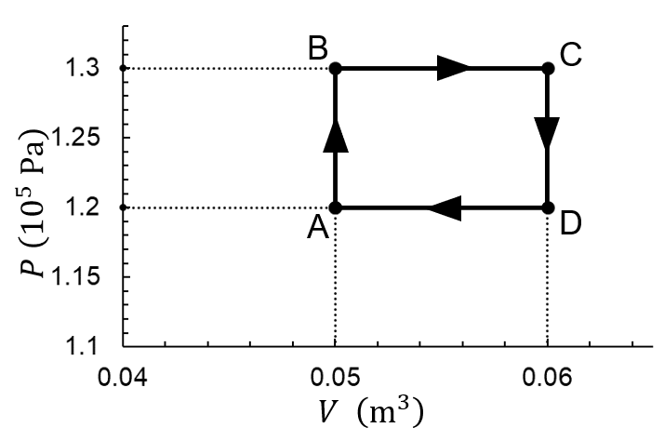
a) Using the ideal gas equation, calculate the gas temperature at the four stages of the cycle. (Gas constant: $R=8.31 J K^{-1} mol^{-1}$) [5]

b) Determine the internal energy of the gas at the four (A, B, C, and D) stages.
(For a diatomic gas, the internal energy is: $U=\frac{5}{2}nRT$) [5]

c) Find the work done by the gas during each of the four processes:
$W_{A→B}$, $W_{B→C}$,$W_{C→D}$, and$W_{D→A}$ [5]

d) Based on the first law of thermodynamics, work out the heat absorbed or emitted by the gas during each of the four processes: $Q_{A→B}$, $Q_{B→C}$,$Q_{C→D}$, and$Q_{D→A}$ [5]

e) The efficiency, $e$, of a heat engine is the ratio between the net work done by the gas and the heat absorbed by the gas during a cycle. Calculate the efficiency of the heat engine. [5]

Question 2
After jumping, a person lands on a mat at speed $v=6.3 m s^{-1}$ and comes to rest in a time of $t=0.34 s$. The mean force exerted by the mat on the person is $F=1280 N$.
Determine how heavy (mass) the person is. [5]

Question 3
An object of height $h=5 cm$ is placed at $s=30 cm$ in front of a thin double-convex lense of focal length $f=10 cm$.
Find the size and the position of the image.
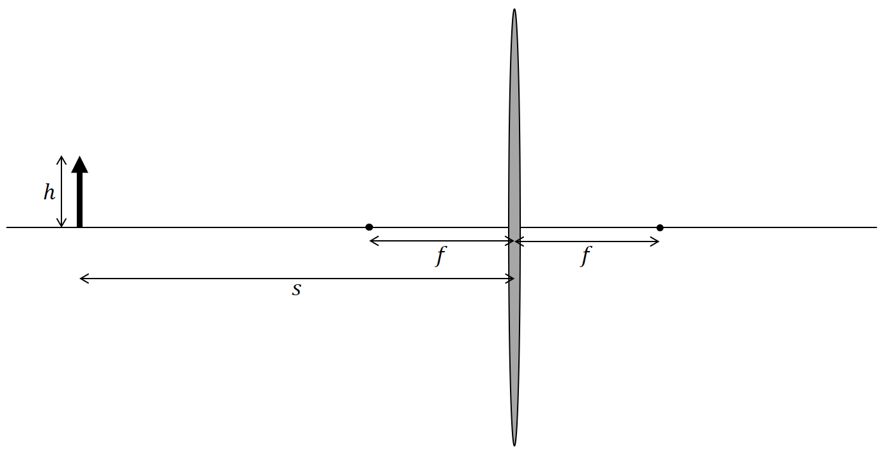
[5]

Question 4
An object with mass $m=11 kg$ is shot upwards from the surface of Mars at a speed of $v=12 m s^{-2}$. Calculate the height the object can reach by using that the mass and diameter of Mars are $M=6.39×{10}^{23} kg$ and $D=6779 km$.
[5]

Question 5
Material A is radioactive and decays into material B, which is stable. A closed tank contains a mixture of the two materials. Initially, the amount of material A is three times that of material B, $N_{A0}=3N_{B0}$. One hour later, there are three times more material B in the mixture than material A, $N_{B}=3N_{A}$. Determine the half-life of the radioactive material.
[5]

Question 6
A block of mass $m=2 kg$ is hanging from a uniform rod of length $L=1400 mm$ at $l_{2}=300 mm$ from a pivot point on which the rod is balancing. The pivot point is at $l_{1}=900 mm$ from the other end of the rod (see the illustration).
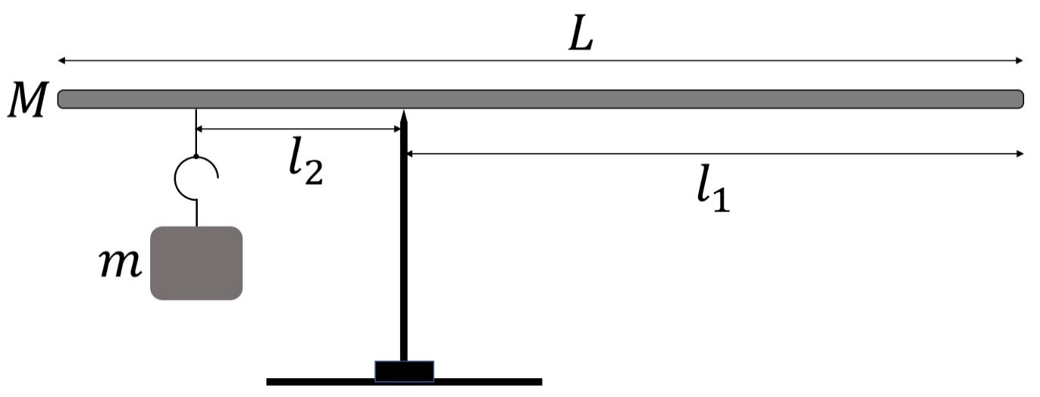
Determine the mass of the rod.
[5]

Question 7
In a circuit (see below), $R_{1}$ is a variable resistor. When it is at the position shown in Figure 1A, the currents measured by the two ammeters $A_{1}$ and $A_{2}$ are:
$I_{1}=3 mA$ and $I_{2}=2 mA$
Using Kirchhoff’s current law and voltage law, determine currents $I_{3}$ and $I_{4}$, measured by the two ammeters, $A_{3}$ and $A_{4}$, when the variable resistor is at the position shown in Figure 1B.
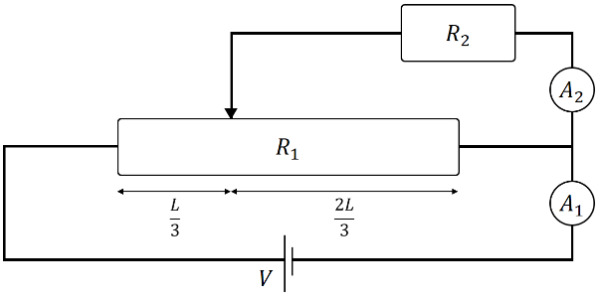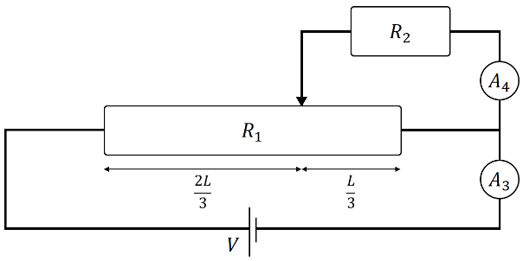
Figure 1A Figure 1B
[5]

Question 8

During the fusion of carbon and helium into oxygen:
$${}_{6}^{12}C+{}_{2}^{4}{He}→{}_{8}^{16}O$$
$U=7.16 MeV$ energy is released.
The masses of carbon and helium nuclei, proton, and neutron are $m_{C}=4.0015 u$ and $m_{He}=11.9967 u$, $m_{p}=1.0073 u$, and $m_{n}=1.0087 u$. One unit is: $1 u=931 MeV$
Determine the binding energy of the oxygen nucleus.
[5]

Question 9
There is a position between the Earth and the Moon where the net gravitational force of the Earth and the Moon on an obejct would be zero. Find the distance of that place from the Moon. (Earth’s mass: $m_{E}=5.97×{10}^{24} kg$; Moon’s mass: $m_{M}=7.35×{10}^{22} kg$; distance between Earth and Moon: $D=384 400 km$)
[5]

- End of Questions -

