Ysgrifennu ac ailysgrifennu’r gorffennol: Pat Barker, Regeneration (1991)

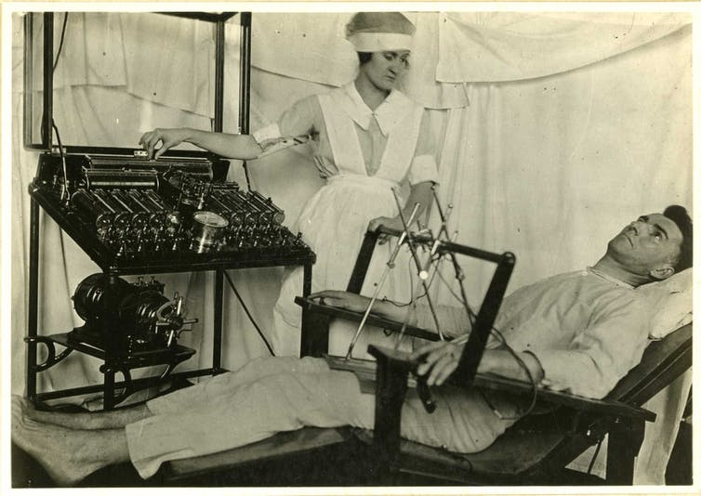

Mae’r ddwy dasg hyn yn gofyn i fyfyrwyr ddarllen detholiadau o Regeneration ochr yn ochr â deunydd ffynhonnell hanesyddol y tynnodd Pat Barker arno wrth ysgrifennu’r nofel, a meddwl am beth sy’n digwydd pan gaiff hanes ei ‘drosi’ yn ffuglen: pa gwestiynau moesegol a llenyddol mae hyn yn eu codi? Gellir gwneud hyn gyda’i gilydd neu ar wahân.
Dr Tasha Alden, Adran Saesneg ac Ysgrifennu Creadigol, Prifysgol Aberystwyth (nla@aber.ac.uk)

Tasg A:
Darllenwch bennod 21 Regeneration (mae’n fyr!) a thudalennau 7-15 o gyfrol y meddyg Rhyfel Byd Cyntaf Lewis Yealland ar ei ddefnydd o therapi sioc drydanol gyda milwyr oedd wedi dioddef siel-syfrdandod, Hysterical Disorders of Warfare (1918), sydd ar gael yma: https://archive.org/details/hystericaldisord00yealuoft/page/6/mode/2up.

Cwestiynau:
- Pam allai Pat Barker fod wedi dewis seilio ei hanes mor fanwl ar gofnodion Yealland?
- Beth yw’r gwahaniaethau allweddol rhwng y ddau hanes? Gallai’r canlynol fod ymhlith y pethau i feddwl amdanyn nhw:
  - Traethu – sut mae’r dechneg adrodd stori (llais, safbwynt, pwyslais ac ati) yn newid rhwng y testun meddygol a’r nofel?
  - Sut mae Barker wedi newid y digwyddiadau? Pam? Beth yw effaith, er enghraifft, ei newidiadau i’r darn am y ‘long pharyngeal electrode’ (Regeneration t. 230, Yealland t. 9).
  - Beth yw’r newidiadau o ran tôn? Beth yw eu heffaith?
  - Sut mae iaith yn cael ei defnyddio’n wahanol yn y ddau i effeithio – neu efallai ddylanwadu – ar y darllenydd?
  - Beth mae’r cwestiynau hyn yn ei ddatgelu am
1) Agwedd Pat Barker at ryfel; beth yw’r pwynt mae hi’n defnyddio’r deunydd hanesyddol hwn i’w wneud?
2) Yn ehangach, beth mae’n ei ddweud wrthym ni am yr hyn mae ffuglen hanesyddol yn gallu ei wneud gyda hanes, nad yw hanes ei hun ddim yn gallu ei wneud? Pa fath o honiadau am y gwirionedd mae’r nofel hanesyddol yn eu gwneud? Sut mae’n wahanol i fathau eraill o ysgrifennu hanesyddol? Ydych chi’n meddwl bod Barker yn iawn i wneud y newidiadau mae hi’n eu gwneud (fel cyfuno dau achos) ai peidio? Pam?

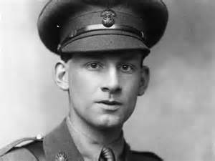
Siegfried Sassoon (1886-1967)

Tasg B:

Darllenwch bapur Rivers ‘Repression of War Experience’ (ar gael ar-lein: http://net.lib.byu.edu/estu/wwi/comment/rivers.htm), a cherdd Siegfried Sassoon ‘Repression of War Experience’ (isod). Nawr darllenwch y rhannau am Burns yn Regeneration (tudalennau 17-19, 37-40, 47-48).

Cwestiynau:
- Nodwch dri gwahaniaeth allweddol rhwng ymateb Sassoon a Barker i bapur Rivers. Gallech ddymuno meddwl am y defnydd o safbwynt, cymeriadu, ffurf.
- Pa un sydd well gennych chi? Pa un sydd agosaf at bapur Rivers a pham?
- A yw’n gwneud gwahaniaeth fod un o’r ymatebion hyn yn dod gan ddyn, oedd yn adnabod Rivers yn bersonol ac yn ffrind iddo, yn ysgrifennu ym mis Gorffennaf 1917, a bod y llall gan fenyw, na chafodd gyfarfod â Rivers erioed, yn ysgrifennu yn y mil naw nawdegau? Pa fath o wahaniaeth allai’r ffactorau hyn ei wneud?

Repression of War Experience

Now light the candles; one; two; there's a moth;
What silly beggars they are to blunder in
And scorch their wings with glory, liquid flame—
No, no, not that,—it's bad to think of war,
When thoughts you've gagged all day come back to scare you;
And it's been proved that soldiers don't go mad
Unless they lose control of ugly thoughts
That drive them out to jabber among the trees.

Now light your pipe; look, what a steady hand.
Draw a deep breath; stop thinking; count fifteen,
And you're as right as rain ...
Why won't it rain? ...
I wish there'd be a thunder-storm to-night,
With bucketsful of water to sluice the dark,
And make the roses hang their dripping heads.

Books; what a jolly company they are,
Standing so quiet and patient on their shelves,
Dressed in dim brown, and black, and white, and green,
And every kind of colour. Which will you read?
Come on; O do read something; they're so wise.
I tell you all the wisdom of the world
Is waiting for you on those shelves; and yet
You sit and gnaw your nails, and let your pipe out,
And listen to the silence: on the ceiling
There's one big, dizzy moth that bumps and flutters;
And in the breathless air outside the house
The garden waits for something that delays.
There must be crowds of ghosts among the trees,—
Not people killed in battle,—they're in France,—
But horrible shapes in shrouds--old men who died
Slow, natural deaths,—old men with ugly souls,
Who wore their bodies out with nasty sins.

* * *

You're quiet and peaceful, summering safe at home;
You'd never think there was a bloody war on! ...
O yes, you would ... why, you can hear the guns.
Hark! Thud, thud, thud,—quite soft ... they never cease—
Those whispering guns—O Christ, I want to go out
And screech at them to stop—I'm going crazy;
I'm going stark, staring mad because of the guns.

O: Siegfried Sassoon, Counter-attack, and Other Poems (1918)

