Writing and rewriting the past: Pat Barker, Regeneration (1991)

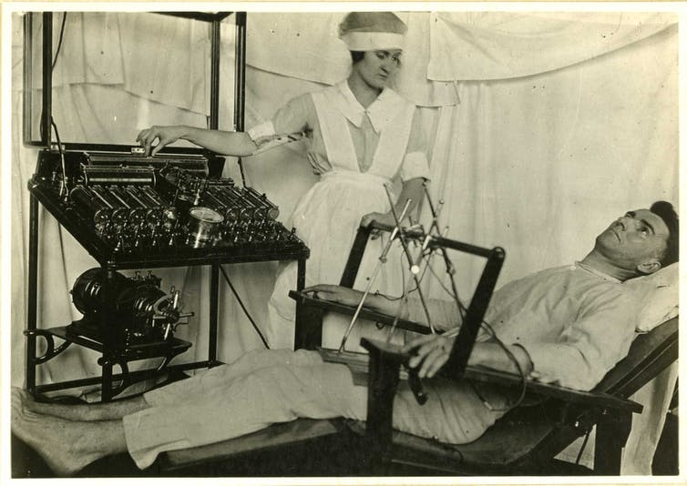

These two tasks ask students to read sections of Regeneration alongside some of the historical source material that Pat Barker drew on when writing the novel, and to think about what happens when history is ‘translated’ into fiction: what ethical and literary questions does this raise? They can be done together or separately.
Dr Tasha Alden, Department of English and Creative Writing, Aberystwyth University (nla@aber.ac.uk)

Task A:
Read chapter 21 of Regeneration (it’s short!) and pages 7-15 of the First World War doctor Lewis Yealland’s book on his use of electric shock therapy with shell-shocked soldiers, Hysterical Disorders of Warfare (1918), available here: https://archive.org/details/hystericaldisord00yealuoft/page/6/mode/2up.

Questions:
- Why might Pat Barker have chosen to base her account so closely on Yealland’s accounts?
- What are the key differences between these two accounts? Things to think about might include:
  - Narration – how does the narrative technique (voice, point of view, emphasis, etc) change between the medical text and the novel?
  - What changes has Barker made to events? Why? What is the effect of, say, her changes to the passage about the ‘long pharyngeal electrode’ (Regeneration p. 230, Yealland p. 9).
  - What changes in tone are made? What is their effect?
  - How is language used differently in each to affect – or maybe manipulate? – the reader?
  - What do these questions reveal about
1) Pat Barker’s attitude towards war: what point is she using this historical material to make?
2) More broadly, what does it tell us about what historical fiction can do with history that history itself can’t? What sort of truth claims does the historical novel make? How is it different from other forms of historical writing? Do you think Barker is justified in making the changes she does (such as combining two cases), or not? Why?

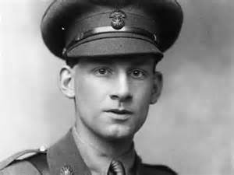
Siegfried Sassoon (1886-1967)

Task B:

Read Rivers’ paper ‘Repression of War Experience’ (available online at http://net.lib.byu.edu/estu/wwi/comment/rivers.htm), and Siegfried Sassoon’s poem ‘Repression of War Experience’ (below). Now read the sections on Burns in Regeneration (pages 17-19, 37-40, 47-48).

Questions:
- Identify three key differences between Sassoon and Barker’s response to Rivers’ paper. You might want to think about the use of point of view, of characterisation, of form.
- Which do you prefer? Which is closer to Rivers’ paper, and why?
- Does it make a difference that one of these responses is by a man, who knew Rivers personally and his friend, writing in July 1917, and one is by a woman, who never met Rivers, writing in the nineteen nineties? What sort of differences might these factors make?

Repression of War Experience

Now light the candles; one; two; there's a moth;
What silly beggars they are to blunder in
And scorch their wings with glory, liquid flame—
No, no, not that,—it's bad to think of war,
When thoughts you've gagged all day come back to scare you;
And it's been proved that soldiers don't go mad
Unless they lose control of ugly thoughts
That drive them out to jabber among the trees.

Now light your pipe; look, what a steady hand.
Draw a deep breath; stop thinking; count fifteen,
And you're as right as rain ...
Why won't it rain? ...
I wish there'd be a thunder-storm to-night,
With bucketsful of water to sluice the dark,
And make the roses hang their dripping heads.

Books; what a jolly company they are,
Standing so quiet and patient on their shelves,
Dressed in dim brown, and black, and white, and green,
And every kind of colour. Which will you read?
Come on; O do read something; they're so wise.
I tell you all the wisdom of the world
Is waiting for you on those shelves; and yet
You sit and gnaw your nails, and let your pipe out,
And listen to the silence: on the ceiling
There's one big, dizzy moth that bumps and flutters;
And in the breathless air outside the house
The garden waits for something that delays.
There must be crowds of ghosts among the trees,—
Not people killed in battle,—they're in France,—
But horrible shapes in shrouds--old men who died
Slow, natural deaths,—old men with ugly souls,
Who wore their bodies out with nasty sins.

* * *

You're quiet and peaceful, summering safe at home;
You'd never think there was a bloody war on! ...
O yes, you would ... why, you can hear the guns.
Hark! Thud, thud, thud,—quite soft ... they never cease—
Those whispering guns—O Christ, I want to go out
And screech at them to stop—I'm going crazy;
I'm going stark, staring mad because of the guns.

From: Siegfried Sassoon, Counter-attack, and Other Poems (1918)

