Aberystwyth University
Department of English and Creative Writing
Dr Tasha Alden (nla@aber.ac.uk)

‘He could not escape those very words’: Dorothy and William Wordsworth – from journal to poem
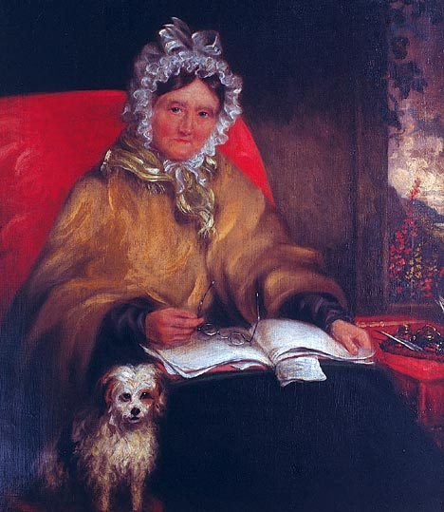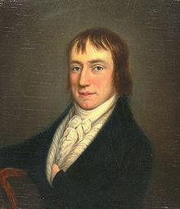
This session asks you to consider the extent, and nature, of William Wordsworth’s (1770 -1850) debt to his sister Dorothy Wordsworth (1771 – 1855), by making a comparative analysis of one of his poems and one of her journal entries. You’ll be asked to consider the larger literary and ethical questions about authorship, originality, and gender politics that arise from this.

Introduction:
It is often suggested that the source for many of William Wordsworth’s poems lies in the pages of Dorothy Wordsworth’s journal. Quite frequently, Dorothy describes an incident in her journal, and William writes a poem about the same incident, often around two years later (all the material discussed here is in The Grasmere and Alfoxden Journals, ed. Pamela Woof, Oxford University Press 2002).
For example, on October 3rd 1800, William and Dorothy together encountered an old man gathering leeches (Woof, 23-4); during the period May to June 1802, William wrote a poem called ‘The Leach Gatherer’, which he later gave the slightly more grandiose title ‘Resolution and Independence’. In the poem, the meeting is presented as a solitary encounter, with Dorothy written out (“I was a traveller then upon the moor”).
Another example, and the best known one: on April 15th 1802, William and Dorothy walked by Eusemere and came across a long belt of daffodils, which, in Dorothy’s words, “tossed and reeled and danced” (Woof, 85). Two years later, William wrote a poem “I wandered lonely as a cloud…” using Dorothy’s journal account, but again – why? – writing her out of the scene (“lonely as a cloud”...).
A final example – on May 27th 1800, Dorothy opened the door of their cottage ‘to a very tall woman, much beyond the measure of tall women’, and described the ensuing encounter in her journal (Woof, 9-10). There is no indication that William saw this person at all, but on March 13th 1802 Dorothy read her account of the meeting to him, and ‘an unlucky thing it was, for he could not escape those very words, and so he could not write the poem’ (Woof, 77. My italics). In fact, the poem, titled ‘Beggars’, was finished the following day.
William’s inability to escape from Dorothy’s words may partly be due to the fact that he had not seen the woman himself, yet once again, Dorothy is written out of the incident, and the encounter becomes a solitary one, transferred from their cottage door to the open countryside.
The question is, simply, whose poem is ‘Beggars’? Here is Dorothy’s journal entry (extract 1), followed by William’s poem (extract 2).

Extract 1:
On Tuesday, May 27th, a very tall dark women, tall much beyond the measure of tall women, called at the door. She had on a very long brown cloak, & a very white cap without Bonnet – her face was excessively brown, but it had plainly once been fair. She led a little bare footed child about 2 years by the hand & said her husband who was a tinker was gone before with the other children. I gave her a piece of Bread. Afterwards on my road to Ambleside, beside the Bridge at Rydale, I saw her husband sitting by the road-side, his two asses feeding beside him & the two young children at play upon the grass. The man did not beg – I passed on & about ¼ of a mile further I saw two boys before me, one about 10 the other about 8 years old at play chasing a butterfly. They were wild figures, not very ragged, but without shoes & stockings; the hat of the elder was wreathed round with yellow flowers, the younger whose hat was only a rimless crown, had stuck it round with laurel leaves. They continued at play till I drew very near & then they addressed me with the Begging cant & whining voice of sorrow – I said I served your Mother this morning (The Boys were so like the women who had called at the door that I could not be mistaken.) – O! says the elder you could not serve my mother for she’s dead & my father’s on at the next town – he’s a potter – I persisted in my assertion & that I would give them nothing. Says the elder Come, let’s ‘away’ & away they flew like lightening. They had however sauntered so long in their road that they did not reach Ambleside before me, & I saw them go up to Matthew Harrison’s house with their wallet upon the elder’s shoulder, & creeping with a Beggars complaining foot. On my return through Ambleside I met in the street the mother driving her asses; in the two Panniers of one of which were the two little children whom she was chiding & threatening with a wand which she used to drive on her asses, while the little things hung in wantonness over the Panniers edge. The woman had told me in the morning that she was of Scotland, which her accent fully proved, but that she had lived (I think at Wigton) that they could not keep a house, & so they travelled.

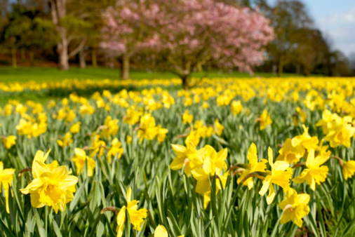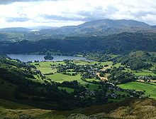

Extract 2:
‘Beggars’
She had a tall Man's height, or more;
No bonnet screen'd her from the heat;
A long drab-colour'd Cloak she wore,
A Mantle reaching to her feet:
What other dress she had I could not know;
Only she wore a Cap that was as white as snow.
In all my walks, through field or town,
Such Figure had I never seen:
Her face was of Egyptian brown:
Fit person was she for a Queen, . . . . . . . . . . . . 10
To head those ancient Amazonian files:
Or ruling Bandit's Wife, among the Grecian Isles.
Before me begging did she stand,
Pouring out sorrows like a sea;
Grief after grief:--on English Land
Such woes I knew could never be;
And yet a boon I gave her; for the Creature
Was beautiful to see; a Weed of glorious feature!
I left her, and pursued my way;
And soon before me did espy . . . . . . . . . . . . 20
A pair of little Boys at play,
Chasing a crimson butterfly;
The Taller follow'd with his hat in hand,
Wreath'd round with yellow flow'rs, the gayest of the land.
The Other wore a rimless crown,
With leaves of laurel stuck about:
And they both follow'd up and down,
Each whooping with a merry shout;
Two Brothers seem'd they, eight and ten years old;
And like that Woman's face as gold is like to gold. . . . . . . 30
They bolted on me thus, and lo!
Each ready with a plaintive whine;
Said I, "Not half an hour ago
Your Mother has had alms of mine."
"That cannot be," one answer'd, "She is dead."
"Nay but I gave her pence, and she will buy you bread."
"She has been dead, Sir, many a day."
"Sweet Boys, you're telling me a lie";
"It was your Mother, as I say--"
And in the twinkling of an eye, . . . . . . 40
"Come, come!" cried one; and, without more ado,
Off to some other play they both together flew.

Discussion: Whose poem is ‘Beggars’?
In considering the extent of William’s debt to Dorothy you need to ask:
- How far does he succeed in ‘escaping those very words’? (Does he need to?)
- How far is he dependent on her treatment of the subject more generally?
Try to identify and comment upon:
- Close verbal similarities between the two texts – what sort of language do they use? Similar, or not? Why? What’s the effect?
- More general similarities – point of view, emphasis on certain aspects, tone.
- Significant dissimilarities between the two – i.e. William’s omissions, additions, re-ordering and alterations (i.e. he changes the location of the meeting – why?). Why does he do this, and to what effect? How do their attitudes to the woman and the children differ?

