Prifysgol Aberystwyth
Adran Saesneg ac Ysgrifennu Creadigol
Dr Tasha Alden (nla@aber.ac.uk)

‘He could not escape those very words’: Dorothy a William Wordsworth – o’r dyddiadur i’r cerddi
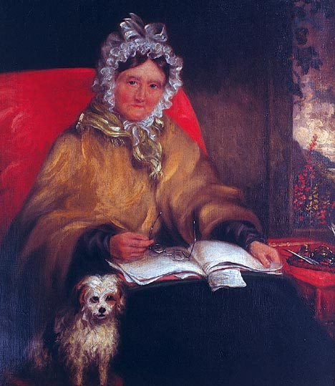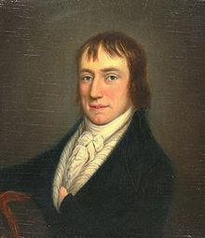
Mae’r sesiwn hon yn gofyn i chi ystyried maint a natur dyled William Wordsworth (1770 -1850) i’w chwaer Dorothy Wordsworth (1771 - 1855), drwy wneud dadansoddiad cymharol o un o’i gerddi ac un o’i chofnodion dyddiadur hi. Bydd gofyn i chi ystyried y cwestiynau llenyddol a moesegol mwy am awduraeth, gwreiddioldeb a gwleidyddiaeth rhywedd sy’n codi o hyn.

Cyflwyniad:
Awgrymir yn aml bod ffynhonnell llawer o gerddi William Wordsworth i’w gweld yn nhudalennau dyddiadur Dorothy Wordsworth. Yn aml iawn, bydd Dorothy’n disgrifio digwyddiad yn ei dyddiadur, a bydd William yn ysgrifennu cerdd am yr un digwyddiad, ond yn gwneud hynny ryw ddwy flynedd yn ddiweddarach (mae’r holl ddeunydd a drafodir yma yn The Grasmere and Alfoxden Journals, gol. Pamela Woof, Oxford University Press 2002).
Er enghraifft, ar Hydref 3 1800, cyfarfu William a Dorothy gyda’i gilydd â hen ddyn yn casglu gelod (Woof, 23-4); yn y cyfnod rhwng mis Mai a mis Mehefin 1802, ysgrifennodd William gerdd o’r enw ‘The Leach Gatherer’, gan newid y teitl yn ddiweddarach i fod ychydig yn fwy mawreddog: ‘Resolution and Independence’. Yn y gerdd, cyflwynir y cyfarfyddiad fel un gyda William yn unig, heb unrhyw sôn am Dorothy (“I was a traveller then upon the moor”).
Enghraifft arall, a’r un mwyaf adnabyddus: ar Ebrill 15, 1802, roedd William a Dorothy yn cerdded ger Eusemere a daethon nhw ar draws stribyn hir o gennin pedr, a disgrifiodd Dorothy y blodau gyda’r geiriau “tossed and reeled and danced” (Woof, 85). Ddwy flynedd yn ddiweddarach, ysgrifennodd William gerdd “I wandered lonely as a cloud…” yn defnyddio cofnod dyddiadur Dorothy, ac unwaith eto – pam? – gadawodd hi allan yn llwyr (“lonely as a cloud”...).
Un enghraifft olaf - ar Mai 27 1800, agorodd Dorothy ddrws eu bwthyn, ac yno roedd ‘a very tall woman, much beyond the measure of tall women’, a disgrifiodd y cyfarfyddiad yn ei dyddiadur (Woof, 9-10). Does dim arwydd bod William wedi gweld y person o gwbl, ond ar Fawrth 13 1802 darllenodd Dorothy ei chofnod o’r cyfarfod iddo, ac ‘an unlucky thing it was, for he could not escape those very words, and so he could not write the poem’ (Woof, 77. Fy italig i). Mewn gwirionedd, cwblhawyd y gerdd, o’r enw ‘Beggars’, y diwrnod canlynol.
Efallai nad oedd William yn gallu dianc o eiriau Dorothy am nad oedd wedi gweld y fenyw ei hun, ond unwaith eto caiff Dorothy ei hepgor o’r digwyddiad, a chyfarfyddiad â William yn unig yw hwn, wedi’i drosglwyddo o ddrws eu bwthyn i gefn gwlad.
Y cwestiwn yn syml yw cerdd pwy yw ‘Beggars’? Dyma gofnod dyddiadur Dorothy (detholiad 1), ac yna gerdd William (detholiad 2).

Detholiad 1:
On Tuesday, May 27th, a very tall dark women, tall much beyond the measure of tall women, called at the door. She had on a very long brown cloak, & a very white cap without Bonnet – her face was excessively brown, but it had plainly once been fair. She led a little bare footed child about 2 years by the hand & said her husband who was a tinker was gone before with the other children. I gave her a piece of Bread. Afterwards on my road to Ambleside, beside the Bridge at Rydale, I saw her husband sitting by the road-side, his two asses feeding beside him & the two young children at play upon the grass. The man did not beg – I passed on & about ¼ of a mile further I saw two boys before me, one about 10 the other about 8 years old at play chasing a butterfly. They were wild figures, not very ragged, but without shoes & stockings; the hat of the elder was wreathed round with yellow flowers, the younger whose hat was only a rimless crown, had stuck it round with laurel leaves. They continued at play till I drew very near & then they addressed me with the Begging cant & whining voice of sorrow – I said I served your Mother this morning (The Boys were so like the women who had called at the door that I could not be mistaken.) – O! says the elder you could not serve my mother for she’s dead & my father’s on at the next town – he’s a potter – I persisted in my assertion & that I would give them nothing. Says the elder Come, let’s ‘away’ & away they flew like lightening. They had however sauntered so long in their road that they did not reach Ambleside before me, & I saw them go up to Matthew Harrison’s house with their wallet upon the elder’s shoulder, & creeping with a Beggars complaining foot. On my return through Ambleside I met in the street the mother driving her asses; in the two Panniers of one of which were the two little children whom she was chiding & threatening with a wand which she used to drive on her asses, while the little things hung in wantonness over the Panniers edge. The woman had told me in the morning that she was of Scotland, which her accent fully proved, but that she had lived (I think at Wigton) that they could not keep a house, & so they travelled.

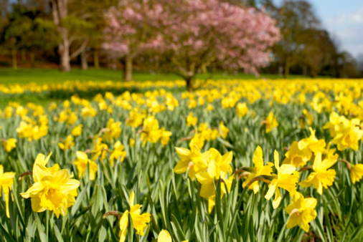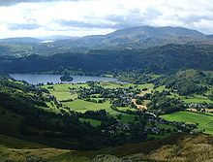

Detholiad 2:
‘Beggars’
She had a tall Man's height, or more;
No bonnet screen'd her from the heat;
A long drab-colour'd Cloak she wore,
A Mantle reaching to her feet:
What other dress she had I could not know;
Only she wore a Cap that was as white as snow.
In all my walks, through field or town,
Such Figure had I never seen:
Her face was of Egyptian brown:
Fit person was she for a Queen, . . . . . . . . . . . . 10
To head those ancient Amazonian files:
Or ruling Bandit's Wife, among the Grecian Isles.
Before me begging did she stand,
Pouring out sorrows like a sea;
Grief after grief:--on English Land
Such woes I knew could never be;
And yet a boon I gave her; for the Creature
Was beautiful to see; a Weed of glorious feature!
I left her, and pursued my way;
And soon before me did espy . . . . . . . . . . . . 20
A pair of little Boys at play,
Chasing a crimson butterfly;
The Taller follow'd with his hat in hand,
Wreath'd round with yellow flow'rs, the gayest of the land.
The Other wore a rimless crown,
With leaves of laurel stuck about:
And they both follow'd up and down,
Each whooping with a merry shout;
Two Brothers seem'd they, eight and ten years old;
And like that Woman's face as gold is like to gold. . . . . . . 30
They bolted on me thus, and lo!
Each ready with a plaintive whine;
Said I, "Not half an hour ago
Your Mother has had alms of mine."
"That cannot be," one answer'd, "She is dead."
"Nay but I gave her pence, and she will buy you bread."
"She has been dead, Sir, many a day."
"Sweet Boys, you're telling me a lie";
"It was your Mother, as I say--"
And in the twinkling of an eye, . . . . . . 40
"Come, come!" cried one; and, without more ado,
Off to some other play they both together flew.

Trafodaeth: Cerdd pwy yw ‘Beggars’?
Wrth ystyried maint dyled Wiliam i Dorothy, mae angen i chi ofyn:
- I ba raddau mae’n llwyddo i ‘escaping those very words’? (Oes angen iddo wneud?)
- I ba raddau mae’n dibynnu ar ei thriniaeth hi o’r pwnc yn fwy cyffredinol?
Ceisiwch nodi a gwneud sylwadau ar:
- Tebygrwydd geiriol agos rhwng y ddau destun - pa fath o iaith maen nhw’n ei ddefnyddio? Tebyg, ai peidio? Pam? Beth yw’r effaith?
- Tebygrwydd mwy cyffredinol – safbwynt, pwyslais ar agweddau penodol, tôn.
- Elfennau annhebyg rhwng y ddau - h.y. yr hyn mae William yn ei hepgor, ychwanegu, aildrefnu a newid (h.y. mae’n newid lleoliad y cyfarfod - pam?). Pam mae’n gwneud hyn, a beth yw’r effaith? Sut mae eu hagweddau at y fenyw a’r plant yn wahanol?

