Illustration of CAN requirements
Author: Jon Bell
Date: 29/08/02
Ref: SD/REQ/ILL/01

Introduction
This simple example system has been drawn to illustrate the need for some of the required extensions to the State Builder language for modelling CANbus systems. While the existing transmit and received methods have been used as a possible starting point, the extensions mean that the system cannot be simulated in its present form.

The most important additions that this system illustrates are the need for the tool to accommodate several transmitters and the need for a data type that allows the sender of a signal (or at least the signal’s nature and so it’s content’s meaning) to be identified.

The illustrative system
This is a simple example of a rather unlikely lighting circuit, with an automatic sensor that turns on dipped headlamps if the light falls below an unspecified threshold value.

It is intended to show the additions necessary to allow State Builder to model simple open loop systems that use CAN messages. The sensor is added simple to show the need for more than one transmitter, and so the need for receivers to distinguish sources of signals.

The schematic looks like this.

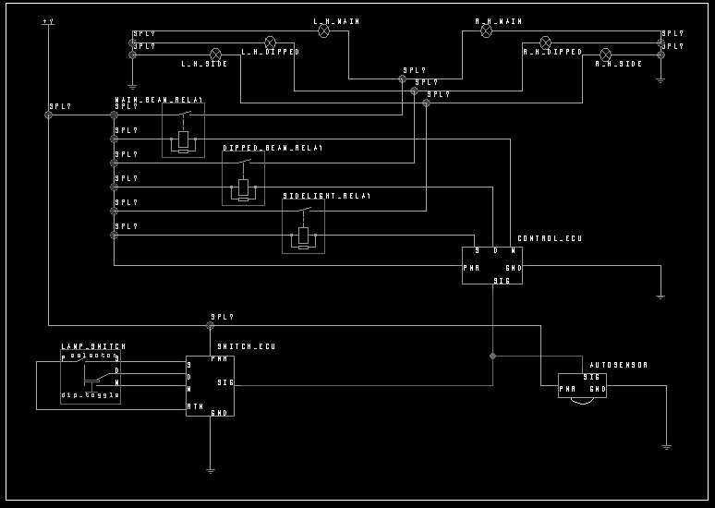

It is based on the traditional simple lighting ECU circuit with the addition of a sensor
(which is really a switch, to be changed by the user in running a simulation) and a network linking the three components – switch ECU, sensor and control ECU.

The switch is modelled on the light switch in my car – it uses a toggle action for dipping the headlamps, which are always dipped when first switched on.

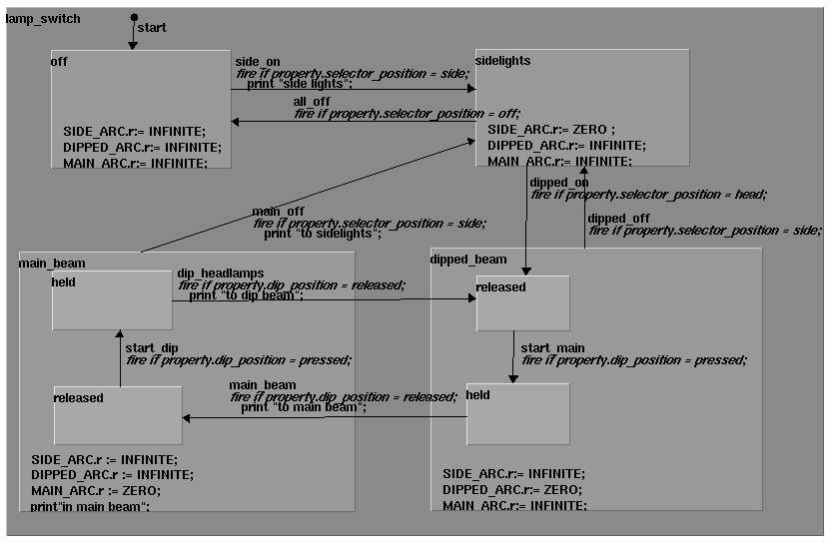

The print statements are not relevant here.

The switch has an associated ECU that “translates” its electrical state to network messages.

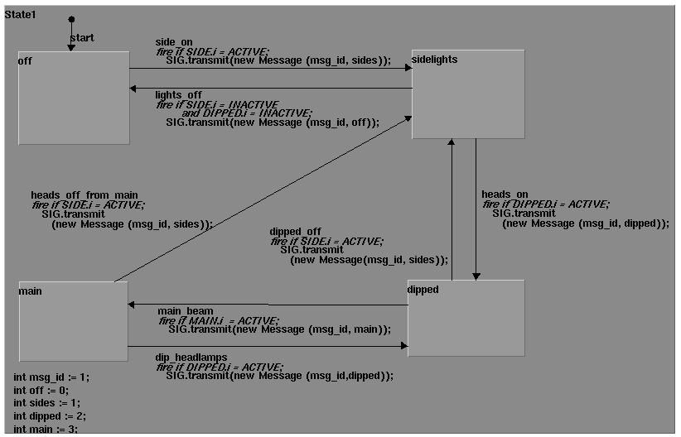

The proposed new data type, Message, has been used in the place of an integer, the existing transmit method being overloaded to allow the use of this type.

The other transmitter is the sensor. This sends a message when the light falls below a threshold, or when it rises above the threshold.

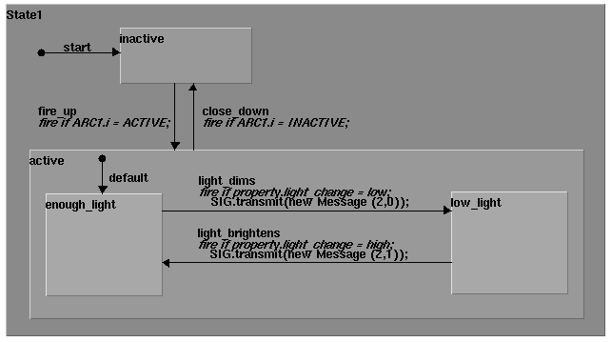

This also sends Messages, the only difference between this and the switch ECU, as far as the messages are concerned, being that the contents and identifier have not been defined as constants.

The control ECU has to receive and handle messages from both sources.

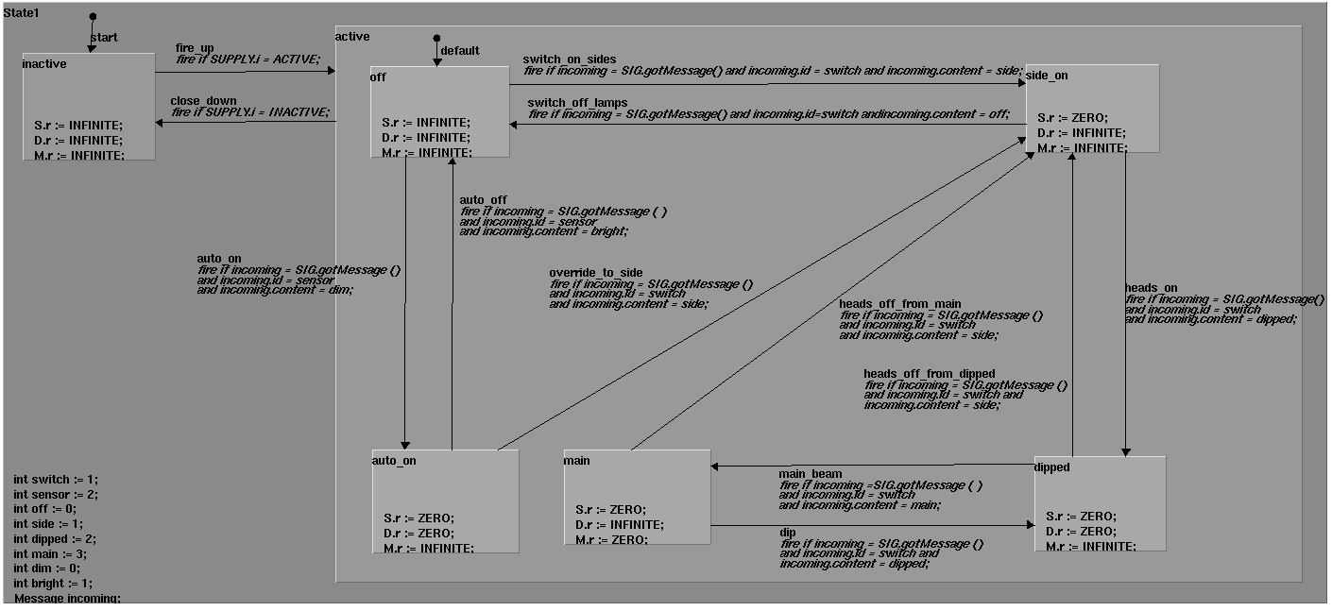

The main feature here is the use of a new method, gotMessage, that returns a message object. This rather elaborates the tests for firing transitions. An alternative might be to have gotMessage returning a Boolean and having that fire a transition to a “processing signal” state that actually handles the incoming message. The difficulty here would be the need to transfer the message itself.

A simple approach has been taken to the relationship between the automatic sensor and the driver’s control. The sensor is over-ridden if the driver’s control is not off. This leaves gaps, such as the fact that the headlamps cannot be switched to full beam if they have been automatically switched on. The state chart was getting quite complex enough, and is sufficient to illustrate the need for the new features.

This circuit is open loop, so there is no feedback, and because the sensor itself compares the light level with the threshold value, all messages are distinct. Indeed, all messages could be modelled as events and the approach suggested earlier, in which the ability of a state machine to pass events to other parts of the state machine could be used, by combining each component’s state chart into a composite state chart for the whole network side of the system, could be used despite its shortcomings.

It occurs that it might be possible to avoid the need for a message data type, by concatenating integers for identifier and content. In this case, for example, the identifiers are 1 and 2, and as no message content is greater than 9, we could multiply the identifier by 10 so the message switch, side could be represented by 11 and the message sensor, dim by 20, etc.

This is pretty problematic, but I imagine a user interface could be used to disguise this botch up, allowing the identifiers and contents to be specified separately. Does this avoid the need for any other changes to the language? If so, it might just be worth consideration as a quick and dirty first cut solution. It is still more accurate than using events, as was proposed earlier. The main difficulty is the fact that a communication network used by transmit and received has only one transmitter. One obvious difficulty is the implicit maximum range of content values, but for simple systems this might not be an impossible limitation. It could be made to work in this case, where the automatic sensor knows the threshold value, so sends messages to say it wants the lamps on or off (like a switch ECU) but it would be difficult if the sensor merely sent the current light level and the control ECU had to act on that, numerical, message whose range could not readily be restricted.

