Passing signals between state charts – a worked example
Author: Jon Bell
Date: 15/5/02
Ref: SD/TR/FSM/02

Introduction
This report discusses a simple worked example that illustrates the idea of adding signal passing between AQQA state machines. It can be read as a follow up to the earlier more theoretical report, Using a state machine language for behavioural modelling, ref SD/TR/FSM/01, in which this approach is introduced.

As the worked example uses the proposed additions to the StateBuilder language, allowing the passing of messages between components’ state charts, the example has, of course, been worked by hand. The state machines in the illustrations cannot be run using the present version of AQQA.

The working has been done with a view to tracing the effects of electrical faults rather than software faults (as specified for SoftFMEA workpackage 3). This method allows some modelling of network faults, and this will be discussed but it will be realised that any independent model of an individual electrical subsystem cannot manage detailed simulation of network signal collisions and arbitration. This is clearly a disadvantage from some viewpoints, but there is a slight compensatory advantage as the model is independent of the actual protocol – it could be used to model a system where the network was, say TTP/C.

The system
The system modelled is a version of the simple can front lamps system discussed in Proposed approaches to network simulation.
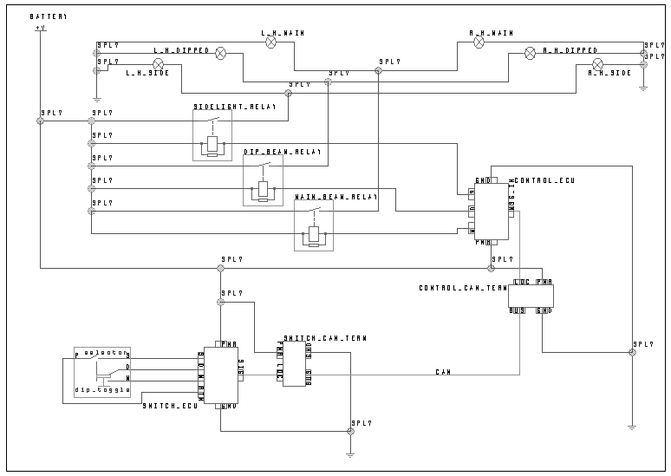
The most significant change is the modelling of the two CAN terminals as separate components. This is realistic as they will typically be separate components. However, I imagine they will be placed on a board with the associated ECU, so will perhaps be drawn as a lower level schematic, with the components combined at this top level. The jaguar schematics do not include the SCP terminals as separate components, but there are advantages in doing so.

As drawn here, the components have a separate power supply. Clearly, if this supply is omitted (as the CAN terminals themselves are not drawn) then failures to the supply cannot be included in an FMEA. Of course, if the CAN terminals are added to a PCB and are only separated from the ECU with which they share their PCB at a lower level in the schematic, modelling of power failures will depend on modelling of the PCB.

Modelling CAN terminals as separate components allows a generic CAN terminal to be re-used. This is useful as this is a correct model of terminal’s behaviour. There are matters arising from this, to be discussed later.

It is worth noting that using event passing (as illustrated in Proposed approaches to network simulation) fails if the CAN terminals are modelled as separate components, or at least requires a very cumbersome work around. This will be discussed later.

A minor change from the original can front lamps circuit worth pointing out is that the switch ECU has been given a switch return pin, so the switch is connected to the ECU, not to power. This is in line with the Jaguar schematic and allows simplification of the switch ECU state machine as there is no need for a distinct “power” arc.

This system has been chosen for its simplicity. One of the suggested advantages of modelling signal passing explicitly, as opposed to using event passing, is the improved support for modelling closed loop systems in which sensors pass data. This is important, but there are other difficulties with modelling closed loop systems, which this report will not address. If we cannot demonstrate the feasibility of signal passing for simple closed loop systems, the idea is a dead end. The fact that this system can be directly compared with the working of the example using event passing was also felt to be beneficial.

System behaviour
In this section, the behaviour of the interesting components will be described.

The switch is identical to that in the earlier version of CAN front lamps system discussed in Proposed approaches to network simulation. As all its interactions with the system are electrical (so will be modelled in the circuit’s structure), the changes to the state machine language do not affect this state machine. It is included here for completeness.

This is the existing state chart. The print statements were added because this state machine was used in Neal’s work. They are of no significance to the present system. This attempts to model the light switch in my car, where a rotary action is used to switch from “off” to “sides on” to “heads on” and a toggle switch dips the headlamps. The headlamps are always dipped on first switching on. There is no apparent interaction between the ignition and the light circuit (you can leave the lights on).
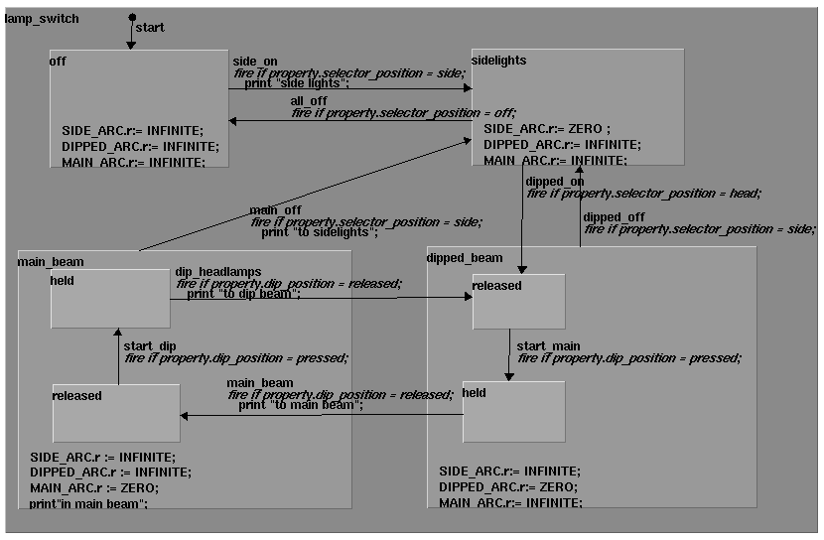

The light switch is connected electrically to the switch ECU.
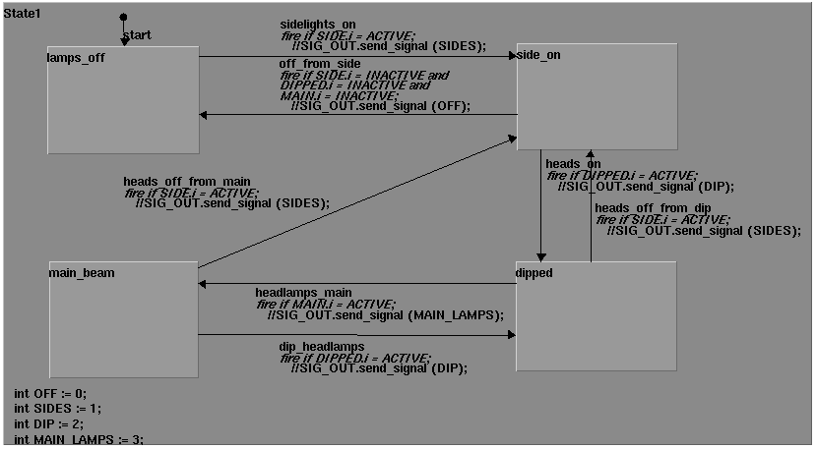
This state chart does not specify all possible behaviours, only those dictated by the correct behaviour of the switch. Therefore if the wire connecting the switch to the side pin goes open circuit, all lighting is disabled as we never enter the side_on state. The transitions’ actions have been commented out, as they are not part of the current state machine language. The syntax is based on that for the existing “transmit” method, which could be used for this state chart, but is inadequate for correct modelling of the CAN terminals. This method allows the user to specify the node (pin) which is to send the message, but only integer messages are supported. To model CAN (and other protocol) messages, we will need to add a message identifier field to the transmitted signal. There is a fuller discussion of the “transmit” and corresponding “received” methods later in this report.

The control ECU’s state chart mirrors that of the switch ECU, in much the same way as the two parts of the CAN side state chart do in the CAN front lamps circuit illustrated in proposed approaches to network simulation.
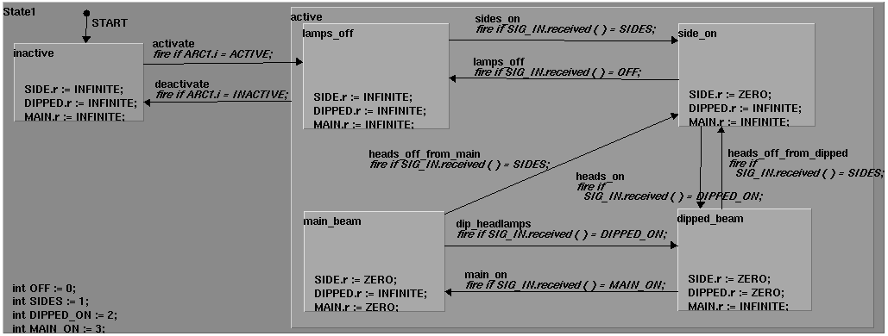
As the structure does not capture the electrical activity of the ECU, it is captured in the state chart by placing all the interesting behaviour in an “active” state.

As CAN terminals are standard “bought in” components, the same state chart should be usable for both. The one shown below is not perfect, but will serve to illustrate the additions needed to the state machine language.
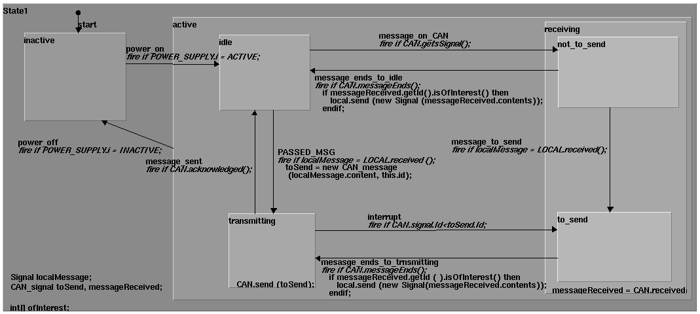
Note that there is no need for the CAN terminal to know the contents of the message as it merely relays them, adding a message id. The CAN terminal associated with the control ECU will, of course, never enter the toSend or transmitting states, as the ECU never sends data. Even though the switch ECU’s terminal never needs to pass a message on the ECU, it will still receive messages, all CAN messages being broadcast, it will at least need to monitor the network to check for interruptions to its own message. Some attempt has been made to explicitly model collisions in this state chart. Associated problems are discussed later, in the section on “Matters arising”.

To summarise the overall behaviour of the system, the user moves the switch (changes its input property), which in turn causes different electrical pins on the switch ECU to become active. This will cause the ECU to send a signal to the CAN terminal, containing (I imagine) an integer denoting the new switch position. The CAN terminal converts this signal to a CAN message (modelled in this case by adding the message id, the only necessary element) and tries to send the message. If the message is interrupted, it will try again. The receiving CAN terminal will then relay the message to the control ECU, which will change its state accordingly and allow the appropriate lights to come on. This state chart attempts to model collisions, and also models “full CAN” behaviour where only interesting message (those with the right ids) are passed to the associated ECU.

The transmit and received methods
As noted above, the existing state chart language has a facility for transmitting and receiving signals between state charts that must be connected by wires or nets. While this facility provides a possible starting point for the additions necessary, it does have several shortcomings from our point of view.

A state machine can specify a “transmit” action, called on a node (e.g. a pin). All that can be transmitted is an integer, and the corresponding “received” method returns an integer. The received method is also called on a node. The transmit action sends the transmitted value to all components with a node connected (by either a wire or a net) to the transmitting node, in what the AQQA help calls a “communications network”.

The transmit method will typically be called as an action associated with a transition, while the
received method will be used as a condition in firing a transition in the receiver’s state chart, along the lines of fire if IN.received ( ) = 0;. This is, of course, not ideal for the CAN terminals, which do not need to know the value of a signal, only that they have got one.

The way this facility associates a message with a node allows the local and CAN message to be readily distinguished on a CAN terminal. This seems useful, and more efficient than having to distinguish between messages by type.

According to the AQQA online help, a communications network can have one transmit node and zero or more receiver nodes. It is not clear whether this means that there can only ever be one transmitter on a network. If so, this is obviously inappropriate for modelling systems where more than one component transmits (such as the heater example). Multiple, isolated communications networks can be present in a schematic, so the example schematic is allowed. Activity of the network does not affect message passing, and neither do failures of network components, unless the failure mode has specific excluded (or corrupted) message passing. This seems to suggest that a wire going open circuit will not stop messages getting through, but this is to be checked. The facility can be used to trigger failure modes. I’m not sure how relevant this is, it is pointed out for completeness.

While it looks as though this facility might be a useful starting point for modelling CAN messages there are several shortcomings. The most important of these is the need for more elaborate data types in the signal - we need to model a CAN message with at least two integers, a value (the contents) and a message id. This is what is meant by the contents and id of the CAN signals in the CAN terminal state chart.

We also need to be able to use the arrival (or start) of any message as the trigger for a state transition, not its value. Using a value becomes impracticable if we are to deal with sensors that can send a range of values, and more so if the sensors might send wrong (out of range) values.

If we are to model the interactions of messages on the network (collisions and arbitration) than we cannot treat messages as atomic events, as the transmit/receive facility seems to do. There are some possibly interesting problems here, which I shall discuss further in the section on “Matters arising”.

The warnings in the on-line help about effects on component failures imply a need for a more formal relationship between the electrical (structural) and behavioural models of components. The idea that we can use a (qualitative) electrical simulator to send a (numerical) message seems odd. There is more discussion of this in section 6.1 but it could be argued that the lack of distinction between these models in the transmit facility exacerbates the problem.

Additions to the state chart language
In this section the necessary additions to the state machine language will be outlined. These are the additions necessary to make message passing work for this system. Most of these are illustrated in the state charts of the example system. Further matters arising will be discussed in the following section.

Data for messages
We clearly need to be able to send more than integers across the network. We need a data type to model a network message. This can be managed with two integers – one for the message contents and one for the message id. This would be appropriate for a CAN message, and I believe, for messages on the other protocols used in the automotive sector (such as Byteflight). We might either add a predefined “message” data type to model these messages (the “CAN_signal” data type in the example), or we might allow message to contain any (user defined) data type. This second approach will be more complicated, as checks will be needed to ensure that the message data type has the right attributes/methods.

In the example CAN terminal state chart a “Signal” data type has been included, but this need be no more than an integer for the message’s contents, as it is intended for modelling local messages between the ECU and its CAN terminal. Indeed, no such data type has been included in the ECU state charts, as the existing message (an integer) is sufficient there. One possible advantage of a specific data type might be that it triggers a received method without returning the value, as outline below.

New received method
We need the received method to simply return a Boolean allowing the arrival of the message to trigger a transition (or even the starting and ending of a message if the messages are not to be treated as atomic events). The existing transmit facility does this by having the received method return the value of the message but this is not useful as some transitions will be independent of the message’s value, and we might equally want to use the message id as its contents.

If we are to model messages as having some duration (to allow interruptions) we need separate methods to trigger transitions based on the start and end of a transmission. This is illustrated in the transitions between “idle” and “receiving”, for example. Related to this is the need to use an acknowledgement to show a message has been successfully transmitted. This is illustrated in the transition from “transmitting” to “idle” in the CAN state chart. To model arbitration we will need to be able to compare the ids of messages, as shown in the transition between “transmitting” and “to_send”.

Passing messages to the ECU
If the CAN terminal is to act as “full CAN” and only pass on the messages the associated ECU wants, it needs a way of storing the interesting message ids, so it can test all incoming messages for interest. This is indicated by having an array of integers in the CAN terminal state chart above, as the ECU might well be interested in messages from more than one source. This is perhaps more a property of the CAN terminal model than the state chart language. It looks likely that we can use a standard model for a CAN terminal, but will need to initialise each instance with the interesting message ids.

Matters arising
In this section various matters will be discussed consideration of which can perhaps be deferred, but will warrant consideration in future. These include the necessity of defining the relationship between a component’s electrical and behavioural models and the possible need for a central repository for data types needed in the system, a counterpart to the Statemate “data dictionary”.

Relationship between electrical and behavioural models
In the example system, the relationship between the two layers has been defined informally, and in different ways for the switch ECU and the control ECU and the CAN terminals.

In the switch ECU, the component’s structure has been drawn in such a way that the conditions for the transitions involve the component’s power supply being active, as the pins connecting the switch and the ECU form part of a path between power and ground.
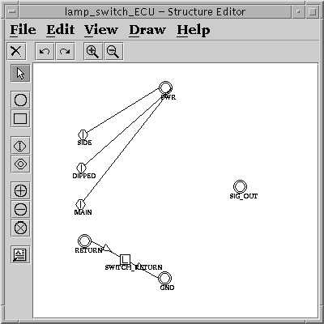
The four pins of the switch are connected to the four nodes on the left of the diagram as in the schematic. It seems likely that this is not a realistic model - it is possible that an arc connecting power and ground will be included. This will be necessary if the ECU was to lack a common return for the switch.

In both the control ECU and the CAN terminal, the need for the component to be electrically active has been incorporated in the state machine, by placing all the interesting behaviour in an “active” state. This is more realistic, as the state chart includes the behaviour that the component will enter an inactive state if the power is lost.

The point about both these methods is that defining the relationship between the two models is left to the model builder. It would be easy to model the state machines without the active and inactive sates, so that the component would work correctly even though it was without power. It seems to be at least worth asking whether there is some way in which the relationship can be formalised, so forcing the behavioural model to depend on the correct functioning of the component’s electrical model. This question needs thought. It seems not impossible that there are matters arising from it to do with the correct modelling of faulty behaviours.

A simple version of the CAN front lamps circuit has been built omitting the CAN terminals, so the ECUs communicate with each other directly. This has been used to test the relationship between the electrical and behavioural models.

The CAN was simply modelled as a wire between the signal terminals of the ECUs, so it could fail by going open circuit. This was tried, and the CAN message was still transmitted – in other words it travels between the behavioural models without reference to the structural model. While this problem could be removed by specifying a CAN component whose behaviour was to fail to transmit messages, it places the onus on the model builder (user) to handle this correctly. Of course, as CAN bus consists of two wires and both would have to go open circuit before transmission was lost, but this does not really answer the general point about the weakness
of the relationship between behavioural and structural models.

As an additional test of the relationship between components’ structural and behavioural models, the control ECU state chart omitted any reference to the active state of the power arc. As expected, this meant that the power supply to that ECU could go open circuit with no effect on the operation of the system. Again, this leaves responsibility for avoiding this problem with the user, who must ensure that the state chart correctly handles both electrical and behavioural sides of the component.

Repository of data
It will be seen from the state charts that it has been necessary to declare similar variables in different places. Both ECUs have a similar set of integer constants to represent switch positions and implicitly both CAN terminals have similar declarations of specially defined data types (Signal and CAN_signal).

The types for Signal and CAN_signal have not been described in the state charts – it might well be that they are provided. The contents of a signal could simply be an integer, and CAN_signal could simply have two – one for the contents and one for the message id.

The existing transmit/receive facility has the receive method returning an integer, so when used as a condition the value of the passed message is tested. This is not appropriate for modelling components such as CAN terminals where the contents of the message will not affect the component’s response to the message, especially as even if the CAN terminal is passed an impossible message, it will still relay it. As transmit and receive are limited to integers, we clearly need something more sophisticated to model CAN messages. It seems proper to declare the incoming and outgoing messages as local to the CAN terminal, at least at a system level, though we might want to look into using a central file of all of a vehicle’s CAN messages (like the B2xx spreadsheet we have had from Ford). Clearly, if the variables are declared locally (as in the example system) the type needs to be known globally. Should we allow the declaration of new message types at a system level, however? This might enable acceptable ranges to be declared. If this is done, do we need a central place to declare this data, not unlike the Statemate data dictionary?

The duplication of the constants representing switch position could perhaps be done in a central repository as well, to avoid problems arising from the two (or more) declarations failing to correspond correctly. This seems to me to be of doubtful benefit, as there will be no equivalent central data bank in the distributed system we are modelling.

Collisions and arbitration
The CAN terminal state chart has been modelled in such a way that collisions and arbitration are included. For example, there is a transition from transmitting to to_send if a collision with a higher priority message is detected. There are various conceivable ways of modelling message collision and resulting delays, of which that illustrated is the most elaborate. There is a possible problem here in that we will be modelling a genuinely concurrent system consisting of independent ECUs on one computer. Therefore the timing of the results will not be independent unless we run the simulation on a multi processor machine. If this is not done, then each ECU’s model will actually have to wait while another ECU is being simulated. Strictly this will prevent the simultaneous transmission of conflicting messages.

The other drawback of modelling collisions is the simple one that not all nodes on the network are present when running a subsystem (i.e. less than whole car) simulation. This could perhaps be sidestepped by including the whole network as a component, even though the nodes are not part of the system being simulated. This does, of course, imply simulating every system attached to the network to generate the other systems’ messages and so the collisions.

One possible (if crude) alternative is simply to ignore collisions (at least from other systems) and give the network component a failure mode resulting in the delay of a message. The difficulty here is that only some messages will be delayed, not all of them. Maybe the network component could have a “random delay” generator, so some delays are introduced? The number and length of delays could perhaps be varied depending on the priority of the system’s CAN messages (if this is known). Thomas Plocher pointed out that he would be interesting in tracing the effects of collisions within a system. This suggests that some attempt at modelling collisions should be made.

The whole question of modelling delays in achieving a system function still needs more thought.

Using event passing
A CAN terminal component cannot readily be modelled using event passing (as described in Proposed approaches to network simulation). This is because the ECU needs to pass a send_signal event to the CAN terminal and so the value the ECU want sent is lost. A possible work around would be to have separate events in the CAN terminal state machine for each value it might send, so when the switch ECU wants to tell the network that the switch as at, say, position 1 (sidelights on) it sends a send_sidelights_on_signal event to the CAN terminal. This will make for a fairly cumbersome state chart for the CAN terminal.

The event passing approach means that messages (passed events) are atomic and instantaneous so it cannot be used for modelling collisions in CAN.

The difficulties encountered when the message does not trigger a definite transition have already been discussed.

Modelling CAN terminals
As has been suggested there seem to me to be advantages in modelling CAN terminals as separate components. The advantage addressed here is the idea that they are themselves electrical components, and correct functioning of the system depends on their having functioning as such (so, for example, having a correctly working power supply). However, even if they are not modelled as separate components at he structural level, there is a case for them being regarded as separate components on a combined PCB. This is simply that the CAN terminal behaviour can then be re-used, combining the CAN terminal state chart with that of the ECU (joined using signal passing), instantiating the generic CAN model with the message ids it is to pass on the ECU (if any). This also allows some modelling of PCB failure modes, if this is of interest, such as a dry joint preventing message passing.

There seems to be some question of the value of modelling collisions so explicitly (see section 6.3). This was not considered for the “event passing” example, and for workpackage three, it is not necessary. We do, arguably need to give some thought to the idea of modelling delays in achieving functions, even if those delays are to be generated by a network failure mode, at first. Even this is not necessary for the electrical fault simulation required for workpackage 3, however.

