Systems with telematic components

Author: Jon Bell
Date: 11/2/02
Document ref. SD/TR/02

Introduction
This report presents some simple systems for use as case studies in SoftFMEA and discusses questions that arise from these examples. There is also some discussion of types of system we might wish to consider, and also the effect of network communication on the idea of relatively isolated subsystems.

The report uses CAN as a term for the network side, and the example circuits assume the use of CAN or a similar CSMA/CR protocol. In fact, as drawn the examples use “full CAN” in which the CAN terminal filters all messages from sources not interesting to the associated component, so only relevant messages are passed on to the ECU. It is not clear whether terminals in other networks (such as SCP, Byteflight, etc) do this filtering, so it may that the systems as described will not work with SCP, even though the protocol is similar. The examples’ behaviour will also need altering to model the new time based protocols intended for drive by wire applications, but these protocols will generally be easier to model, having deterministic latency. There is some discussion of other protocols in this report.

Types of system
Many diagrams of networks in a vehicle have two distinct but connected networks - a high speed one for real time control functions, such as engine management, and a low speed one for bodywork electrics, such as cabin heating/air conditioning and vehicle lighting. These two networks are typically linked through a central bridge of some sort. The simple systems herein do not involve such linked networks. It seems to be possible that these two distinct networks use different protocols, such as CAN for the high speed one and SAE J1850 for the other.

Arguably a more significant difference is between open and closed loop systems. An open loop system will simply have a component reacting to an activator but has no sensor, as there is no feedback. Using a network to control vehicle lighting is a simple example. A closed loop system has one or more sensors to provide feedback. High speed control systems (engine management, ABS) will generally be closed loop, but so might bodywork systems, such as a heating or air conditioning system with a temperature sensor. Modelling these systems is more interesting as they are intrinsically time varying. How critical the timing is will depend on the system, a few seconds delay in response to a cabin temperature sensor is tolerable, but clearly useless in the case of an engine management system.

It is, perhaps, worth noting that there is a possible subdivision of closed loop systems, according to the feedback’s relation to the external (driver’s) control setting. A heating system will alter the heater settings simply to reach and then maintain the chosen temperature. In contrast, ABS control systems will override the chosen setting (i.e. release brake pressure to prevent wheel locking). Whether this distinction is important or interesting is not yet clear.

Some, at least, of these systems will have non-electrical components. ABS is largely hydraulic, for example. Do we want our mixed modelling language to be capable of modelling these, as well as modelling electrical/electronic/software components/subsystems at different levels of abstraction? The importance of this will depend on how important these non-electrical components are to the functioning of the system.

Subsystems
Clearly, the use of a network adds another layer of connection between the various electrical systems in a vehicle. It might be the case, for example, that the reason a message is not being received is because another node on the network is constantly transmitting. In addition, the use of a multiplexed “ring main” wiring system might also be felt to militate against the idea that we can model subsystems in isolation.

I suggest that it is not impossible that we can model the bus in such a way that faults in other nodes are considered faults in the bus component/subsystem, so this loss of separateness can be handled in that way. It seems reasonable to model the CAN terminals associated with the actual system being modelled and have them connected by a CAN component, faults in which might actually caused by a specific component of the CAN, such as some other terminal. For example, we might treat the failure of some other terminal broadcasting constantly as a failure “transmission fails”, as at a system level, we do not need to know the causes of failure of the CAN bus. This seems compatible with the network failures in Generic Network FMEA [1].

The use of a network might also electrically divide a subsystem, which will clearly affect AutoSteve’s simulation. If we are modelling the network at a higher level of abstraction so it will not be electrically simulated, this will make the various bits of the subsystem electrically separate. The schematics of the speculative systems illustrate this.

Of course, the network is an electrical component, at least in part. The terminals will depend on power and ground lines (failures of which can, of course, readily be modelled) and the transmission medium itself may well be electrical, though some network technologies favour optical transmission.

Example systems
This section discusses two sets of example systems. Two speculative, but plausible, systems have been drawn. These are illustrated and described in appendices. There is a discussion of the questions raised by these systems in this section, together with a discussion of the Jaguar schematics provided by James Border.

SoftFMEA examples
This section discusses the two specially drawn, speculative example systems, and the questions they raise.

The lighting system
This system is essentially a CANbus version of the AutoSteve simple headlamps system, with sidelights added. Strictly speaking, of course, it should have the rear light clusters as the tail lights are also part of the system. It would, of course, be quite simple to add this later, the only connection being the bus. The rear lamp ECU will also receive and react to the same messages, but will also need to be told abut switching the brake lights and reversing lights. The same might also apply to the instrument lighting, of course.

This system has no sensors, so is a simple open loop. Even so simple a system raises some questions that are worth noting.

In the diagram I have used dashed lines to suggest parts of the system that might be modelled in AutoSteve (i.e. the top and bottom) and parts that might be modelled at a functional (or behavioural) level. This simple break down fails to capture the results of power failure to the CANbus terminals. This should perhaps be modelled electrically. This would, of course, introduce more components that are boundaries between electrical and behavioural modelling. Indeed as all network components depend on electricity, there would be such a boundary in each component. There seems not to be any intrinsic problem with this, but it will complicate the system. The boundary between electrical and behavioural simulation is actually inside the ECUs.

The two CANbus terminals might, in many implementations, each model two components, a controller, which constructs the message and a transceiver that handles transmission. These should perhaps be modelled separately, if only the more accurately to capture their own connections to power and ground. Is this separation a useful complication? My thinking is that the CAN connections for the system we are modelling should be modelled separately from a general CAN component, as failure of these nodes to transmit or receive will have distinct effects on the system. The failure of any other node is less relevant and can (probably) be treated as a failure of the bus in general. It seems reasonable to suppose that we must model an incompletely specified network, because it is likely that users will want to simulate subsystems before the numbers of nodes and prioritisation of sources on the network are known. Modelling a complete, known network will give finer resolution of the faults, in that we might be able to model loads, and so delays, possibly using a specialist tools, such as CANoe. This is something of a parallel approach to Dougal’s finer grained simulation.

As a side effect it is noticeable that as the two ends of the system are electrically distinct, it should be simple to simulate them differently, for example simulating the lamp end quantitatively, while using qualitative state charts to model behaviour at the switch end.

For simplicity I have not modelled different voltage sources (such as 14 and 42 volt systems). This would not be unduly difficult to add. In this system the two ECUs and the CAN model between them do no more than the simple lighting ECU in the simple lighting example. As such, modelling the behaviour of these components with state charts is no more problematic than any other component, but there are more of them. Some way of modelling the messages themselves is needed, of course.

The components’ behaviour can happily be described using the sort of state machine language used in the AQQA State Builder tool, or Statemate. SDL should also be well able to cope, at least at a process level.

This system has been simulated using qualitative AQQA. How this was done is described in the companion report, Proposed approaches to network simulation.

The simple heating system
This is about the simplest system I could devise in which feedback is used, the idea being that the heater is turned on and off to maintain the desired temperature, which is set using an analogue control knob. It is likely that a real system would include a further sensor at the heater to guard against the element overheating and also some connection between heater operation and fan operation might be required, partly for the same reason. These ideas are described in a little more detail in the system’s description.

The system has been designed with a passive mode in the sensor, to give the opportunity to include a CAN terminal that must both receive and transmit. An attempt has been made to model this behaviour using a simple state chart. The behaviour of CAN terminals that never transmit or never need to pass on a message are subsets of this behaviour. This raises the possibility of providing a sort of abstract model CAN terminal component where the user instantiates the interesting sources and the behaviours in each state and also whether transmission is ever used. This also means that a message might be of interest to two receivers so provides some modelling of the broadcasting of messages in CANbus. This is something that SDL does not appear to model well.

It is felt that the description of the behaviour of this system’s components needs more thought, and the state charts herein could be improved. This relative difficulty in generating good descriptions is a likely consequence of modelling systems with more complex behaviour.

It is perhaps worth noting that state charts are suited for modelling reactive behaviour. More thought needs to be given to how the sensor, in this case, is to be modelled as is not a reactive component - it will operate continuously, at least when activated.

The drawing of the CAN terminals for this system includes their PWR and GND pins, to point up the idea that they are electrical components, so a failure of the wire connecting the terminal to ground, say, will result in loss of communication over the CAN. This raises the idea that even these components need modelling on two levels, as a (simple) electrical subsystem, and as a behavioural model. This adds weight to the idea that the local CAN terminals do need modelling as well as the network in general.

Power supply has been modelled on a more or less “regional” basis, with a local subsystem having its own power supply and ground (strictly “chassis”). It might well be that the CAN terminal will share a power supply with its associated ECU and certainly in instances where different voltages are used, the “power side” components (such as the fan and heater) will have a different supply. This gives us ten electrically distinct subsystems, as drawn. All these might need electrical simulation, so as to enable (or not) the behavioural modelling. For example, a power failure (connecting wire goes open circuit) to the SENSOR_CAN will mean no current temperature is ever received by the HEATER_CONTROL_ECU, so the heater will stay on constantly, and the cabin will overheat.

This system also introduces the idea of variables associated with a component. Clearly in order to maintain the right temperature, the HEATER_CONTROL_ECU must remember what it is! In the system integer and Boolean variables are used. The use of integer variables especially might appear to militate against qualitative modelling of the system, but if they are merely to be compared to a landmark value, this can be handled qualitatively. In the case of the heater system, the desired temperature is, of course, the landmark value. SDL supports the idea of variables associated with a “process” (which approximates to a component in these systems), as do StateMate and State Builder.

Unlike in the lighting circuit, the need for the ECUs and CAN terminals to be electrically live has been taken as read in the behaviour description state charts. It seems likely that we will model these components on two levels, one as a component in an electrical circuit, so establishing whether or not it is live, and also at a behavioural level. Clearly the behavioural modelling will depend on the electrical circuit working correctly. This does complicate simulation, in that we might need to run the electrical simulator (CIRQ) on several distinct electrical subsystems, in order establish that all behaviours are available for simulation. Each of these subsystems can be expected to be quite small, however.

The time varying nature of this closed loop circuit militates against modelling it in AQQA, because of the need to model changes in the system’s environment (temperature in this case) that are directly affected by the system’s behaviour. There is a discussion of this problem in the companion report Languages for simulation of network and software components and a possible solution is proposed in Proposed approaches to network simulation.

The Jaguar example systems
Since the earlier version of this report was presented at the project meeting held in October 2001, James Border has provided schematics of three electrical systems using a network to communicate between components. The protocol used is SCP, rather than CAN. These systems are: -
- Front lights
- Rear lights
- Central locking
The front lights system is, of course, closely comparable to the SoftFMEA example, and indeed the similarities are quite pronounced.

The schematics are on paper and it is not clear how the systems were simulated. Discussion of the behaviour is based on reading of these schematics.

In these schematics, no attempt was made to draw network components, instead network connections are shown using a double line with an arrowhead at each end, labelled “SCP”. These connections join ECUs, so the network terminals are not shown as separate components. This modelling of the network is sufficient for modelling the network faults in Generic Network FMEA [1]. However, an electrical fault affecting only message transmission could not be simulated. An example might be a wire connecting the network terminal to power going open circuit. The network would have to be treated as an atomic component with its own failure modes. Faults in the ECUs leading to wrong messages being sent could be modelled, of course.

The lighting systems
Two of the schematics are for lighting systems, front lights and rear lights of the same car. The switch gear, switches and ECU, are common to both, of course. The switching ECU controls the light controller by sending messages over SCP. There is a separate controller for the front and rear lights, so the topology of the system is not unlike the speculative example in section 6.1. The behaviour is different, however, in that groups of lights are fed from the battery via a power relay, whose coil connections are not shown. The controllers therefore provide paths to ground depending on the messages sent via SCP from the switch ECU. The rear light ECU also listens to SCP messages from the power train controller, so the reversing lights come on when reverse is engaged. The brake lights do not use SCP, possibly for fear of excessive delays in message transmission.

Both lighting schematics include an AUTOLAMP_SENSOR, connected (electrically) to the switch ECU. I understand that it automatically powers up the lights when darkness falls. In the example systems it does not affect the network side, being connected electrically to the switch ECU.

The central locking system
This has three components connected to the SCP network. An ECU controls the driver’s door locking and it communicates with another ECU that controls the other three doors via SCP. Another ECU, labelled GEM, appears to detect the state of the two front door ajar switches and communicates this with the driver’s door ECU, apparently not the passenger door one, even though the passenger door one receives these messages, they being broadcast. There are therefore two SCP links shown on the drawing, between the driver’s door ECU and the passenger doors’ ECU and between the driver’s door ECU and the GEM. The exterior boot release switch is connected electrically to the driver’s door module, by the driver door lock/unlock status pin.

In both systems, there are fewer ECUs than might be expected, so the amount of wiring is not reduced as much as might be supposed and there are fewer network terminals. In the central locking system, for example, one might imagine an ECU for each door, with each ECU listening to messages from the driver’s door ECU, assuming that the driver’s door is the master for all doors, and the passenger door only locks and unlocks itself. If this is the case, there would be no increase in load on the network by having separate ECUs and there would be less wiring as each locking latch is connected to its ECU by at least four wires.

Other protocols
As the Jaguar schematics illustrate, there are several other automotive protocols which the system might need to be capable of modelling. SCP, Ford’s Standard Corporate Protocol is apparently being phased out in favour of CAN, but there are new protocols being developed, such as Byteflight and TTP/C, intended to have guaranteed message latency, for use in real time drive by wire systems.

There is a description of some of these protocols in the SoftFMEA document Other automotive industry protocols, copies of which can be made available. Here discussion will be confined to significant common features and differences between the protocols as they relate to modelling of electrical systems.

All protocols investigated use broadcast messages, identified by source. In the case of CAN, this also determines priority for collision resolution. The B2xx CAN specification [2] suggests that different sources can send messages with apparently identical content, which suggests that the ECU itself needs to know the source of an incoming message, to enable correct processing of the contents. This is presumably the case with all protocols.

The probability of an undetected error is similar (being extremely low) in all protocols. However, this refers to message corruption by the network. If a component (say a sensor) sends inaccurate data, this data will be what is received. This is, of course, a failure of the sensor, not the network.

The most significant difference between the protocols is whether they are time or event driven. Protocols such as TTP/C avoid collisions by allocating a specific slot in time during which a node can transmit. This eases modelling, as there should be no collisions and message latency is known. However, additional faults are introduced, as the network needs a common notion of time, and a failure of that node which manages time might need modelling, though all such protocols have fault mitigation strategies.

Conclusion
The simpler of the speculative systems has been successfully modelled in AQQA and there seems no reason to suppose that the Jaguar systems could not be modelled in the same way. The closed loop heating system needs more thought, however.

Both speculative systems drawn here so far use “full CAN”, though the changes in behaviour necessitated by “basic CAN” (or J1850) would be slight. Indeed, at a state chart level there may be no need to change behaviour at all.

Neither of the current systems is very time critical, it would be interesting to see how delayed messages can be included, where delay matters. Nor does either system have any significant non-electrical component. ABS is an obvious example of one that does. It will be interesting to try examples where the behavioural modelling language is used to model such components. I need to learn more about how systems such as ABS and engine management systems work before I can attempt to draw possible examples.

There is no example of a system where there is a change in degree of setting. One simple example might be a motorised seat adjustment system, where the seat is moved by a motor. An interesting example might be a heater not unlike the simple heating system but using a heat exchanger extracting heat from the engine coolant. The temperature in this case would be governed by the position of a duct mixing warmed and cool air. This duct might be positioned by some sort of stepping motor, allowing electrical control of the temperature, so the sensor would work in much the same way as it does in the existing example. This seems a bit contrived, but plausible. It would have advantages over the example system (no heating elements to burn out!).

Future work
Experience of modelling the lighting system seems to suggest that using a simple state chart language to model the network can give useful results. It would be interesting to try to model the heating system in AQQA, in the same way, to explore the limitations in modelling time varying systems.

It would be interesting to have examples of time critical systems, and also possibly systems where the behaviour of other non-electrical components (such as software or hydraulic components) need to be modelled.

References
Internal SoftFMEA documents have not been referenced, they are referred to by title in the text. Where copies are not provided, they can be made available. Contact Jon Bell, jpb@aber.ac.uk.

[1] Timothy Thomas, Generic Network FMEA, Ford Motor Company 2001

[2] Huw Thomas, B2xx CAN message list structure and packeted data encoding, Ford Motor Company 2001

Appendix – the speculative example systems and their representation
In this section will be found a few example systems rather speculatively devised to try to find how a telematic component might be incorporated into an electrical system. Each system is illustrated by a schematic, followed by textual and diagrammatic description of its behaviour. In the schematics, I have used thick lines to represent paths for messages (not necessarily CAN ones) and thin lines to represent electrical connections.

The behaviours of components are described using simple state charts, with a language not unlike that used in the AutoSteve state chart tool. This language has not been formally defined, but might provide a starting point for consideration of how well a state machine based language (such as Statemate’s or SDL) will function for SoftFMEA. A brief description of the language used follows.

While I hope the modelling is accurate (if perhaps a little imprecise), I would be grateful for notification of any errors, especially any that affect the arguments presented herein.

The language used
The language used in the state charts describing the behaviour of components is based on that used by StateMate and has not been properly defined, being added to on an ad hoc basis as the diagrams were drawn. It associates conditions with transitions and actions with states, in general. This proved impractical in one case. SDL appears to prefer associating actions with transitions. It is assumed that a finished language would allow this.

A state can have an action performed on entering the state (“ENTERING”), exiting the state (“EXIT”) or while in the state (no qualifier).

In an action ‘=’ implies assignment, while in a condition ‘=’ or ‘==’ implies a test for equality. This needs tightening up!

I have assumed that the language supports a data type message that is passed from one component to another. An ECU passes a message to its CAN terminal which adds the source address and sends the message over the bus. The receiving CAN terminal then passes the message to its associated ECU. Therefore sendMessage means over the CAN bus (broadcast) while passMessage means pass to an associated component. I have used getMessage to mean “receive a CAN message” and passed_message to mean receive one from an associated component. I have modelled a CAN message with the attributes source and message. This modelling of message will work for other CSMA/CR protocols. It might be felt to be too simple. One obvious shortcoming is the possibility of sending an RTR message, which has no content. The diagrams would benefit from a distinct symbol for a conduit for these messages. This modelling of messages needs tidying up.

Components which would be simulated electrically have similar properties to AutoSteve components. R is resistance, and might have the values 0, load, inf. A pin might be described as active or inactive. This implies current flow. Voltage is also used in the simple heater system. I have identified pins by letter, in both the schematic and the behaviour diagrams.

The method/function sendMessage implies carrying on trying until the message has been acknowledged. This is CAN behaviour.

The lighting system
This is a more elaborate approximation to the AutoSteve simple_headlights example. As such it is an open loop system, with no feedback.

This is the schematic:-
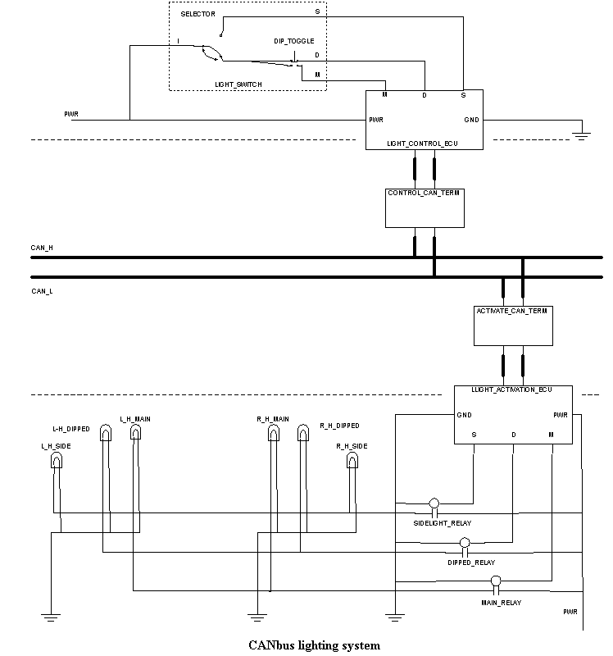
The dashed lines are intended to indicate where the system is to be simulated electrically (top and bottom) and behaviourally. Therefore the lines joining components in the middle section are conduits for messages, not wires. The power and ground connections for the CAN terminals have been omitted. This is an over simplification.

The component LIGHT_SWITCH models a car’s head (and tail) light switch. As such it has two parts, a selector for off, sidelights and headlights and a toggle switch for dipping the headlights. The toggle switch means the component has memory, so a state chart is needed to model its behaviour.
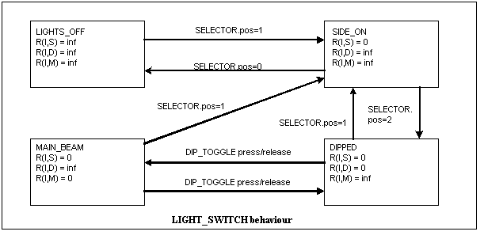
The selector has three positions 0 (off), 1 (sidelights) and 2 (headlights). On first moving the selector to position 2 we enter state dipped, so headlamps will always come on dipped rather than main beam. It is, of course possible to switch off the headlamps from either dipped or main beam.

The supposed behaviour is that the switch position will activate different pins on the LIGHT_CONTROL_ECU. This behaviour is copied from SIMPLE_LIGHTING.
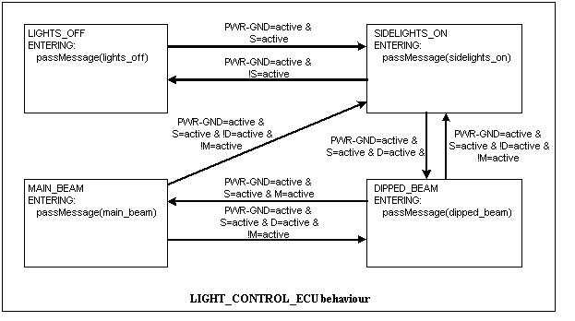
This component’s states mirror those of the switch, as its job is simply to translate the electrical inputs to messages for the CAN bus. It therefore passes a message to its associated CAN terminal, CONTROL_CAN_TERM, on entering any state.

The role of CONTROL_CAN_TERM is to translate any message passed to it from the ECU into CAN format (adding the source) and send it over the bus.
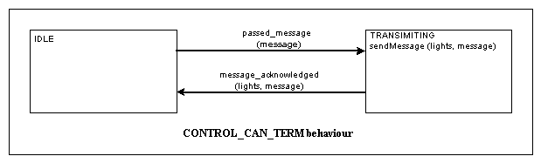
This diagram is perhaps a simplification of its actual behaviour as when it is not transmitting it will be receiving. This behaviour is not of interest in this system, so has been included in the BUS_IDLE state. It is assumed that the terminal will carry on trying to send the message until it has been acknowledged, when it will return to its idle state.

A message over CAN is broadcast, so it should be received by the ACTIVATE_CAN_TERM.
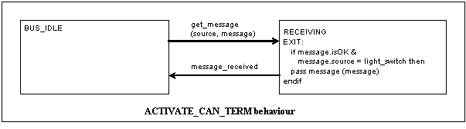
This terminal implements “full CAN” as it only passes a message from an interesting source on to its associated ECU, LIGHT_ACTIVATION_ECU. Acknowledgement of the message is implicit in the message received transition.

The job of LIGHT_ACTIVATION_ECU is to convert the message back into electrical conditions to light the lamps. It drives relays in much the same way as does the ECU in SIMPLE_HEADLAMPS.
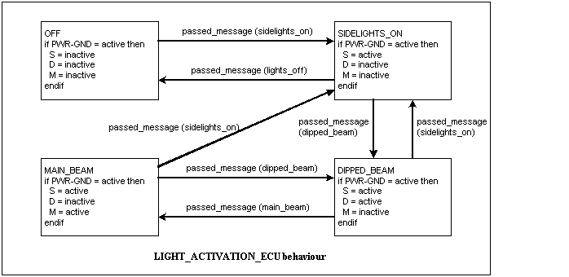
The transitions in this chart have been (over) simplified by omitting their dependency on the ECU being powered, i.e. PWR_GND being active. This also, of course, applies to the CAN terminals.

One possible problem not modelled here is that the switch might be switched past position one before the message sidelights on is sent. If this meant the message was not sent, the following message has no effect on the current state of the ECUs. This is assumed not to be a problem with the control ECU as there is no competition for it. The problem would be solved if it assumed that a CAN terminal can buffer messages to send, so the control ECU’s terminal will still send each message in turn. I think it possible that this is the case. Clearly the state diagrams could (should?) include these transitions.

The simple heating system
This system models a simple cabin heating system with a sensor to maintain a desired cabin temperature. It is about the simplest closed loop system I could devise and is probably not a realistic model of any actual system, though it is, I claim, at least plausible.

Here is the schematic: -
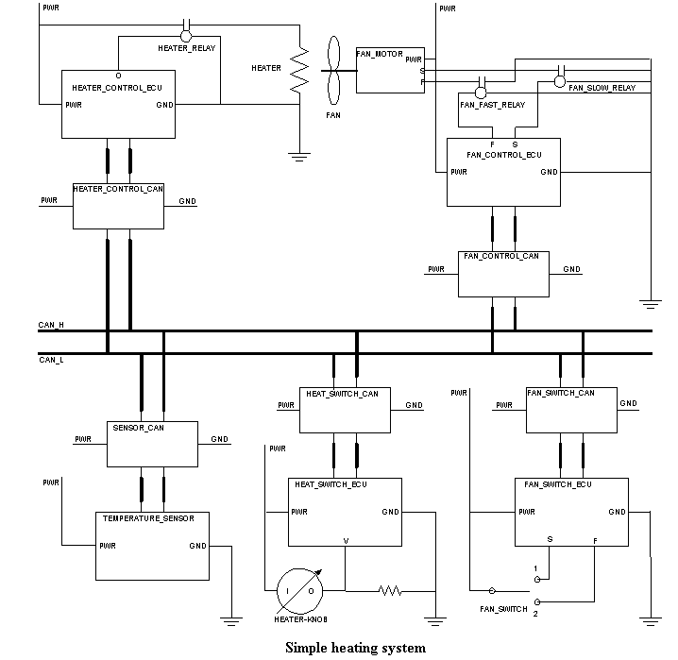
The fan subsystem (top and bottom right) is really quite separate, and could have been omitted, as the interesting behaviour is in the heater. The fan has been included for completeness, the two systems being fairly closely related, and more specifically to point out possible relationships between the heater and fan subsystems. The simplest of these is the possibility that if the heater is switched on without the fan, the fan comes on to the slow setting, the idea being that this prevents overheating around the element, and also ensures the cabin warms up more quickly so saving power as the heater will be able to cut out sooner. Even this introduces further complexity. Should there be a sensor so that if the fan fails, the heater is disabled? Further components might well be added, such as a sensor near the heater which either operates a cut out if an excessive temperature is reached, or prevents further heat build up by switching on the fan.

Having raised these points, the fan subsystem will not be discussed further, so the description of the system’s behaviour only deals with the heater switch, heater and temperature sensor subsystems. As drawn here, the fan subsystem is similar to the previous example, but simpler (no dip switch!).

The switch (HEATER_KNOB) is assumed to be a variable resistor in which contact is broken (so resistance is infinite) when set to off. The balance between the resistance of the switch and the balance resistor will vary the voltage at pin V of the HEAT_SWITCH_ECU. If this voltage is equal to ground then the heater is to be turned off. The ECU has an ADC to allow the desired temperature to be passed digitally across the CAN. The behaviour of this ECU is not well described in a simple state chart, but here it is anyway.
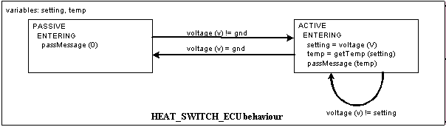

The associated CAN terminal, HEAT_SWITCH_CAN, naturally transmits any message passed to it by the ECU. Its behaviour can therefore be abstracted in much the same way as the light switch CAN terminal in that system and is not described further here.

The sensor’s CAN terminal is more interesting as it both passes on some received messages and transmits the new temperature from the sensor (if the heater is on).
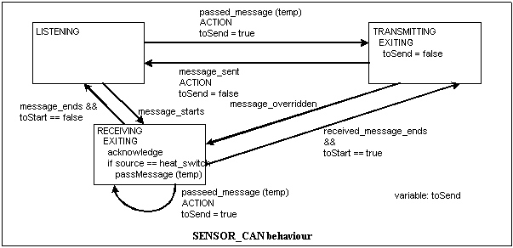

This attempts to model all a CAN terminal might do, in that it is both a receiver and transmitter for its associated component. The idea is that if the heater is off, the sensor goes “passive” and does not bother to transmit, so reducing the load on the CAN.

The sensor is therefore assumed to have two states, as shown here.
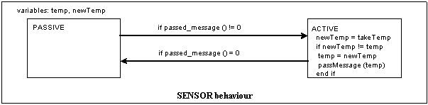

This implies full CAN, so that only the right messages will be passed to the sensor itself. In basic CAN the sensor will have to check the source of the message itself.

We now have both the desired temperature and the current temperature being sent over the bus, so we can look at the behaviour of the heater controller HEAT_CONTROL_ECU. Its CAN terminal is another simple one, that never transmits, similarly to ACTIVATE_CAN_TERM in the lighting system. It does need to pass on messages from two sources, however.

The behaviour of the ECU itself is rather more complex.
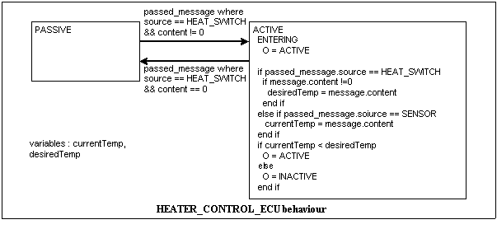
If O is ACTIVE (and the electrical circuit is working properly), then the relay coil is live and the heater comes on. A message from HEAT_SWITCH of value 0 implies the switch has been turned off.

It seemed sensible to assume heat was wanted until the sensor indicated otherwise (why would the heater be switched on if the cabin was warm enough?) so on entering the ACTIVE state, the heating element is on.

All these behaviours depend on the components being live (i.e. a current or p. d. between the PWR and GND pins). I have not included these in the behaviour models for the components, for simplicity. It seems likely that we will model such components at two levels, electrical and behavioural. The behavioural model will only be used if the component is electrically active.

